**FUSION**

**LEWIS MAZZEI**

**PROJECT PLAN**

**Project Proposal** (Version 1.1)

**Concept**

Fusion is a simple puzzle game inspired by the popular app ‘2048’ in which the player slides tiles around a 5x5 game board and combines identical tiles. These tiles represent elements in the periodic table and are displayed on the game board with their chemical formula and respective atomic number.

**Mechanics**

A tile occupies a 1x1 cell on the board. When the player initiates a game either of the lowest two elements will spawn in a random cell on the board. Player input will be accepted in the form of arrow key presses. A key press will cause all tiles shift in the direction of the arrow key, provided the tile has an unoccupied cell to move into. tiles will continue to shift until they are either at the edge of the game board or are blocked by an occupied cell.

Every time the player makes a move another tile (either of the two smallest elements: i.e. Hydrogen as it has the atomic number 1 or Helium as it has atomic number 2) will spawn in a random cell on the board. If a tile collides with another tile identical to it (i.e. the same element) it will merge into a new tile (occupying a 1x1 cell) representing the next higher element on the periodic table.

To allow players to progress through all elements in the periodic table the game will be divided into stages. Once the 11th element has been created (i.e. 2 Neon tiles are combined to create a Sodium tile) a ‘Stage complete’ screen will be shown and the player will be prompted to proceed to the next stage. In doing so the game board will be cleared (i.e. every cell will be made empty) and as before, either of the lowest two elements will spawn into a random cell on the board. The difference is however that now the two lowest elements will be that of Magnesium and Aluminium (as they have atomic numbers 12 and 13 respectively).

This system will repeat every time the 11th element is created with the final stage being that of stage 11 with the final obtainable element therefore being unbiunium with an atomic number of 121. Reaching this element will be how the game is effectively ‘won’. A score will be kept throughout the game and will be incremented every time two tiles are combined with the atomic number of the two tiles combined being what the score is incremented by. For example, if two Boron tiles (with the atomic number 5) are combined to create a single Carbon (with the atomic number 6) then a total of 10 will be added to the player’s score. When the player starts a game they will be prompted to submit a username between 3 and 8 characters long allowing their score to then be saved in a leaderboard when the game is over. If the user wishes to pause the game before it is over and close the application they will have the option to save and restart it from the game state that they left it in by entering the name they chose at the start of their game.

This game is targeted at novice users of both genders over the age of 8. It will be specifically targeted at kids interested in science however it is a casual game that can be enjoyed by anyone, even if they have no scientific background. This is true as players can simply use the numbers on the tiles to play even if they do not understand what the element abbreviations actually represent.

I am going to be developing the game using the Python language and the PyGame class library.

It will fulfill the following requirements:

* Include an appropriate interface that validates all inputs
* The interface of the menu and game itself will be very basic and cater to my selected target audience
* The username will be validated to check it is no shorter than 3 character and no longer than 8 characters before it is submitted
* Include an interface with stored data
* My leaderboard will be stored on an external file and will be written and read to by the program to both retrieve and add scores to it
* Include a 2D array
* The game board itself will consist of a 2D array, with the tiles being objects that are placed inside it
* Include a sort algorithm
* I will sort the scores shown on the leaderboard using the bubble sort algorithm

**Feasibility Study** (Version 1.1)

Technical

As I will be using my laptop to run and test my program the minimum technical specifications will be that of my laptop's:

* RAM – 3820MB
* Processor - Intel® Core™ i3-2310M CPU @ 2.10GHz × 4
* Graphics Card - Intel® Sandybridge Mobile
* Operating System – Ubuntu 15.10 64-bit
* Hard Disk – 488.1GB
* Screen Resolution - 1366 x 768 pixels
* Screen Size - 15.6 Inches (Diagonally)
* Screen Bit Depth - 32 bit

The only software required to run the program will be a Python compiler.

Legal

**Data Protection Act**

My program will not store sensitive data about the user as their abbreviated name does not reveal their identity. This means that I do not need to worry about the implications of the Data Protection Act.

**Copyright, Designs and Patents Act**

All images used in my program will either be non-copyright or will be created by me therefore I will not need to worry about the implications of the Copyright, Designs and Patents Act.

Economic

All hardware and software (laptop, scanner, text editor, word processing software etc.) I will use to create my program I own or will be free to use therefore I will not need to budget for any resources. Educational resources I will use to help me build my solution will all come from free sources as well. I am not selling my software on therefore I do not need to concern myself with marketing costs.

Schedule

I have 6 months and 3 days until the final submission deadline. I have already created an outline plan and will create a detailed plan of my schedule to help me plan when I need to achieve certain aspects of the project by. I believe I have sufficient time to fully complete my project and that I have built in enough contingency time into my plan so that if I fall behind I will not run up to the deadline with an incomplete submission.

**User Survey** (Version 1.0)

I gave this survey to this several people of varying gender and age, the responses can be found in the appendix. The survey given out was as follows.

Question 1

In a casual 2D puzzle game, do you prefer to see all settings on the user interface at all times, or hidden within a separate settings menu? Why?

Question 2

In a grid-based game involving tiles do you prefer the colours of these tiles to be contrasting or of similar shades? Why?

Question 3

How essential on a scale of 1 to 10 do you feel an instructions page is in a casual puzzle game? Why?

Question 4

How long do you usually spend playing a casual game?

Question 5

What usually makes you want to come back to a casual game? Why?

**Analysis Of Findings** (Version 1.0)

I have analysed the responses from my user surveys and drawn the following conclusions.

User Interface

It is clear that people prefer that options are hidden within a menu that can be accessed without cluttering the screen with icons or switches. A simplistic interface seems to be preferred as it allows more concentration on the game itself and is more pleasant for the eye.

*Conclusion:* I will aim to keep the user interface simplistic and keep the options hidden, accessible through a single menu icon on the screen.

Colour Palette

There was a slightly mixed opinion when it came to colours as it is a more subjective topic. However the majority thought that contrasting colours would work better as it make the tiles easier to distinguish and would also keep players engaged for longer.

*Conclusion:* I will aim to keep tiles of similar values that appear on the board at the same stage relatively contrasting.

Instructions

Another varied response with some saying that the game should be intuitive enough to the point that no instructions are needed whereas others said that instructions are essential so that everyone fully understands the mechanics of the game.

*Conclusion:* I will aim to include a brief set of instructions somewhere easily accessible but unobtrusive within the game.

Engagement

Responses on this topic were very varied however I found a slight majority saying around 10-20 minutes playing it (I have to assume that these people meant that amount of time ‘per session’ as I did not explicitly state that it had to be).

*Conclusion:* I will involve this aspect in my end-user testing and will aim to the make my game engaging enough for people to feel they would spend 10-20 minutes playing it per session.

Replay Value

From the limited helpful responses I required regarding this topic I see that people feel that the the score needs to be not too difficult to top still requires substantial skill to improve upon. This seems to make users want to come back as they can see themselves relatively easily going further through the game.

*Conclusion:* I will now aim to implement a fully functioning and well presented leaderboard within the game.

**Outline Plan** (Version 1.1)

|  |  |  |
| --- | --- | --- |
| **Task** | **Time** | **Target Date** |
| *Project Start* |  | 08/09/16 |
| Project Plan | 3 weeks | 29/09/16 |
| Requirements Spec | 1 week | 07/10/16 |
| Test Plan | 2 weeks | 22/10/16 |
| Interface Design | 1 week | 30/10/16 |
| Program Design | 2 weeks | 14/11/16 |
| Implementation | 3 months | 07/02/17 |
| *‘Working’ Alpha* |  | 13/12/16 |
| Testing | 2 weeks | 22/02/17 |
| Evaluation | 2 weeks | 09/03/17 |
| *Final Submission* |  | 14/03/17 |

**Detailed Plan** (Version 1.1)

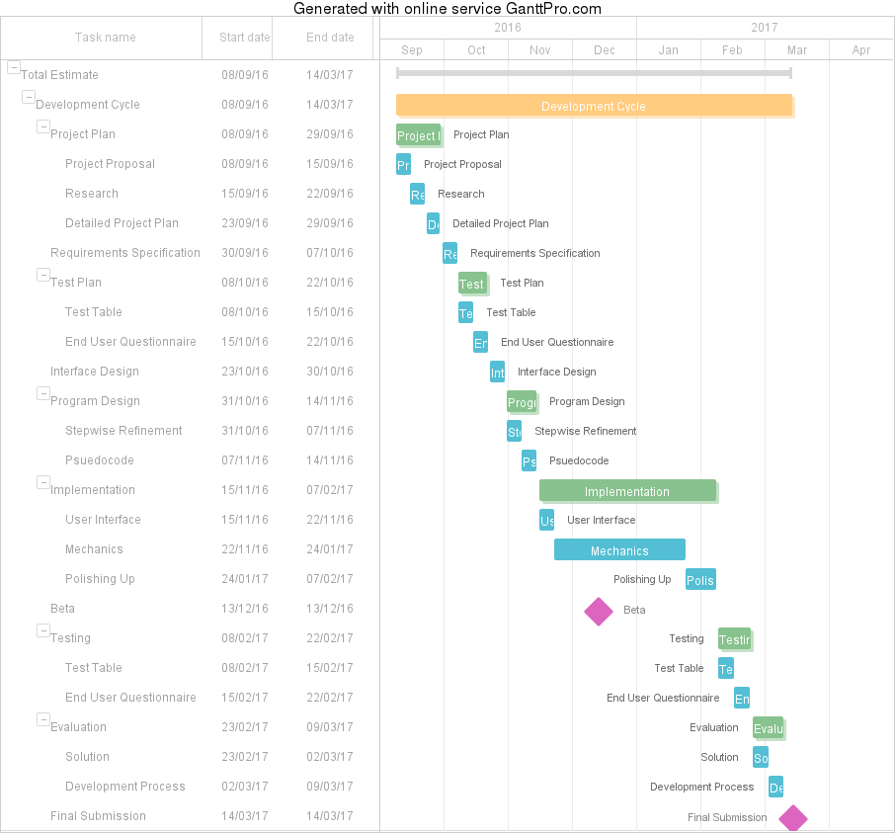

**Resources** (Version 1.2)

Tools

* Laptop
* Word Processor - WPS Writer
* Printer
* Surveyees
* Gantt Chart Software - GanttPro.com
* Pen
* Paper
* Ruler
* Text Editor - Sublime Text
* Wireframe Tool - Moqups.com
* Python Translator - REPL
* Printer
* Ring Binder
* Dividers

Educational Resources

* Youtube.com
* StackOverflow.com
* Pygame.org
* Atomas.wikia.com

Python Packages

* Pygame - Game functions/window control
* Random - Randomise Functions
* Datetime - For Non Functional Testing (How long operations take)
* Os - For file handling/manipulation
* Pickle - For dealing with binary files
* Re - Regular Expressions, for input validation

**REQUIREMENTS SPEC**

**Requirements Specification** (Version 1.1)

Scope

My program will have the following implemented:

* Several screens including the:
* Main menu
* Name input for a new game
* Name input for loading a game
* Game
* Leaderboard
* Options menu
* Instructions
* A square 5x5 game board
* Coloured tiles that can be moved across this game board and combined
* 11 stages; each with a goal of reaching the 11th highest element of that stage
* An options menu with the option to go back to the main menu, save your game and quit the game
* A feature that allows you to save your game under a certain name so that you can go back and load that same game later from the main menu
* A leaderboard that sorts itself when a new score is entered so that the scores are always in descending order from the top down
* An instructions page explaining the basic mechanics of the game

Boundaries

My program will not have the following implemented:

* Sprite animations
* Screen transition animations
* The option to change the size of the game board
* Sound
* The option to change name once one is initially chosen

End Users

This game is targeted at novice users of both genders over the age of 8. It will be specifically targeted at kids interested in science however it is a casual game that can be enjoyed by anyone, even if they have no scientific background. This is true as players can simply use the numbers on the tiles to play even if they do not understand what the elements actually represent.

User Requirements

To run and play the game successfully users will require:

* A laptop/desktop with the minimum requirements or better (Specifications stated in the technical section of my feasibility study)
* A mouse and keyboard (Only necessary if using a desktop computer)
* All the relevant source code files and an operating system that can run a .exe file (as this is what the ‘main’ file will finally be)

Functional Requirements

My program should be able to:

* Track mouse location and listen for clicks
* Take in input from both the mouse and keyboard
* Read data (scores and save data) from a text file
* Write data (scores and save data) to a text file
* Sort a list of scores (in descending order)
* Validate input from the keyboard (length of name)
* Store the positions of multiple tiles of different values within a 5x5 2D grid
* Display images
* Display text
* Draw shapes

Non-Functional Requirements

My program should:

* Not crash unexpectedly
* Have a fast response time after input from the user (almost instant)
* Read from the text file instantly
* Write to the text file instantly
* Reliably store save data without it being corrupted or deleted

Inputs, Processes and Outputs

My program will have the following:

**Inputs:**

* Left mouse click
* Right mouse click
* Scrolling
* Up arrow key
* Left arrow key
* Down arrow key
* Right arrow key
* All character keys from a-z
* Reading from a binary file

**Outputs:**

* Display
* Writing to a binary file

**TEST PLAN**

**Approach**

My solution will be tested in two ways:

1. By creating a test table that will cover both the functional and non-functional requirements of the program (Which can be found in my requirements specification) as well as input validation. Each test will also have a comment from me justifying why I believe that requirement has been achievement. Input validation will be tested with both normal, extreme and exceptional data.
2. By creating a questionnaire that asks more subjective questions and giving it to independent testers. This will provide more varied feedback on my solution and may even bring up some additional bugs that I hadn’t encountered during my independent testing.
3. By live testing the game as I go. I will be able to quickly run the program after I make changes to the code, big or small, therefore this immediate testing will be extremely useful during implementation. This form of testing should eliminate most, if not all syntax and execution errors by the time I get to final testing as if the program fails to start then I can refer to the ‘traceback’ that python will send to the console explaining what is causing the problem, and fix it straight away. Although these bugs and their fixes will not be in the final testing I will document them as I go and they will be found in both the progress diary at the points when they occurred and possibly also in the ‘significant bugs/issues’ section of the evaluation.

**Comprehensive Test Plan** (Version 1.3)

Functional Requirements

|  |  |  |  |
| --- | --- | --- | --- |
| **Action** | **Expected Result** | **Actual Result** | **Comments** |
| **Main Menu Screen** | | | |
| Display switches to ‘Main Menu Screen’ | * Title header displays in the correct position and is the correct size * ‘New Game’ button loads and displays in the correct position and is the correct size * ‘Load Game’ button loads and displays in the correct position and is the correct size * ‘Leaderboard’ button loads and displays in the correct position and is the correct size * ‘Instructions’ button loads and displays in the correct position and is the correct size |  |  |
| Left clicking the ‘New Game’ button | Switches display to the ‘Name Input (New Game)’ screen |  |  |
| Left clicking the ‘Load Game’ button | Switches display to the ‘Name Input (Load Game)’ screen |  |  |
| Left clicking the ‘Leaderboard’ button | Switches display to the ‘Leaderboard’ screen |  |  |
| Left clicking the ‘Instructions’ menu | Switches display to the ‘Instructions’ screen |  |  |
| Right clicking the ‘New Game’ button | Switches display to the ‘Name Input (New Game)’ screen |  |  |
| Right clicking the ‘Load Game’ button | Switches display to the ‘Name Input (Load Game)’ screen |  |  |
| Right clicking the ‘Leaderboard’ button | Switches display to the ‘Leaderboard’ screen |  |  |
| Right clicking the ‘Instructions’ menu | Switches display to the ‘Instructions’ screen |  |  |
| Scrolling the scroll wheel whilst pointer is over the ‘New Game’ button | Switches display to the ‘Name Input (New Game)’ screen |  |  |
| Scrolling the scroll wheel whilst pointer is over the ‘Load Game’ button | Switches display to the ‘Name Input (Load Game)’ screen |  |  |
| Scrolling the scroll wheel whilst pointer is over the ‘Leaderboard’ button | Switches display to the ‘Leaderboard’ screen |  |  |
| Scrolling the scroll wheel whilst pointer is over the ‘Instructions’ button | Switches display to the ‘Instructions’ screen |  |  |
| **Game Screen** | | | |
| Pressing the right arrow key | Tile(s) move to the left (tiles with empty cell(s) to the left) |  |  |
| Pressing the right arrow key | Tile(s) move to the right (tiles with empty cell(s) to the right) |  |  |
| Pressing the up arrow key | Tile(s) move upwards (tiles with empty cell(s) upwards) |  |  |
| Pressing the down arrow key | Tile(s) move downwards (tiles with empty cell(s) downwards) |  |  |
| Two tiles of the same element collide | * The two elements combine into a single 1x1 tile of the next higher element * Score is incremented and displays in the ‘User’s Score’ text as such (score += element atomic number * 2) |  |  |
| Display switches to ‘Game Screen’ | * ‘User’s Name’ text loads and displays in the correct position and is the correct size * ‘User’s Score’ text loads and displays in the correct position and is the correct size * ‘Highscore’ text loads and displays in the correct position and is the correct size * ‘Level’ text loads and displays in the correct position and is the correct size * ‘Options’ button loads and displays in the correct position and is the correct size * All text displays the correct information * A 5X5 grid (populated depending on whether or not the game is new or is being loaded) |  |  |
| Left clicking the ‘Options’ button | Switches display to the ‘Options’ Screen |  |  |
| Right clicking the ‘Options’ button | Switches display to the ‘Options’ Screen |  |  |
| Scrolling the scroll wheel whilst pointer is over the ‘Options’ button | Switches display to the ‘Options’ Screen |  |  |
| Player’s saved game is loaded | The correct game state displays and is fully playable from that point |  |  |
| 11th highest element of current stage is created | ‘Stage Complete’ text is shown, Game board’ is reset and either of the two lowest (previously two highest) elements spawns in a random cell |  |  |
| **Options Screen** | | | |
| Display switches to ‘Options Screen’ | * ‘Options’ text loads and displays in the correct position and is the correct size * ‘Save’ button loads and displays in the correct position and is the correct size * ‘Leaderboard’ text loads and displays in the correct position and is the correct size * ‘Main Menu’ text loads and displays in the correct position and is the correct size * ‘Continue’ text loads and displays in the correct position and is the correct size |  |  |
| Left clicking the ‘Save’ button | Writes the current game state to an external text file and is linked with the ‘User’s Name’ |  |  |
| Right clicking the ‘Save’ button | Writes the current game state to an external text file and is linked with the ‘User’s Name’ |  |  |
| Scrolling the scroll wheel whilst pointer is over the ‘Save’ button | Writes the current game state to an external text file and is linked with the ‘User’s Name’ |  |  |
| Left/RIght clicking or ‘scrolling’ over the ‘Leaderboard’ button | Switches display to the ‘Leaderboard’ screen |  | Worked as expected  The combination of left/right clicking a button and also ‘scrolling’ whilst over it is becoming very repetitive so from now on I will just refer to them all within one row |
| Left/Right clicking or ‘scrolling’ over the ‘Main Menu’ button | Switches display to the ‘Main Menu’ screen |  |  |
| Left/Right clicking or ‘scrolling’ over the ‘Continue’ button | Switches display to the ‘Game’ screen and displays the same game state that the player left the game in when they clicked the ‘Options’ button on the ‘Game’ screen |  |  |
| **Name Input (New Game) Screen** | | | |
| Display switches to ‘Name Input (New Game) Screen ’ | Correct ‘Prompt’ text loads and displays in the correct position and is the correct size |  |  |
| Display switches to ‘Name Input (New Game) Screen’ | ‘Input Box’ loads and displays in the correct position and is the correct size |  |  |
| Left/Right clicking or ‘scrolling’ over the inside the input box and typing | Displays typed characters inside input box |  |  |
| Left/Right clicking or ‘scrolling’ over the ‘Enter’ button | Switches display to the ‘Game screen’ |  |  |
| Left/Right clicking or ‘scrolling’ over the ‘Enter’ button | Writes the ‘User’s Name’ to an |  |  |
| **Name Input (Load Game) Screen** | | | |
| Display switches to ‘Name Input (Load Game) Screen’ | Correct ‘Prompt’ text loads and displays in the correct position and is the correct size |  |  |
| Display switches to ‘Name Input (New Game) Screen’ | ‘Input Box’ loads and displays in the correct position and is the correct size |  |  |
| Left/RIght clicking or ‘scrolling’ inside the input box and typing | Displays typed characters inside input box |  |  |
| Left/RIght clicking or ‘scrolling’ over the ‘Enter’ button | Switches display to the ‘Game screen’ |  |  |
| Left/Right clicking or ‘scrolling over the ‘Enter’ button | Reads the ‘User’s name’, then successfully searches for them and their corresponding score in an external file |  |  |
| **Leaderboard Screen** | | | |
| Display switches to ‘Leaderboard Screen’ | * ‘Leaderboard’ text loads and displays in the correct position and is the correct size * ‘Back’ button loads and displays in the correct position and is the correct size |  |  |
| Left/Right clicking or ‘scrolling’ over the ‘Back’ button | Switches display to the ‘Main Menu Screen’ |  |  |
| Display switches to ‘Leaderboard Screen’ | * ‘Leaderboard’ table and headers load and display in the correct position and are the correct size * All names and scores display in the correct columns. * All scores display in descending order from the top to the bottom * All names match up with their correct corresponding scores |  |  |
| **Instructions Screen** | | | |
| Display switches to ‘Instructions Screen’ | * ‘Back’ button displays in the correct position and is the correct size * ‘Instructions’ text loads and displays in the correct position and is the correct size |  |  |
| Left clicking the ‘back’ button | Switches display to the ‘Main Menu Screen’ |  |  |

Non-Functional Requirements

|  |  |  |  |  |
| --- | --- | --- | --- | --- |
| **Action** | **Expected Result** | **Actual Result** | **Comments** | |
| **Name Input Screen** | | | | |
| Application has a fast response time after input is received from the user | < 25ms from key press to all updates displaying on the screen (text appearing on the screen) |  |  |
| Writes to the ‘Save Data’ text file quickly | < 10ms from key press to the file being written |  |  |
| Save from ‘Save Data’ text file | Reliably stores saved game state data in the correct format without it being corrupted or deleted |  |  |
| **Game Screen** | | | |
| Application has a fast response time after input is received from the user | < 25ms from key press to all updates displaying on the screen (tiles having moved to their new location on the gameboard) |  |  |
| **All Screens** | | | |
| Application is run | Runs without crashing or freezing unexpectedly |  |  |

Input Validation

|  |  |  |  |
| --- | --- | --- | --- |
| **Action** | **Expected Result** | **Actual Result** | **Comments** |
| **Name Input (New Game) Screen** | | | |
| Name input: Normal Data | Switches to game screen with submitted name |  |  |
| Name input: Extreme Data | Switches to game screen with submitted name |  |  |
| Name input: Exceptional Data | Displays an appropriate error message |  |  |

**User Questionnaire**

Age:

Gender:

Prior gaming experience:

Question 1

Did you find the user interface easy to understand and use? If not, how do you think this aspect of the game could be improved?

Question 2

Did you find the colours of the tiles appealing? If not, why do you think this was?

Question 3

How challenging did you find the game? If it was either too easy or too hard why was this?  
  
  
Question 4

Were the instructions easy to understand? If not, how do you think they could have been improved?

Question 5

Have you played the game ‘2048’ before? If so do you think it helped your understanding of how to play the game?

Question 6

How long do you think you would play this game for at a time? What do you think would make you want to play it for longer?

Question 7

On a scale of 1 to 10 what would you rate this game overall? Would you play it again?

**INTERFACE DESIGN**

Window will be 500 x 600 pixels (illustrated by the white box, the gray border is for clarity). Size of elements will not be exactly the same but the rough proportions will remain the same

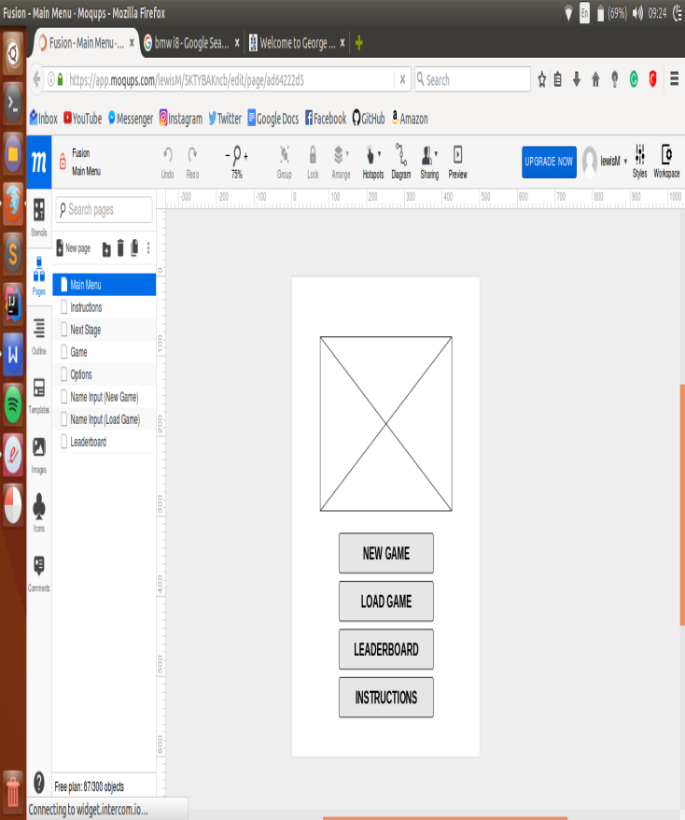Main Menu Screen (Version 1.0)

Button: Switches display to ‘Instructions Screen’

Button: Switches display to ‘Leaderboard Screen’

Title Picture

Button: Switches display to ‘Name Input (New Game) Screen’

Button: Switches display to ‘Name Input Screen (Load Game) Screen’

Game Screen (Version 1.0)

Image: Displays level number the user is currently on

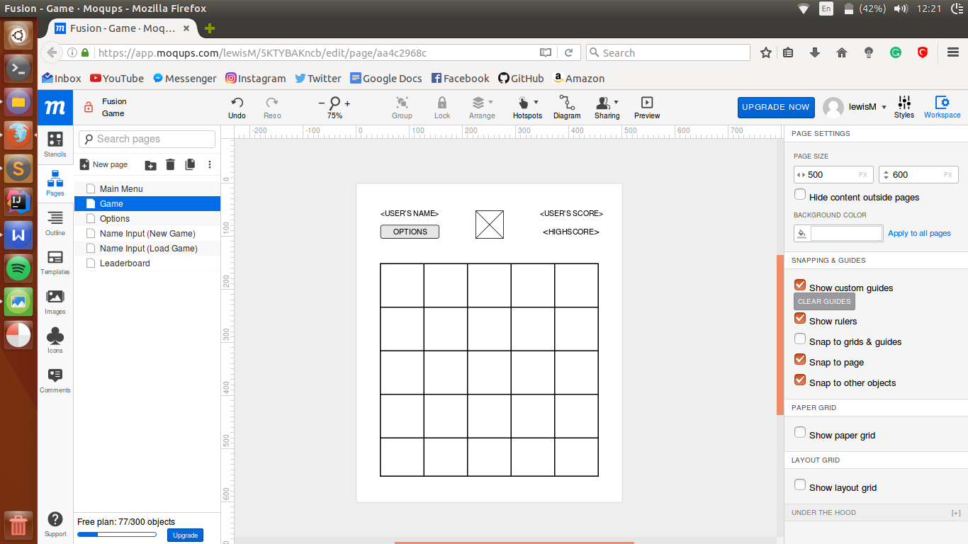

Button: Switches display to ‘Options Screen’

Game Board: 5x5 grid that contains the 1x1 element tiles within it’s cells

Name Input (Load Game) Screen (Version 1.0)

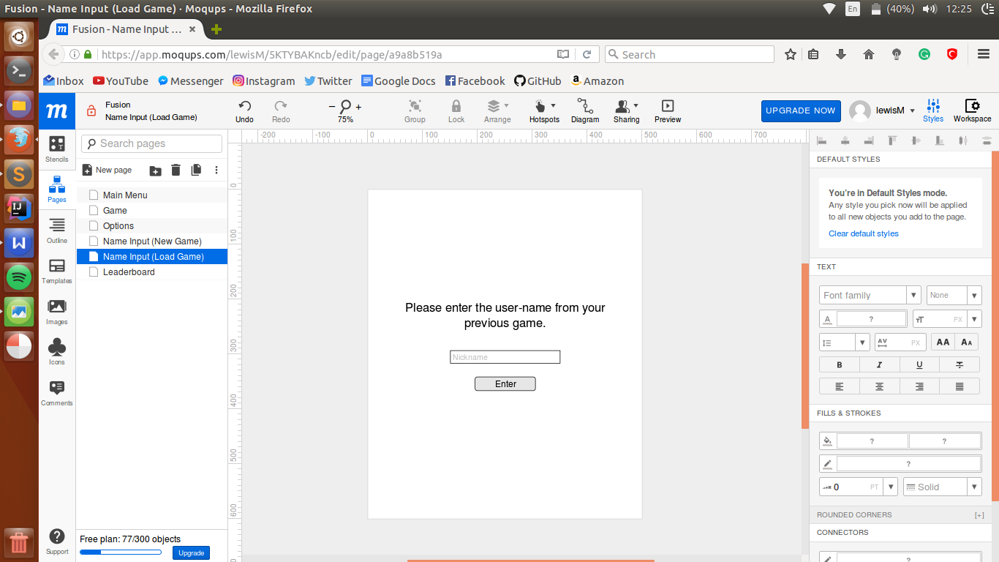

Prompt text

Input Box: Takes user input from the keyboard and displays it when selected

Button: Switches display to the ‘Game Screen’ in the game state that user last saved at

Name Input (New Game) Screen (Version 1.0)

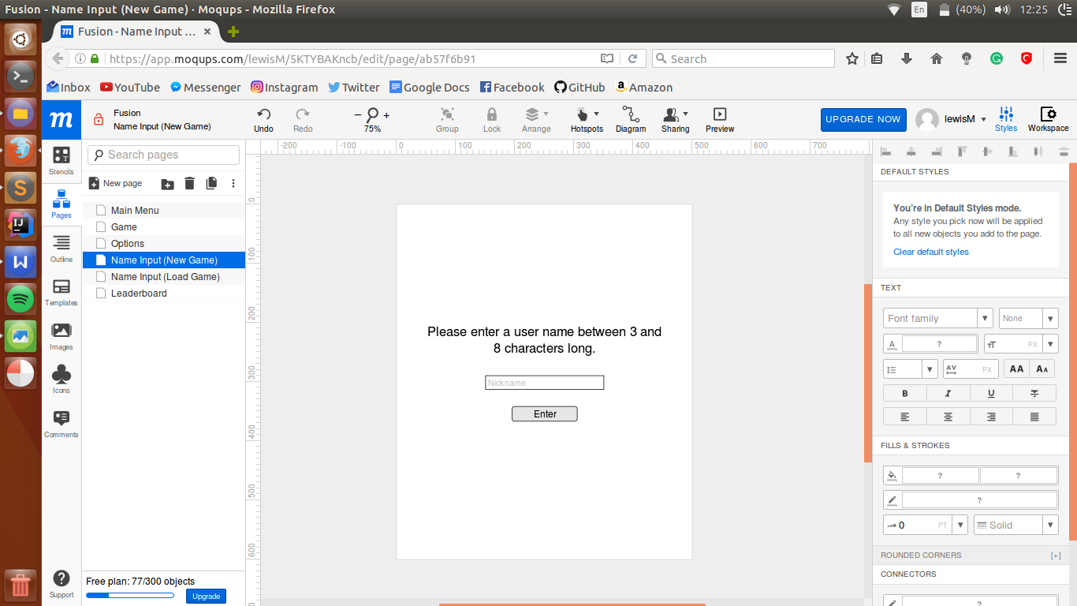

Prompt text

Input Box: Takes user input from the keyboard and displays it when selected

Button: Switches display to the ‘Game Screen’ a freshly initialised game state

Options Screen (Version 1.1)

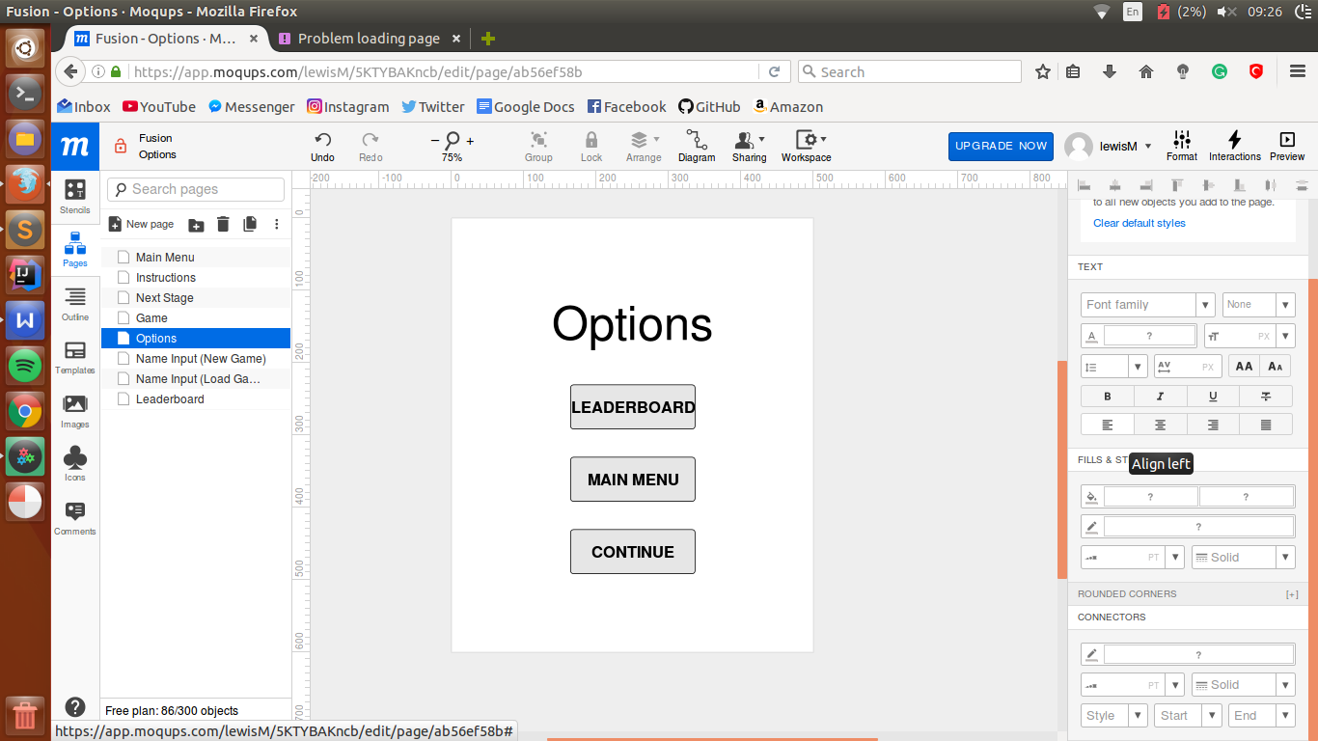

Button: Switches display back to the ‘Game Screen’

Button: Switches display to the ‘Main Menu Screen’

Button: Switches display to ‘Leaderboard Screen’

Leaderboard Screen (Version 1.1)

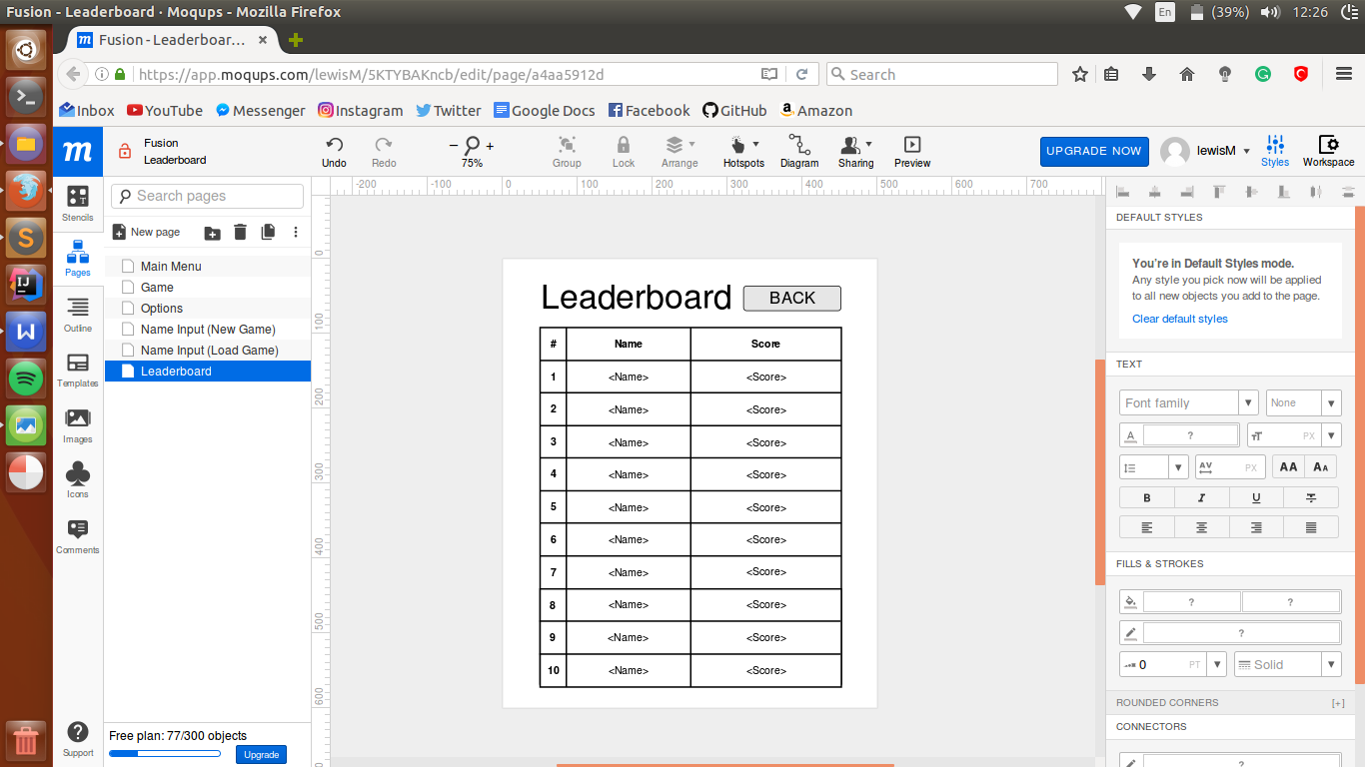

Button: Switches display to the previous screen (either the ‘Main Menu Screen’ or the ‘Options Screen’ depending on where it was accessed from

Title header

Leaderboard Grid

Instructions Screen (Version 1.0)

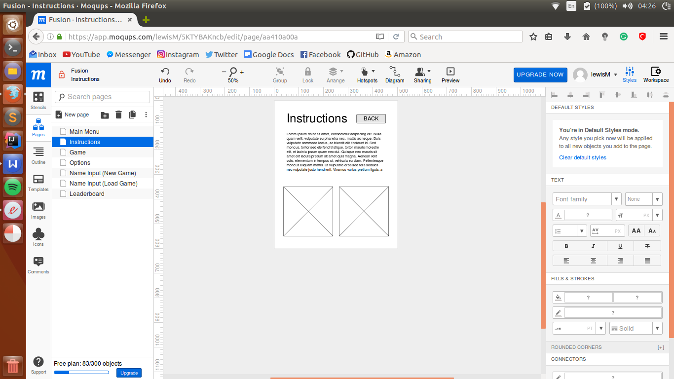

Button: Switches display to the ‘Main Menu Screen’

‘Instructions’ body text

Images: Explaining how the mechanics of the game work (how the tiles collide and combine)

**Program Design**

‘Main’ File

INITIALISE pygame

INITIALISE display (500px x 600px)

INITIALISE colour values

SET gridDictionary TO <a map of locations on the board that each correspond to the centre of a square on the screen>

PROCEDURE drawGameBoard

DRAW square (game board)

DRAW lines (that split the square up into a 5 x 5 grid)

PROCEDURE drawBlocks(GAMEBOARD gameboard)

FOR EACH block in gameboard.blocks DO

<create 'Block' text object>

SET <text centre> TO gridDictionary[block.location]

DRAW textObject TO display

PROCEDURE drawGameScreenHeader(STRING username, INTEGER score, INTEGER Highscore)

<create 'Username' text object>

<create 'Options' button object>

<create 'Level Number' text object>

<create 'Score' text object>

<create 'Highscore' text object>

SET <'Username' text position> TO <top left hand side of screen>

SET <'Options' button position> TO <left hand side of the screen just below username>

SET <'Level number' text position> TO <centre at the top of the screen>

SET <'Score' text position> TO <top right hand side of the screen>

SET <'Highscore' text position> TO <right hand side of the screen just below the score>

FOR EACH object DO

DRAW object TO display

PROCEDURE drawGameScreen(GAMEBOARD gameboard)

drawGameScreenHeader(gameboard.name, 'Score: ' + gameboard.score, <get highscore from the leaderboard table>)

drawGameBoard()

drawBlocks(gameboard)

PROCEDURE drawMainMenuScreen

<load 'Title Picture' image>

<create 'New game' button object>

<create 'Load Game' button object>

<create 'Leaderboard' button object>

<create 'Instructions' button object>

SET <'Title Picture' image position> TO <top of screen>

SET <'New Game' button position> TO <top of screen>

SET <'Load Game' button position> TO <top of screen>

SET <'Leaderboard' button position> TO <top of screen>

SET <'Instructions' button position> TO <top of screen>

FOR EACH object DO

DRAW object TO display

UPDATE display

PROCEDURE gameLoop(GAMEBOARD Gameboard(name)(DEFAULT: Gameboard()))

running = True

WHILE running = True DO

FOR EACH event IN <list of pygame events> DO

IF <user clicks 'x' button on window> THEN

running = False

IF <user clicks key> THEN

IF <that key is the 'down' arrow> THEN

IF gameboard.moveBlocksDown()

gameboard.spawn()

IF <that key is the 'up' arrow> THEN

IF gameboard.moveBlocksUp()

gameboard.spawn()

IF <that key is the 'right' arrow> THEN

IF gameboard.moveBlocksRight()

gameboard.spawn()

IF <that key is the 'left' arrow> THEN

IF gameboard.moveBlocksLeft()

gameboard.spawn()

IF <user clicks 'Options' button> THEN

optionsLoop()

DRAW <white fill> TO display

drawGameScreen(gameboard)

saveGameState(gameboard)

<quit>

PROCEDURE mainMenuLoop()

drawMainMenuScreen()

running = True

WHILE running = True DO

FOR EACH event IN <list of pygame events> DO

IF <user clicks 'x' button on window> THEN

running = False

IF <user clicks 'New Game' button> THEN

nameInputLoop('New Game')

IF <user clicks 'Load Game' button> THEN

nameInputLoop('Load Game')

IF <user clicks 'Leaderboard' button> THEN

leaderboardLoop()

IF <user clicks 'Instructions' button> THEN

instructionsLoop()

<quit>

PROCEDURE nameInputLoop(STRING gameType)

drawInputScreen(gameType)

running = True

WHILE running = True DO

FOR EACH event IN <list of pygame events> DO

IF <user clicks 'x' button on window> THEN

running = False

IF <user clicks on 'Name' input box object> THEN

name = []

<wait for user input>

IF <user presses 'Character Key'> THEN

APPEND character TO name

<create 'Character Key' text object>

SET <'Character Key' position> TO <the right of the last letter>

IF <user presses 'Backspace Key'> THEN

REMOVE <last character> FROM name

<fill the last character white>

IF <user clicks 'Enter' button> THEN

gameLoop(Gameboard(username = name))

<quit>

PROCEDURE drawInputScreen(STRING gameType)

IF gameType = 'New Game' THEN

<create 'New Game Name Input' text object>

SET <'New Game Name Input' text position> TO <centre of the screen>

IF gameType = 'Load Game' THEN

<create 'Load Game Name Input' text object>

<create 'Name' input box object>

<create 'Enter' button object>

SET <'Name' input box position> TO <just below the 'Name Input' text>

SET <'Enter' button position> TO <just below the 'Name' input box>

FOR EACH object DO

DRAW object TO display

UPDATE display

PROCEDURE leaderboardLoop()

drawLeaderboardScreen()

running = True

WHILE running = True DO

FOR EACH event IN <list of pygame events> DO

IF <user clicks 'x' button on window> THEN

running = False

IF <user clicks 'Back' button> THEN

RETURN null

PROCEDURE drawLeaderboardScreen()

<create 'Leaderboard' text object>

<create 'Back' text object>

<create 'Leaderboard' table object>

SET <'Leaderboard' text position> TO <top left of screen>

SET <'Back' button position> TO <top right of screen>

SET <'Leaderboard' table position> TO <below 'Leaderboard Title' text>

<read in names and scores from leaderboard file>

SET verticalShift TO <vertical distance between the centres of the name boxes in the 'Leaderboard' table object>

SET counter TO 0

FOR name IN file DO

<create 'Name' text object>

SET <'Name' text position> TO <firstNamePosition> + (verticalShift * counter)

SET counter TO (counter + 1)

SET counter TO 0

FOR score IN file DO

<create 'Score' text object>

SET <'Score' text position> TO <firstScorePosition> + (verticalShift * counter)

SET counter TO (counter + 1)

FOR EACH object DO

DRAW object TO display

UPDATE display

PROCEDURE instructionsLoop()

drawInstructionsScreen()

running = True

WHILE running = True DO

FOR EACH event IN <list of pygame events> DO

IF <user clicks 'x' button on window> THEN

running = False

IF <user clicks 'Back' button> THEN

RETURN null

PROCEDURE drawInstructionsScreen()

<create 'Instructions Title' text object>

<create 'Back' button text object>

<create 'Instructions Body' text object>

<load 'Instructions' images>

SET <'Instructions Title' text position> TO <top left of screen>

SET <'Back' button position> TO <top right of screen>

SET <'Instructions Body' text position> TO <below 'Instructions Title' text>

SET <'Instructions' images positions> TO <below 'Instructions Body' text>

FOR EACH object DO

DRAW object TO display

UPDATE display

PROCEDURE optionsLoop()

drawOptionsScreen()

running = True

WHILE running = True DO

FOR EACH event IN <list of pygame events> DO

IF <user clicks 'x' button on window> THEN

running = False

IF <user clicks 'Leaderboard' button> THEN

leaderboardLoop()

IF <user clicks 'Main Menu' button> THEN

mainMenuLoop()

IF <user clicks 'Continue' button> THEN

RETURN null

PROCEDURE drawOptionsScreen()

<create 'Options' text object>

<create 'Leaderboard' button object>

<create 'Main Menu' button object>

<create 'Continue' button object>

SET <'Options' text position> TO <just above centre of the screen>

SET <'Leaderboard' button position> TO <just below 'Options' text>

SET <'Main Menu' button position> TO <just below 'Leaderboard' text>

SET <'Continue' button position> TO <just below 'Main Menu' text>

FOR EACH object DO

DRAW object TO DISPLAY

UPDATE display

RETURN

PROCEDURE saveGameState(GAMEBOARD gameboard)

<write gameboard.username, state, level, blocks and score to the new or existing file named: gameboard.name within the 'game saves' folder>

PROCEDURE openGameSave(STRING targetName)

SET gameSaveFileName TO targetName

FOR EACH fileName IN <game saves folder> DO

IF fileName = gameSaveFileName THEN

<open the file>

<read the data (i.e. username, state, level, blocks and score) from the file>

RETURN Gameboard(username, state, level, blocks, score)

mainMenuLoop()

‘Gameboard’ File

//As the language I am implementing in (Python) does not require* explicitely declared variables I will not do so in my pseudocode

//*Except when initialising lists

//Using adaptable lists instead of fixed arrays is the standard in python as they are more flexible, hence why I will use them

//(value, value, value....) denotes a tuple (definition: a sequence of immutable python objects) NOT TO BE CONFUSED WITH

//<...> denotes elision

CLASS Gameboard:

CONSTRUCTOR gameboard(LIST state(DEFAULT: 5 x 5 2D list populated with the string 'empty'), INTEGER level(DEFAULT: 1),

LIST blocks(DEFAULT: Empty list), INTEGER score(DEFAULT: 0), STRING username):

SET this.state TO state

SET this.level TO level

SET this.blocks TO blocks

SET this.score TO score

SET this.username TO username

SET this.levelDictionary TO <map the level numbers to the lowest block in each level>

PROCEDURE spawn(INTEGER level, LIST blocks):

SET element TO <random element between the two lowest elements for the corresponding level>

DECLARE emptyCells AS LIST

FOR row FROM 0 TO 4 DO

FOR col FROM 0 TO 4 DO

IF self.state[row][col] = 'empty' THEN

APPEND (row, col) TO emptyCells

END IF

NEXT col

NEXT row

SET location TO <random tuple out of the emptyCells list>

SET newBlock TO Block(element, location)

APPEND newBlock TO this.blocks

SET this.state[row][col] TO newBlock

PROCEDURE moveBlocksLeft

SET blockHasMoved TO False

FOR EACH block IN this.blocks DO

SET leftShift TO 0

WHILE True DO

SET col TO <1 column further left>

SET cell TO this.state[<original row][col]

IF col >= 0 AND cell = 'empty' THEN

leftShift += 1

blockHasMoved = True

ELSE

IF <cell is a block> THEN

combine(block, cell)

ELSE

BREAK OUT OF WHILE LOOP

SET <current location of block> TO 'empty'

SET <new location of block> TO (<same row>, <original column - leftShift>)

SET this.state[<same row>][original column - leftShift] TO block

RETURN blockHasMoved

PROCEDURE moveBlocksRight

SET blockHasMoved TO False

FOR EACH block IN this.blocks DO

SET rightShift TO 0

WHILE True DO

SET col TO <1 column further right>

SET cell TO this.state[<original row>][col]

IF col <= 4 AND cell = 'empty' THEN

rightShift += 1

blockHasMoved = True

ELSE

IF <cell is a block> THEN

combine(block, cell)

ELSE

BREAK OUT OF WHILE LOOP

SET <current location of block> TO 'empty'

SET <new location of block> TO (<same row>, <original column + rightShift>)

SET this.state[<same row>][<original column + rightShift>] TO block

RETURN blockHasMoved

PROCEDURE moveBlocksUp

SET blockHasMoved TO False

FOR EACH block IN this.blocks DO

SET upShift TO 0

WHILE True DO

SET row TO <1 column further up>

SET cell TO this.state[<original row - upShift>][same column]

IF col >= 0 AND cell = 'empty' THEN

upShift += 1

blockHasMoved = True

ELSE

IF <cell is a block> THEN

combine(block, cell)

ELSE

BREAK OUT OF WHILE LOOP

SET <current location of block> TO 'empty'

SET <new location of block> TO (<original row - upShift>, <same column>)

SET this.state[<original row - upShift>][same column] TO block

RETURN blockHasMoved

PROCEDURE moveBlocksDown

SET blockHasMoved TO False

FOR EACH block IN this.blocks DO

SET downShift TO 0

WHILE True DO

SET row TO <1 column further down>

SET cell TO this.state[original row + downShift][<same column>]

IF col <= 4 AND cell = 'empty' THEN

downShift += 1

blockHasMoved = True

ELSE

IF <cell is a block> THEN

combine(block, cell)

ELSE

BREAK OUT OF WHILE LOOP

SET <current location of block> TO 'empty'

SET <new location of block> TO (<original row + downShift>, <same column>)

SET this.state[<original row + downShift>][same column] TO block

RETURN blockHasMoved

PROCEDURE combine(BLOCK firstBlock, BLOCK secondBlock)

SET this.state[firstBlock.location] TO 'empty'

REMOVE firstBlock from this.blocks

SET this.score TO (secondBlock.element * 2)

SET secondBlock.element TO secondBlock.element + 1

SET secondBlock.element TO newElement

RETURN secondBlock

‘Block’ File

CLASS Block:

CONSTRUCTOR Block(INTEGER element, TUPLE location):

SET this.location TO location

SET this.element TO element

**Implementation**

**Final Testing**

Functional Requirements

|  |  |  |  |
| --- | --- | --- | --- |
| **Action** | **Expected Result** | **Actual Result** | **Comments** |
| **Main Menu Screen** | | | |
| Display switches to ‘Main Menu Screen’ | * Title header displays in the correct position and is the correct size * ‘New Game’ button loads and displays in the correct position and is the correct size * ‘Load Game’ button loads and displays in the correct position and is the correct size * ‘Leaderboard’ button loads and displays in the correct position and is the correct size * ‘Instructions’ button loads and displays in the correct position and is the correct size | * Title header displays in the correct position and is the correct size * ‘New Game’ button loads and displays in the correct position and is the correct size * ‘Load Game’ button loads and displays in the correct position and is the correct size * ‘Leaderboard’ button loads and displays in the correct position and is the correct size * ‘Instructions’ button loads and displays in the correct position and is the correct size | Worked as expected |
| Left clicking the ‘New Game’ button | Switches display to the ‘Name Input (New Game)’ screen | Switches display to the ‘Name Input (New Game)’ screen | Worked as expected |
| Left clicking the ‘Load Game’ button | Switches display to the ‘Name Input (Load Game)’ screen | Switches display to the ‘Name Input (Load Game)’ screen | Worked as expected |
| Left clicking the ‘Leaderboard’ button | Switches display to the ‘Leaderboard’ screen | Switches display to the ‘Leaderboard’ screen | Worked as expected |
| Left clicking the ‘Instructions’ menu | Switches display to the ‘Instructions’ screen | Switches display to the ‘Instructions’ screen | Worked as expected |
| Right clicking the ‘New Game’ button | Switches display to the ‘Name Input (New Game)’ screen | Switches display to the ‘Name Input (New Game)’ screen | Worked as expected |
| Right clicking the ‘Load Game’ button | Switches display to the ‘Name Input (Load Game)’ screen | Switches display to the ‘Name Input (Load Game)’ screen | Worked as expected |
| Right clicking the ‘Leaderboard’ button | Switches display to the ‘Leaderboard’ screen | Switches display to the ‘Leaderboard’ screen | Worked as expected |
| Right clicking the ‘Instructions’ menu | Switches display to the ‘Instructions’ screen | Switches display to the ‘Instructions’ screen | Worked as expected |
| Scrolling the scroll wheel whilst pointer is over the ‘New Game’ button | Switches display to the ‘Name Input (New Game)’ screen | Switches display to the ‘Name Input (New Game)’ screen | Worked as expected |
| Scrolling the scroll wheel whilst pointer is over the ‘Load Game’ button | Switches display to the ‘Name Input (Load Game)’ screen | Switches display to the ‘Name Input (Load Game)’ screen | Worked as expected |
| Scrolling the scroll wheel whilst pointer is over the ‘Leaderboard’ button | Switches display to the ‘Leaderboard’ screen | Switches display to the ‘Leaderboard’ screen | Worked as expected |
| Scrolling the scroll wheel whilst pointer is over the ‘Instructions’ button | Switches display to the ‘Instructions’ screen | Switches display to the ‘Instructions’ screen | Worked as expected |
| **Game Screen** | | | |
| Pressing the right arrow key | Tile(s) move to the left (tiles with empty cell(s) to the left) | Tile(s) move to the left (tiles with empty cell(s) to the left) | Worked as expected |
| Pressing the right arrow key | Tile(s) move to the right (tiles with empty cell(s) to the right) | Tile(s) move to the right (tiles with empty cell(s) to the right) | Worked as expected |
| Pressing the up arrow key | Tile(s) move upwards (tiles with empty cell(s) upwards) | Tile(s) move upwards (tiles with empty cell(s) upwards) | Worked as expected |
| Pressing the down arrow key | Tile(s) move downwards (tiles with empty cell(s) downwards) | Tile(s) move downwards (tiles with empty cell(s) downwards) | Worked as expected |
| Two tiles of the same element collide | * The two elements combine into a single 1x1 tile of the next higher element * Score is incremented and displays in the ‘User’s Score’ text as such (score += element atomic number * 2) | * The two elements combine into a single 1x1 tile of the next higher element * Score is incremented and displays in the ‘User’s Score’ text as such (score += element atomic number * 2) | Worked as expected |
| Display switches to ‘Game Screen’ | * ‘User’s Name’ text loads and displays in the correct position and is the correct size * ‘User’s Score’ text loads and displays in the correct position and is the correct size * ‘Highscore’ text loads and displays in the correct position and is the correct size * ‘Level’ text loads and displays in the correct position and is the correct size * ‘Options’ button loads and displays in the correct position and is the correct size * All text displays the correct information * A 5X5 grid (populated depending on whether or not the game is new or is being loaded) | * ‘User’s Name’ text loads and displays in the correct position and is the correct size * ‘User’s Score’ text loads and displays in the correct position and is the correct size * ‘Highscore’ text loads and displays in the correct position and is the correct size * ‘Level’ text loads and displays in the correct position and is the correct size * ‘Options’ button loads and displays in the correct position and is the correct size * All text displays the correct information * A 5X5 grid (populated depending on whether or not the game is new or is being loaded) | Worked as expected |
| Left clicking the ‘Options’ button | Switches display to the ‘Options’ Screen | Switches display to the ‘Options’ Screen | Worked as expected |
| Right clicking the ‘Options’ button | Switches display to the ‘Options’ Screen | Switches display to the ‘Options’ Screen | Worked as expected |
| Scrolling the scroll wheel whilst pointer is over the ‘Options’ button | Switches display to the ‘Options’ Screen | Switches display to the ‘Options’ Screen | Worked as expected |
| Player’s saved game is loaded | The correct game state displays and is fully playable from that point | The correct game state displays and is fully playable from that point | Worked as expected |
| 11th highest element of current stage is created | ‘Stage Complete’ text is shown, Game board’ is reset and either of the two lowest (previously two highest) elements spawns in a random cell | ‘Stage Complete’ text is shown, Game board’ is reset and either of the two lowest (previously two highest) elements spawns in a random cell | Worked as expected |
| **Options Screen** | | | |
| Display switches to ‘Options Screen’ | * ‘Options’ text loads and displays in the correct position and is the correct size * ‘Save’ button loads and displays in the correct position and is the correct size * ‘Leaderboard’ text loads and displays in the correct position and is the correct size * ‘Main Menu’ text loads and displays in the correct position and is the correct size * ‘Continue’ text loads and displays in the correct position and is the correct size | * ‘Options’ text loads and displays in the correct position and is the correct size * ‘Save’ button loads and displays in the correct position and is the correct size * ‘Leaderboard’ text loads and displays in the correct position and is the correct size * ‘Main Menu’ text loads and displays in the correct position and is the correct size * ‘Continue’ text loads and displays in the correct position and is the correct size | Worked as expected |
| Left clicking the ‘Save’ button | Writes the current game state to an external text file and is linked with the ‘User’s Name’ | Writes the current game state to an external text file and is linked with the ‘User’s Name’ | Worked as expected |
| Right clicking the ‘Save’ button | Writes the current game state to an external text file and is linked with the ‘User’s Name’ | Writes the current game state to an external text file and is linked with the ‘User’s Name’ | Worked as expected |
| Scrolling the scroll wheel whilst pointer is over the ‘Save’ button | Writes the current game state to an external text file and is linked with the ‘User’s Name’ | Writes the current game state to an external text file and is linked with the ‘User’s Name’ | Worked as expected |
| Left/RIght clicking or ‘scrolling’ over the ‘Leaderboard’ button | Switches display to the ‘Leaderboard’ screen | Switches display to the ‘Leaderboard’ screen | Worked as expected  The combination of left/right clicking a button and also ‘scrolling’ whilst over it is becoming very repetitive so from now on I will just refer to them all within one row |
| Left/Right clicking or ‘scrolling’ over the ‘Main Menu’ button | Switches display to the ‘Main Menu’ screen | Switches display to the ‘Main Menu’ screen | Worked as expected |
| Left/Right clicking or ‘scrolling’ over the ‘Continue’ button | Switches display to the ‘Game’ screen and displays the same game state that the player left the game in when they clicked the ‘Options’ button on the ‘Game’ screen | Switches display to the ‘Game’ screen and displays the same game state that the player left the game in when they clicked the ‘Options’ button on the ‘Game’ screen | Worked as expected |
| **Name Input (New Game) Screen** | | | |
| Display switches to ‘Name Input (New Game) Screen ’ | Correct ‘Prompt’ text loads and displays in the correct position and is the correct size | Correct ‘Prompt’ text loads and displays in the correct position and is the correct size | Worked as expected |
| Display switches to ‘Name Input (New Game) Screen’ | ‘Input Box’ loads and displays in the correct position and is the correct size | ‘Input Box’ loads and displays in the correct position and is the correct size | Worked as expected |
| Left/Right clicking or ‘scrolling’ over the inside the input box and typing | Displays typed characters inside input box | Displays typed characters inside input box | Worked as expected |
| Left/Right clicking or ‘scrolling’ over the ‘Enter’ button | Switches display to the ‘Game screen’ | Switches display to the ‘Game screen’ | Worked as expected |
| Left/Right clicking or ‘scrolling’ over the ‘Enter’ button | Submits the username | Submits the username | Worked as expected |
| **Name Input (Load Game) Screen** | | | |
| Display switches to ‘Name Input (Load Game) Screen’ | Correct ‘Prompt’ text loads and displays in the correct position and is the correct size | Correct ‘Prompt’ text loads and displays in the correct position and is the correct size | Worked as expected |
| Display switches to ‘Name Input (New Game) Screen’ | ‘Input Box’ loads and displays in the correct position and is the correct size | ‘Input Box’ loads and displays in the correct position and is the correct size | Worked as expected |
| Left/RIght clicking or ‘scrolling’ inside the input box and typing | Displays typed characters inside input box | Displays typed characters inside input box | Worked as expected |
| Left/RIght clicking or ‘scrolling’ over the ‘Enter’ button | Switches display to the ‘Game screen’ | Switches display to the ‘Game screen’ | Worked as expected |
| Left/Right clicking or ‘scrolling over the ‘Enter’ button | Reads the ‘User’s name’, then successfully searches for them and their corresponding score in an external file | Reads the ‘User’s name’, then successfully searches for them and their corresponding score in an external file | Worked as expected |
| **Leaderboard Screen** | | | |
| Display switches to ‘Leaderboard Screen’ | * ‘Leaderboard’ text loads and displays in the correct position and is the correct size * ‘Back’ button loads and displays in the correct position and is the correct size | * ‘Leaderboard’ text loads and displays in the correct position and is the correct size * ‘Back’ button loads and displays in the correct position and is the correct size | Worked as expected |
| Left/Right clicking or ‘scrolling’ over the ‘Back’ button | Switches display to the ‘Main Menu Screen’ | Switches display to the ‘Main Menu Screen’ | Worked as expected |
| Display switches to ‘Leaderboard Screen’ | * ‘Leaderboard’ table and headers load and display in the correct position and are the correct size * All names and scores display in the correct columns. * All scores display in descending order from the top to the bottom * All names match up with their correct corresponding scores | * ‘Leaderboard’ table and headers load and display in the correct position and are the correct size * All names and scores display in the correct columns. * All scores display in descending order from the top to the bottom * All names match up with their correct corresponding scores | Worked as expected |
| **Instructions Screen** | | | |
| Display switches to ‘Instructions Screen’ | * ‘Back’ button displays in the correct position and is the correct size * ‘Instructions’ text loads and displays in the correct position and is the correct size | * ‘Back’ button displays in the correct position and is the correct size * ‘Instructions’ text loads and displays in the correct position and is the correct size | Worked as expected |
| Left clicking the ‘back’ button | Switches display to the ‘Main Menu Screen’ | Switches display to the ‘Main Menu Screen’ | Worked as expected |

Non-Functional Requirements

|  |  |  |  |  |
| --- | --- | --- | --- | --- |
| **Action** | **Expected Result** | **Actual Result** | **Comments** | |
| **Name Input Screen** | | | | |
| Application has a fast response time after input is received from the user | < 25ms from key press to all updates displaying on the screen (text appearing on the screen) | < 25ms from key press to all updates displaying on the screen (text appearing on the screen) | Worked as expected |
| Writes to the ‘Save Data’ text file quickly | < 10ms from key press to the file being written | < 10ms from key press to the file being written | Worked as expected |
| Save from ‘Save Data’ text file | Reliably stores saved game state data in the correct format without it being corrupted or deleted | Reliably stores saved game state data in the correct format without it being corrupted or deleted | Worked as expected |
| **Game Screen** | | | |
| Application has a fast response time after input is received from the user | < 25ms from key press to all updates displaying on the screen (tiles having moved to their new location on the gameboard) | < 25ms from key press to all updates displaying on the screen (tiles having moved to their new location on the gameboard) | Worked as expected |
| **All Screens** | | | |
| Application is run | Runs without crashing or freezing unexpectedly | Runs without crashing or freezing unexpectedly | Worked as expected |

Input Validation

|  |  |  |  |
| --- | --- | --- | --- |
| **Action** | **Expected Result** | **Actual Result** | **Comments** |
| **Name Input (New Game) Screen** | | | |
| Name input: Normal Data (‘billyjo’) | Switches to game screen with submitted name | Switches to game screen with submitted name | Worked as expected |
| Name input: Extreme Data (‘lew’) | Switches to game screen with submitted name | Switches to game screen with submitted name | Worked as expected |
| Name input: Exceptional Data (‘’) | Displays an appropriate error message | Window closes, program crashes | Didn’t work as expected, the error turned out to be due to a ‘typeError’ being thrown by the render() function, fixed by adding an exception to account for this |

**EVALUATION**

In this evaluation I will review:

* My progress through the development process
* The solution
* My performance throughout

I have used the reflective commentary that I have made throughout my project since day one extensively and use it to sum up both what I was thinking at that time and my opinion on matters now that the project is near completion.

**Development Process**

Project Proposal

This aspect was very solid from the start and only needed refined once when I made a design change regarding the range of characters valid for the username. I feel this is because I already knew how the game would work due to my experience of the game ‘2048’ from which I took heavy inspiration from.

Feasibility Study

This aspect was fairly solid and only required a slight bit of refinement to both make it more precise and to flesh it out, however the main points stand the same up to this point.

User Surveys/Analysis Of Findings

There was relatively little hassle in acquiring a suitable number of user survey. Although the age range was not very big as the surveyees I used were from my own class and a slightly younger class that were next door I feel that I got a varied and balanced selection of opinions. The original analysis and conclusions that I drew from these surveys were solid enough that I did not need to refine this aspect at all. I followed the conclusions I made and believe I achieved the aims that I set out for myself by:

* Keeping the interface simplistic and the options hidden, accessible through a icon/button.
* Keeping tiles of similar values relatively contrasting.
* Adding an instructions screen that are easily accessible (through either the main menu or options menu) but unobtrusive to the game.
* Creating a game that I believe will keep an average player engaged for 10-20 minutes per session.
* Implementing a fully functioning and well presented within the game.

Further discussion, including evidence of whether or not I achieved these self-made aims can be found in the end user testing section of this evaluation.

Outline/Detailed Plan

I didn’t stick to this outline as closely as I would have hoped but I decided to not change the target dates about if I slipped off of schedule as it kept me more motivated knowing that I was behind what I had originally planned. More discussion on how I felt my time management went throughout the project as a whole can be found in the ‘performance’ section of this evaluation. The resources aspect of this section was added to throughout development also, as I worked with more packages and tools so this was another reason for the number of refinements.

Test Plan

The test plan was completed in steps throughout the development process, as I thought of more things that needed to be tested, they were added. There were 4 iterations of the test plan before it was finally used in final testing and I believe I covered all aspects of the game that needed to be covered, both functional and non-functional. For the non functional testing I used the ‘dateTime’ module to help me time how long different operations took. Screenshots of the function I used to get these results and it in action are in the appendix, numbered 5.0 and 5.1 respectively.

Interface Design

The first wireframing tool that I tried using for this aspect worked well and so I stuck to it. Only a couple screens were refined as I had a pretty good idea of what I wanted them to look like already as I had made rough sketches of these designs beforehand. This approach definitely saved time and I’m glad I did it this way

Program Design

My initial iteration of pseudocode took a while to create but once I had finished it I felt fairly confident that it would work when I translated it into actual code and ran it. It worked somewhat but the movement mechanics were not completely right. The problem was very hard for me to visualise by just editing the pseudocode therefore I made the decision to try and fix the problem within the actual editor and by utilising my ability to ‘live test’ my solution it was much easier o visualise what was going wrong. Using this approach I managed to fix the problem, before and after screenshots of which can be found in the appendix, numbered 2.0 and 2.1. A closeup of the actual fix is numbered 2.2 Another point that I think is worth mentioning regarding my pseudocode is the amount of elision that has been used. This may look lazy from the onset but I did it primarily as the code that would have replaced that elision was very python/pygame specific and would not have been appropriate for pseudocode. Therefore I left these parts of the code with elision detailing what that part of the code would do. The navigation test that I made to test out my navigation concept was definitely a good move as it would have been a pain to full implement, only to find out it did not work.

Implementation

This aspect of the development process definitely took the longest, but I don’t feel this was because there was a lack of planning or design. The pygame syntax was new to me therefore I had to research and look up how to do certain things whilst the pure python parts of the code I did majorly without looking at any resources. Looking back at the progression of the game I can definitely say it has come a long way. From being presented as a ‘print’ statement in the console that was called via a ‘__str__’ method, to being displayed in full colour within the pygame window, with all elements fully functioning, I am really proud of how far it has come. This progression is demonstrated by the 4 screenshots located in the appendix numbered 1.0 through to 1.3.

**Solution**

Closeness to requirements spec

**Scope**

I successfully implemented:

* All the screens that I was I was planning to implement, these were the:
* Main Menu Screen
* Name Input Screen (for a new game)
* Name Input Screen (for loading a game)
* Game Screen
* Leaderboard Screen
* Options Screen
* Instructions Screen

The name input screens ended up merging and only required one ‘loop’ for both of them. They have slightly differing ‘draw’ functions achieved using a flag variable that told the function whether or not it was a new game. This then determined what prompt text to show, and what text to display within the ‘enter’ button.

* A square 5x5 game board that matches my interface design.
* Coloured tiles that can be moved across this game board with the arrow keys and combined to create tiles of a higher value.
* 11 stages/levels that each require the 11th block created to be completed.
* An options menu with the option to go back to the main menu, see the leaderboard or to continue the game. Originally the options menu was going to have a ‘save game’ button but since the game became ‘autosaving’ this was replaced with the option to see the leaderboard without having to return to the main menu. I feel this was a more useful feature anyway, and removing the need to manually save was definitely a good thing in my opinion.
* A feature that allows users to return to their unfinished games by entering the name they chose when they first started the game, accessible from the main menu.
* A leaderboard that sorts itself when a new score is entering, leaving the leaderboard in descending order from top to bottom.
* An instructions screen, accessible from both the main menu and options screen that explains the basic mechanics of the game.

**Boundaries**

I stuck to my boundaries consistently and did not implement:

* Any form of animation involving the movement of the blocks or screen transitions, the only feature of the game I would regard an ‘animation’ in any sense would be the input box’s border turning red when it is clicked on. However this did not take much time at all to implement and did not slow down my progress in any noticeable way
* The option to change the size of the game board, which I’m glad I kept to as it definitely would have taken a good while to implement
* Any sounds, again I am glad I did not take the time to add these as it would have involved further research into pygame and in my opinion would not have added much to the game
* The option to change name once it is initially chosen. This wouldn’t have been to hard to implement in terms of storing the information but would have required extra interface elements that would have seriously cut time implementing.

**End Users**

I stuck to the same paragraph describing my target audience. Felt my description was very solid and still accurate now that the program is complete.

**User Requirements**

The user requirements remained unchanged throughout the development process. My initial thoughts on what would be needed to both run and use the program were correct and did not need refined.

**Functional Requirements**

These requirements are not extremely precise however I left that to the functional requirements section of my test plan and final testing. I did not feel this list needed to be as detailed as the test plan itself and could remain as the original bracket statements that I used to describe what operations the program would need to perform. The list of these that I thought of when first writing them turned out to cover all of them so I just left it as it was.

**Non Functional Requirements**

These requirements also remained unchanged since the first version of the requirements specification. The non-functional requirements that I first proposed the program meet were all the ones I feel that it needed, although in the test plan and final testing itself I split these statements into slightly more precise requirements. (For example giving actual run times for certain operations to meet)

Final testing

Every button click and screen transition worked perfectly by the time they were formally tested, to no surprise however as I have been ‘live testing’ these actions for a while now just in the development of the last few features and therefore knew that most, if not all of these actions were working already. The only thing that didn’t work as expected was when I tested submitting an empty string as a username. When this data was given the game crashed. The fix was relatively simple, all I needed to do was add an exception for if it gets given this type of string, and if it does then to just submit a ‘None’ type object instead of a null value. Screenshots of the before and after of this fix can be found in the appendix, screenshots 4.0 and 4.1 respectively.

End user testing

My end user testing went successfully and I managed to collect 9 user questionnaires. The age range was not very large and if I was to conduct this testing again with more time then I would have tried to collect feedback a more varied audience. On the contrary to this, the age range was definitely within my target audience, so this was a positive and means the feedback is relevant. I sat down the surveyees with my laptop, let them play the game for about 5 minutes, asked them to comment out loud as they went. I noted these comments down using pen and paper (which can be found in the ‘rough workings’ section of the appendix), and then got the participant to fill out a questionnaire at the end. I have summarised the main constructive feedback from both the comments and the questionnaire into these statements:

* The instructions on the instructions screen were too blurry and small, they were not very readable at all, especially for people who may have bad vision
* The game was still enjoyable and playable without animations, but they definitely would have been a nice addition and would probably have made the game considerably more engaging
* There would be no negatives to allowing capital letters, and it would leave less players confused as to why they cannot use them
* The red highlight on the input box was a nice detail however more of this sensory highlighting (for example, buttons changing colour when you hover over them) would be a nice addition to the game
* Some of the colours were quite dull, they could be made more exciting my brightening the palette.

Further developments

If I had more time to work on this project then I would look to implement:

* Animations that illustrated the tiles:
* Sliding across the game board
* Colliding and combining
* A clearer instructions screen, with larger, sharper text, split between 2 pages if need be
* A change to the input validation that meant that capital letters were valid
* Sensory indicators such as buttons changing colours when you hovered over them
* A brighter colour palette for the blocks

If I had considerable more time to work on this game then I might also look to implement bigger changes such as a resizable grid, a more colourful interface design and possibly even an online leaderboard.

**Performance**

Time Management

Although in the end I did manage to complete everything within good enough time, I did end up finishing this evaluation within the extension time given to the whole class. I feel like although I may have procrastinated at points throughout the development process I did manage to keep up a decent overall pace and it was the sheer magnitude of the project that overwhelmed me at times.

Implementation

Looking back at the code that makes up my solution I can definitely say that I’m very proud of what I have made, and that I am surprised that I actually managed to make it work as well as it does. It’s the first time I’ve really had to put all my coding knowledge/skill to use to achieve one big solution and although I had to research how to implement bits and pieces along the way I was happy that a lot of the time I could just sit inside the editor and code away without having to refer to any other resources.

**Conclusion**

All in all I feel that this project went very well. I stuck very well to my initial scope and boundaries, my initial idea on who this program would be aimed at remained true throughout and all the requirements, both functional and non functional were met. I moved through the planning phase relatively on schedule, and when I got to the implementation there were no major roadblocks that prevented me from moving on.

**Ongoing Refinement**

Project Plan

**13/10/16**

Initially completed all aspects of project plan

**30/10/16**

Added to ‘resources’ list (version 1.1)

**17/11/16**

Changed username character range of 1 to 3 characters to a range from 3 to 8 characters in *project proposal (Version 1.1)*

**27/02/16**

Deadline changed from 24th to 14th of March, edited this in *outline plan (version 1.1)* and *detailed plan (version 1.1)*

Requirements Specification

**16/10/16**

Initially completed (V1.0)

**17/11/16**

Added screen size, resolution and bit depth to minimum requirements in the technical section of the feasibility study, added to the schedule feasibility, and amended screens in the scope to include the ‘instructions’ screen (V1.1)

Test Plan

**25/10/16**

Initially completed (V1.0)

**07/11/16**

Amended/added to the non functional requirements of my test plan (V1.1)

**09/11/16**

Amended/added to functional requirements of my test plan (V1.2)

**07/02/17**

Made final revision (version 1.3) of the test plan before final testing is carried out using it, took out the duplicate name input screen in non functional and input validation tables as it makes no difference what the value of the ‘gameOver’ flag is for these tests

Interface Design

**16/11/16**

Initially completed

**18/11/16**

Added ‘Instructions’ screen

**18/11/16**

Amended ‘Main Menu Screen’ to include ‘Instructions’ button

**13/01/17**

Updated design for the ‘Option’ screen (removed ‘Save’ button)

Implementation

**05/02/17**

Initially completed

**11/02/17**

Refactored instances of the word ‘block’ to ‘tiles’ to match documentation

**Record of Progress**

|  |  |  |  |
| --- | --- | --- | --- |
| **Date** | **Action** | **Dur.** | **Reflective Commentary** |
| **25/08/16** | Project was announced, teacher went through the candidate instructions with us | 0h40 | Started thinking about what I might want to build, came to the conclusion that a 2D game would easily fulfill the project requirements and would also be something I am interested in creating. |
| **29/08/16** | Thinking about different 2D games that I could make | 0h30 | Have thought about a few games that I could attempt to make, all of them being clones. I feel like a clone would be a good route to go down as I will probably already be very familiar with the mechanics of it and how it will work/how it should feel. A few ideas going through my head, all being classics, are Snake, Pong and Minesweeper. Have also maybe thought of doing a clone of the more modern game ‘2048’. Will continue to think. |
| **06/09/16** | Started project proposal | 0h30 | Decided on creating a game inspired by the app ‘2048’, happy that it is feasible within the time frame I have and that it will fulfill all the necessary requirements. |
| **07/09/16** | Created outline project plan | 1h00 | Happy with the timings I have given each aspect of the project. Although I may go in an out of these timings I do feel it’ll help me be completely ready come submission time. |
| **14/09/16** | Completed project proposal | 0h30 | Whilst keeping to the basic premise of the the original ‘2048’, I decided to extend the progression of the game by adding multiple levels. If I’m being pushed for time later on I may have to cut this idea though. |
| **21/09/16** | Completed feasibility study | 1h00 | I feel all aspects of my project seem completely feasible however I know it’s unlikely by the time submission comes around for there not to have been anything that has gone wrong at all. |
| **22/09/16** | Created user survey and distributed it to my fellow students in class | 0h30 | Tried hard to think of questions that would help me make decisions, mainly involving the design and feel of the game. I feel the user interface of a simple game is extremely important. |
| **28/09/16** | Completed analysis of findings | 0h40 | Felt that the first three questions helped me decide key aspects of the interface and design however the last two were too ambiguous and vague to give me very helpful responses. Especially question 4 in which I did not specify that I meant time ‘per session’. |
| **06/10/16** | Teacher issued updated project specification and I combined my project files into one document | 1h00 | Decided it was more efficient and uniform to hold all documents in my project in one file. Feels nicer having everything all in one place |
| **13/10/16** | Created detailed project plan in the form of a Gantt chart | 1h30 | The visual representation of my schedule has shown me I need to get the requirements spec and test plan done quickly so I can get onto actually building my game. Aware that it could take a while to get everything working nicely. |
| **15/10/16** | Started requirements specification | 0h40 | I feel as though there will probably be a few changes to my scopes and boundaries down the line, some scope will probably become a boundary and although unlikely if I have enough time after implementing all the scope I need I may potentially try and add some boundaries for fun, sound for example sounds interesting, although unnecessary. |
| **16/10/16** | Completed requirements specification | 0h20 | Realised that a downside to writing my solution in python may be ease of access on getting it onto other machines, will need to look into this as thinking a good approach for testing would be to give my game to a lower year to try. So will possibly need to look at ways of converting .py files. into windows .exe. I’m sure there’s a way somehow. |
| **25/10/16** | Created preliminary test plan | 0h60 | Will need to revisit this at a later date when I think of more things that my game should be able to do. |
| **30/10/16** | Added to resources in the project plan | 0h20 | Added youtube and stack overflow to resources list as well as specifics of the software that I will be using |
| **02/11/16** | Started sketching my interface design | 0h20 | Already had a pretty good picture of what most of my interface would look like but it was good to finally get it on paper and think about the spacing of elements on the screen. |
| **05/11/16** | Completed sketch of my interface design | 0h20 | Happy with the design and flow of my interface, feel it keeps with my findings from my user surveys. Kept the design as clean and simplistic as I could, leaving the options behind the game screen is one example of this. |
| **07/11/16** | Amended and added to my test table (functional requirements) | 0h60 | Now that I have a better idea of what elements I will need to test in my user interface I could add those elements to my test table. Having started my interface design later than expected and still not having finished it I am now about a week behind schedule, this will eat into the time I have for actual implementation of my solution but I feel I made my outline and detailed plan with enough contingency time that this should not be a critical problem. |
| **09/11/16** | Amended and added to my test table (non functional requirements) | 0h30 | Will need to come up with a way of testing response time between key presses and the screen actually being updated. Already know that python has a clock module so I’m sure this will be possible to achieve after some research is done. |
| **12/11/16** | Started wireframing my interface design | 0h45 | Took me a while to find a suitable wireframing tool that I liked but finally decided to use ‘moqups.com’. Decided to rename the ‘Hi-Scores’ title on my leaderboard screen to ‘Leaderboard’. Also decided to change the ‘element’ tile that was going to appear in the header between the user’s name and score to a ‘level’ counter label that displays the level the user is currently on. Felt this information would be more useful to the user, especially if they leave their game for a while and then come back to it. The highest element will always be visible on the board anyway. |
| **14/11/16** | Completed wireframing my interface design | 0h30 | Added interactivity to my wireframe and realised that my navigation was not complete. The options menu screen did not have any way off of it. Decided to add a back button so that it was possible to return to the previous screen. This really showed me the importance of planning before actual implementation as if I have probably saved myself a good bit of time finding this now rather than further down the line when I am actually writing the code. |
| **16/11/16** | Annotated interface design wireframes | 0h40 | Turns out I needed the premium version of ‘moqups.com’ to have access to download the PNG image format of my wireframes so I just had to screenshot from the browser and crop the form out as best I could. |
| **17/11/16** | Small amendments to my project proposal, feasibility study and scope | 0h30 | Had previously decided that the username could only be 3 letters long, when creating my name input screen wireframes I decided there was actually no need for this cap therefore I will now accept a range between 3 and 8 characters. Added screen size, resolution and bit depth to my list of minimum requirements as I feel they are necessary to mention, if I think of any other minimum requirements in the future I will come back and amend this again. Also added to the schedule feasibility as I felt it was a bit too short. Amended the scope so that it now includes all game screens, in doing this however I have realised that I have not considered one of the screens I will need: the instructions screen (which also affects the main menu screen as an extra button will need to be added). Will work on this tomorrow. |
| **18/11/16** | Created and annotated wireframes for the ‘Instructions Screen’ | 0h30 | Feel like I have done sufficient UI design now to move onto my program design. I am just over 2 weeks behind schedule at this point but I feel this is manageable given my optimistic deadlines. |
| **25/11/16** | Sketched out class diagrams for the block and gameboard classes | 0h30 | Think I have a good idea now of what methods and attributes and classes both of my classes will need. It’s turned out that the block class will basically just be a node, containing only two bits of information, the element and the location of the block whereas the gameboard object will contain all of the mechanics that will then act on these block objects. |
| **30/11/16** | Started pseudocoding:   * Block constructor * Gameboard constructor | 0h20 | Just copied out what I had wrote in my class diagrams, didn’t think of any other methods or attributes that I will need. |
| **04/12/16** | Continued pseudocoding:   * Spawn method | 0h40 | Relatively simple method, made sure to comment as I went so that it doesn’t all pile up and leave me having to do it at the end. |
| **09/12/16** | Continued pseudocoding:   * MoveBlocksLeft method | 0h30 | This method has been harder to think about, leaving it for now and will come back with a fresh mind another day. Have the general idea in my head, need to iterate through the blocks and look through the empty cells until I find an edge or a block and then take appropriate action. Am sure when I come back to it I’ll be able to think of a solution. |
| **11/12/16** | Continued pseudocoding:   * MoveBlocksLeft method * MoveBlocksRight method * MoveBlocksUp method * MoveBlocksDown method * Combine method * DrawGameBoard method * DrawBlocks method | 1h10 | Confident I have worked out a way to do the movement mechanic now, copy and pasted the left movement method and made the few changes needed for each direction. Thought about how I will combine blocks, confident my method will work. Also started to think about how I will draw each screen to the display and pseudocoded the methods for drawing both the gameboard and the blocks within it. For the moment the colours of the blocks are just some random colours that I could think of rgb values for, will make these values more appealing down the line, not necessary whilst this deep in development. |
| **14/12/16** | Continued pseudocoding:   * DrawGameBoard method * DrawGameScreenHeader method * DrawMainMenuScreen method * DrawInputScreen method * DrawLeaderboardScreen method * DrawInstructionsScreen method * DrawOptionsScreen method | 2h00 | Wrote out all the drawing methods, relatively easy to think about, just referred to my user interface when deciding which elements I will need in each screen. These functions basically just set a list of the elements for their respective screen and return the properties of these elements so that they can be used by the ‘loop’ methods for event triggers such as mouse clicks. The ‘instructions’ screen is a bit too basic at the moment, will come back later and make a more comprehensive guide. |
| **18/12/16** | Continued pseudocoding:   * gameLoop method * nameInputLoop method * leaderboardLoop method * instructionsLoop method * optionsLoop | 1h00 | Thought of a way to switch between game screens that involves infinite loops withing infinite loops. Unsure this method will actually work when written out in code as I feel like python may have problem with so much function calls within function calls. |
| **20/12/16** | Wrote a short script to test out navigation method | 0h45 | Very simple script that just demonstrates that this method works. In this case just using string inputs through the console but eventually the navigation will obviously be triggered by events such as button clicks. Huge relief that this method works as it means I can move on knowing that that this aspect of the game will work!  This code can be found in the appendix. And a screenshot of it working can also be found in the appendix, screenshot number |
| **23/12/16** | Continued pseudocoding:   * saveGameState method * openGameSave method | 0h20 | Decided I will end up using some sort of binary file to store my game save objects. Will research and find a way to do this when I get to it as I have not done this in python before. |
| **25/12/16** | Wrote the block class:   * __init__() * __str__() | 0h20 | Felt good actually finally getting the implementation stage of the project, I decided to use the text editor ‘Sublime Text’ as I have used it in the past and it offers a great number of user created addons that can be really helpful. |
| **27/12/16** | Started writing the gameboard class:   * __init__() * __str__() * spawn() | 0h40 | Wrote a ‘special’ __str__ method that prints out the state to the console so that I can see how I am affecting it. So that I don’t have to run the program from a terminal every time I want to test it I installed a sublime text ad don called ‘REPL’ that opens a new tab and shows what would be printed to the console whenever you build the .py file. This will really help move the project along faster as I can quickly test what affect changes to my code have now, definitely glad I picked sublime text as It’s very fast and fluid to write in. |
| **30/11/16** | Continued writing gameboard class, attempted to add the movement mechanic :   * blocksLeft() | 1h20 | I have begun attempting to write the movement mechanic, today I have focused on just writing out what I had thought up in my pseudocode. Just stuck to testing one direction of movement until it works so that when it works I can just copy/paste and make the few changes that I will need to make each respective direction work as intended. At the moment I am running into a problem involving multiple layers not moving properly. |
| **02/01/17** | Continued writing gameboard class, managed to get the movement mechanic working:   * blocksLeft() * blocksRight() * blocksUp() * blocksDown() * leftSort() * rightSort() * upSort() * downSort() | 3h00 | Finally got the movement mechanic properly working, the tiles were being incorrectly blocked by each other due to them not being moved in the right order, this was fixed by defining 4 separate sort functions (one for each direction) so that the tiles were moved from the side that they were being moved to first. This fixed the problem.  There was another issue with this mechanic, this one being a bit more strange. When tiles were being combined, they were leaving ‘shadows’ to the side of the newly formed tile. I realised that this was because because I was not updating the game state correctly. The fix to this was to introduce a flag variable that flagged the fact that a combination had occurred. This fixed the problems. A before and after screenshot of one of the movement functions can be found in the appendix, screenshots numbered 2.0 and 2.1. And a closer look at the actual ‘combinedBlock’ logic that fixed the bug can be seen on screenshot 2.2.  Also had an issue where the block loop would skip over the block in the list after a block that had been combined. Resolved this by changing the looping structure. |
| **03/01/17** | Continued writing gameboard class:   * combine() | 0h30 | An issue arised where when blocks were combined, a ‘shadow’ of the moving block would be left on the gameboard. First tried to resolve this by giving each block an ID but ended up just needing a boolean variable to flag if blocks have been combined or not so a ‘shadow’ isn’t added to the game state if blocks have been combined. |
| **05/01/17** | Added ‘draw’ methods for the game and main menu screen to my ‘main’ file | 1h00 | Slightly disappointed that pygame doesn’t quite have inbuilt functions to create buttons, labels and input boxes. Looked up how to create these and then made my own functions to do these tasks so to prevent a lot of repetition. |
| **07/01/17** | Added the ‘loop’ methods for the game and main menu screen to my ‘main’ file | 1h30 | Turns out my method of switching screens works as intended, extremely happy about this as it means I will not have to go back to the drawing board in regards to this mechanic. |
| **10/01/17** | Added the save and load functions to my ‘main’ file | 0h45 | Researched how to do binary file handling in python and discovered pickle, this makes the process of saving a game state under a name and then opening it back up quite easy. Implemented the save function so that it runs every time the player makes a move, an ‘autosave’ feature. Therefore the ‘save’ button in my current design for the ‘options’ screen is now redundant, will refine my interface design next session. |
| **13/01/17** | Refined my interface design for the options screen | 0h30 | Removed the ‘save’ button from my ‘options’ screen design as I now have an ‘autosave’ feature as explained above. Replace the ‘save’ button with a ‘leaderboard’ button, which will allow players to check the leaderboard mid game without having to return to the main menu. |
| **15/01/17** | Added the ‘draw’ method for the ‘name input’ screen, consequently added the ‘drawLabel’ and ‘drawButton’ functions | 0h45 | The process of creating labels (text on the screen) and buttons was a relatively long process so I decided to generalise each process and create a ‘drawLabel’ and ‘drawButton’ function to avoid major code duplication throughout the project. |
| **16/01/17** | Added the ‘loop’ method for the ‘name input’ screen and the ‘drawInputBox’ procedure | 1h30 | Used the same loop for both the ‘new game’ and ‘load game’ screens as the only thing different between the two is the text that appears, this can easily checked upon entering the loop. The code for the input box took a while to get working but now it fully functions, only thing I might want to come back and add is some kind of indicator that you have clicked inside the input box. As at the moment it isn’t very clear and might leave some users confused. Could maybe work on filling the box grey when the user clicks on it so it is clear that they are then free to type. This isn’t essential however so I will leave it for now. |
| **18/01/17** | Added the ‘draw’ method for the leaderboard screen | 0h45 | Was going to take me a while to manually put in the coordinates for every line on the table so instead I crated a for loop that incremented the y coordinate and draws all the lines I need. Decided to show just the top 10 scores. |
| **20/01/17** | Added the ‘loop’ method for the leaderboard screen | 1h30 | Back button initially didn’t work as expected, was sending user back to the game screen they had just left. Rectified this by adding a flag that tells the loop if the user is coming from the game screen. If they are then it doesn’t just ‘return’ the function, it calls the ‘mainMenu’ loop instead. |
| **21/01/17** | Removed the white gaps between blocks | 0h45 | This was just an aesthetic fix, however I do think it was worthwhile as it makes the game more appealing to look at, therefore making it more engaging. You can see the white lines I am referring to in screenshot 1.2 in the appendix. The fix involved creating a new dictionary that matches each cell to a tuple value containing the width and height required for a tile occupying that cell, this differs between different cells due to the thickness of the grid lines that each cell touches. The fixed blocks can be seen in screenshot 1.3. The before and after of the fix itself can be seen in screenshots 3.0 and 3.1 respectively. |
| **27/01/17** | Added levels to the game | 1h00 | To test this mechanic out, I changed the code so that it would move onto the next level when you reach block 4. This is just temporary whilst I fully test the feature out. There’s a slight issue where if the user continues pressing keys whilst the ‘level complete’ text comes up then the moves are stored in the event queue and quickly execute after the new board appears. This might confuse some users however I have tried to resolve this by clearing the event queue. But to no avail, so might just have to let this remain. |
| **29/01/17** | Created colours.py | 1h00 | Took the colours from the atomas wikia, have commented the link in on this file, really like the colours used in this game and the colour codes are freely available so I see this as the best solution to the problem of finding a good colour scheme for the blocks. |
| **05/02/17** | * Separated drawing functions into a new file: ‘drawing.py’ * Separated game loop and related functions into a new file: ‘loops.py’ * Separated basic setup variables and other constant variables and structures into a new file: ‘setup.py’ | 1h30 | Took a while to get everything working. With the files now separated, lots of functions have to be imported between the files. It now works though, and as a result, my solution looks and feels a lot cleaner which I am pleased about even it doesn’t actually help the program functionally |
| **07/02/17** | Edited test plan | 1h00 | Created the final version of the test plan (1.3), ready to start actually formally testing the game now, feel like I’m getting closer and closer to the finish line, still got ways to go though |
| **09/02/17** | Carried out final testing | 2h00 | Majority of testing went without a single unexpected result until I found that entering a null string into the name input box triggered a typeError. Easy fix, screenshot is numbered 4.0. |
| **11/02/17** | Refactored ‘block’ to ‘tile’ | 0h30 | Felt it was bad having this inconsistency between the code and the documentation. Especially as it involved one of the key components of the game. |
| **15/02/17** | Collected final end-user testing from class mates and friends | 1h30 | Both wrote down comments that the testers mentioned while testing and collected answers from the questionnaire I made in my test plan. Happy with the varying feedback I got, plenty to talk about in the evaluation. |
| **21/02/17** | Started evaluation, completed the ‘development process’ section | 1h00 | Referred to requirement spec extensively for this part, basically just listed all my scopes and boundaries saying what I had(not) achieved. |
| **24/02/17** | Continued evaluation, completed the ‘solution’ section | 1h20 | Compared my end result to my requirements spec. Fortunately, nearly all of it matches meaning that I have done a good job sticking to the original plan, very pleased about this |
| **27/02/17** | Deadline changed | 0h20 | Edited project plan to show this (1.1) Really thankful for this extension as I believe it will give me just enough time to fully complete this thing. |
| **01/03/17** | Continued evaluation, completed the ‘performance’ section | 1h00 | Decided to focus this part of the evaluation on my time management and my implementation. Feel that I gave myself a fair review. Is good to reflect on myself and how I have done |
| **05/03/17** | Started compiling appendix, added old versions | 1h00 | Put all my old versions into this document, bit fiddly with formatting and such but got there in the end. |
| **09/03/17** | Added all screenshots into appendix | 1h00 | Took a while but compiled all the screenshots I had taken for final testing (and others that I had taken during development that may be referred to in other areas) into an appendix. |
| **10/03/17** | Cross referenced screenshots in final testing | 0h40 | Added references in this record of progress to some screenshots of various bug fixes. Feel this will give a better understanding of the bugs. |
| **13/03/17** | Final formatting | 0h50 | Feels good to package everything up and make it all look nice, can see all the hard work that I’ve put into this over the months. |
| **14/03/17** | Printed everything, sorted it into ring binder, converted .py ‘main’ file to .exe so it can run on windows | 2h00 | Final comment: I’m not going to lie, it’s a massive relief to get this of my back, it’s been a good experience and has definitely taught me a lot however it did get stressful at times and it was beginning to become a bit of a burden. Anyway, all over now, happy with my final product. |

**Appendix**

**User Surveys**

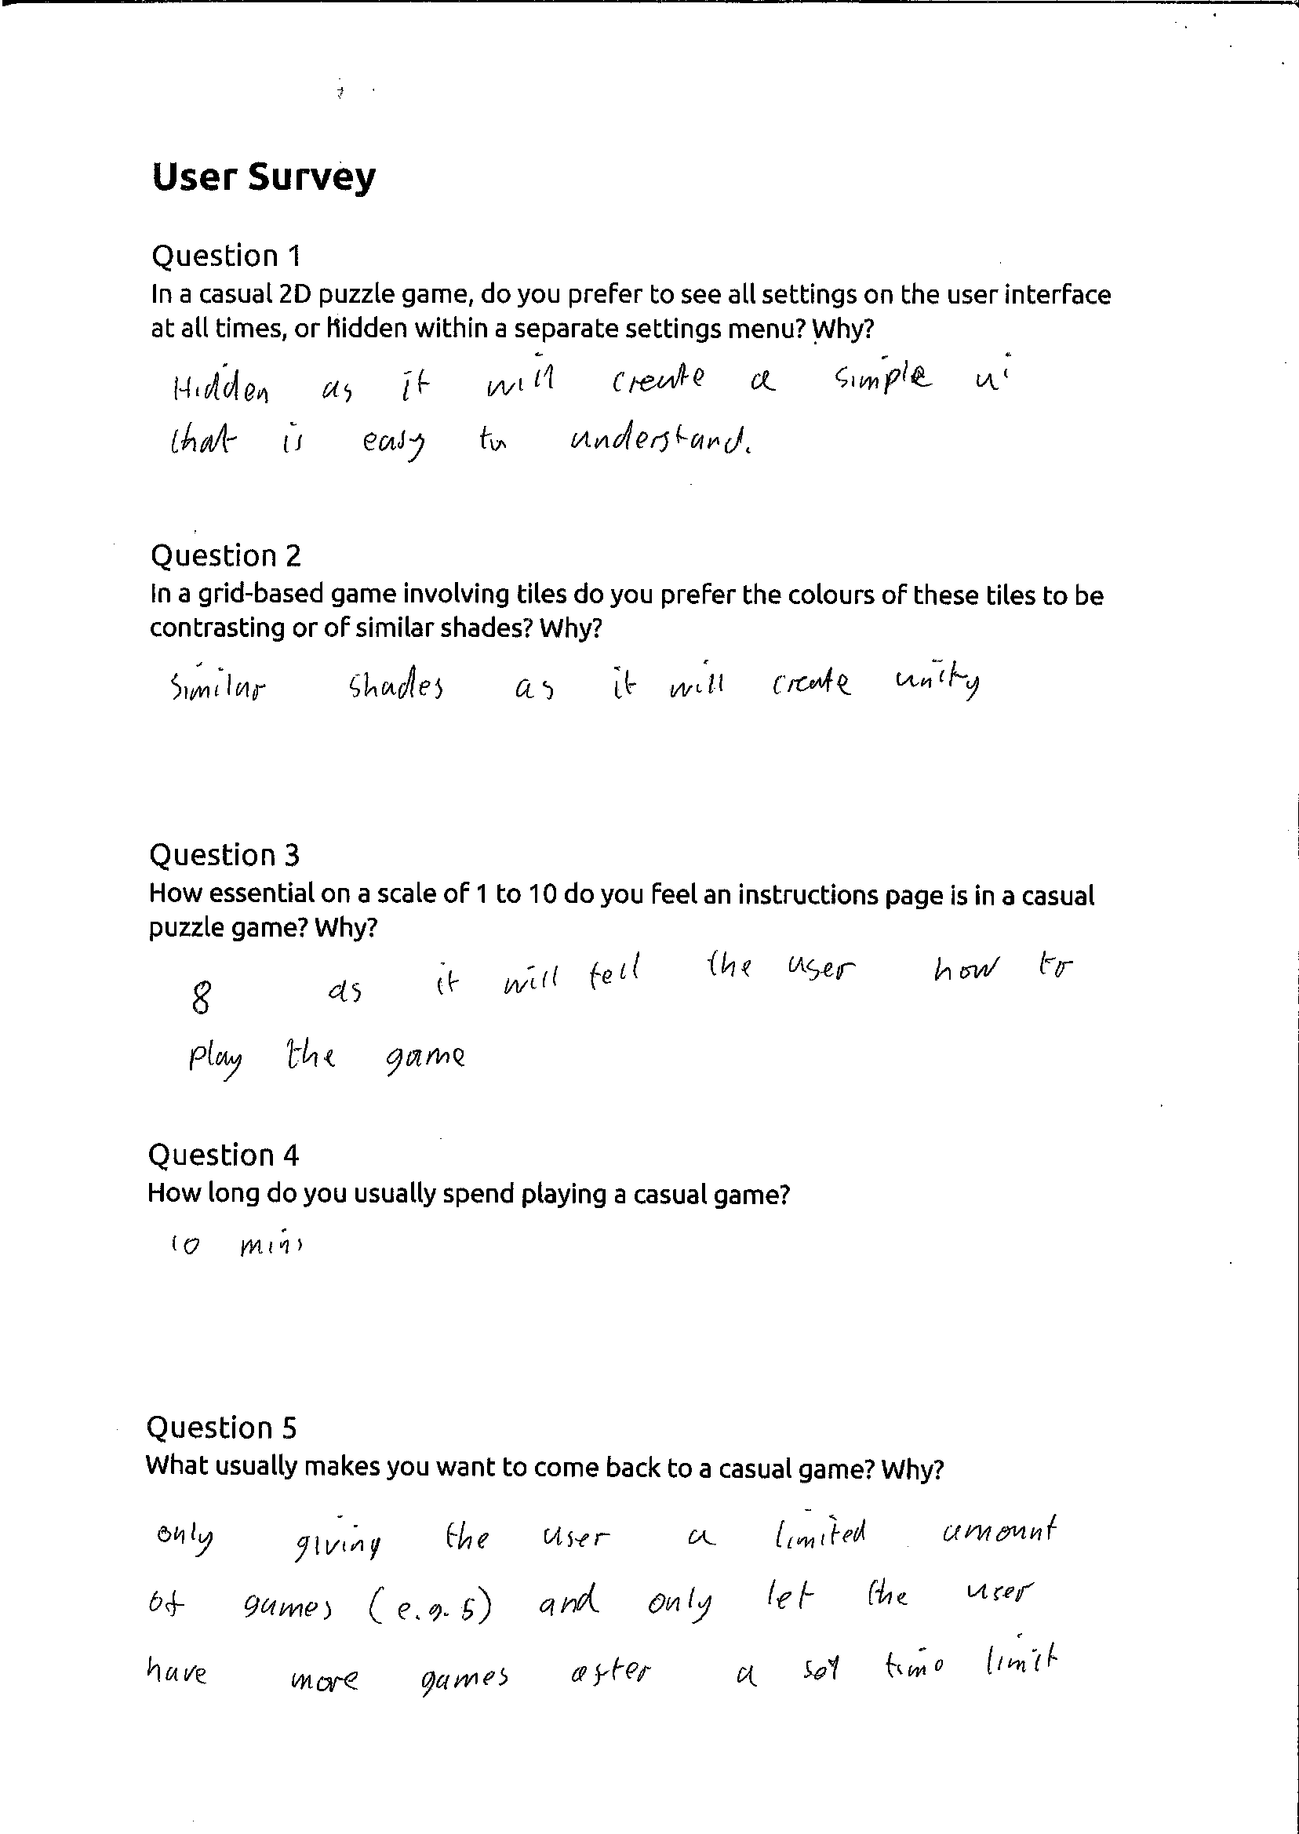

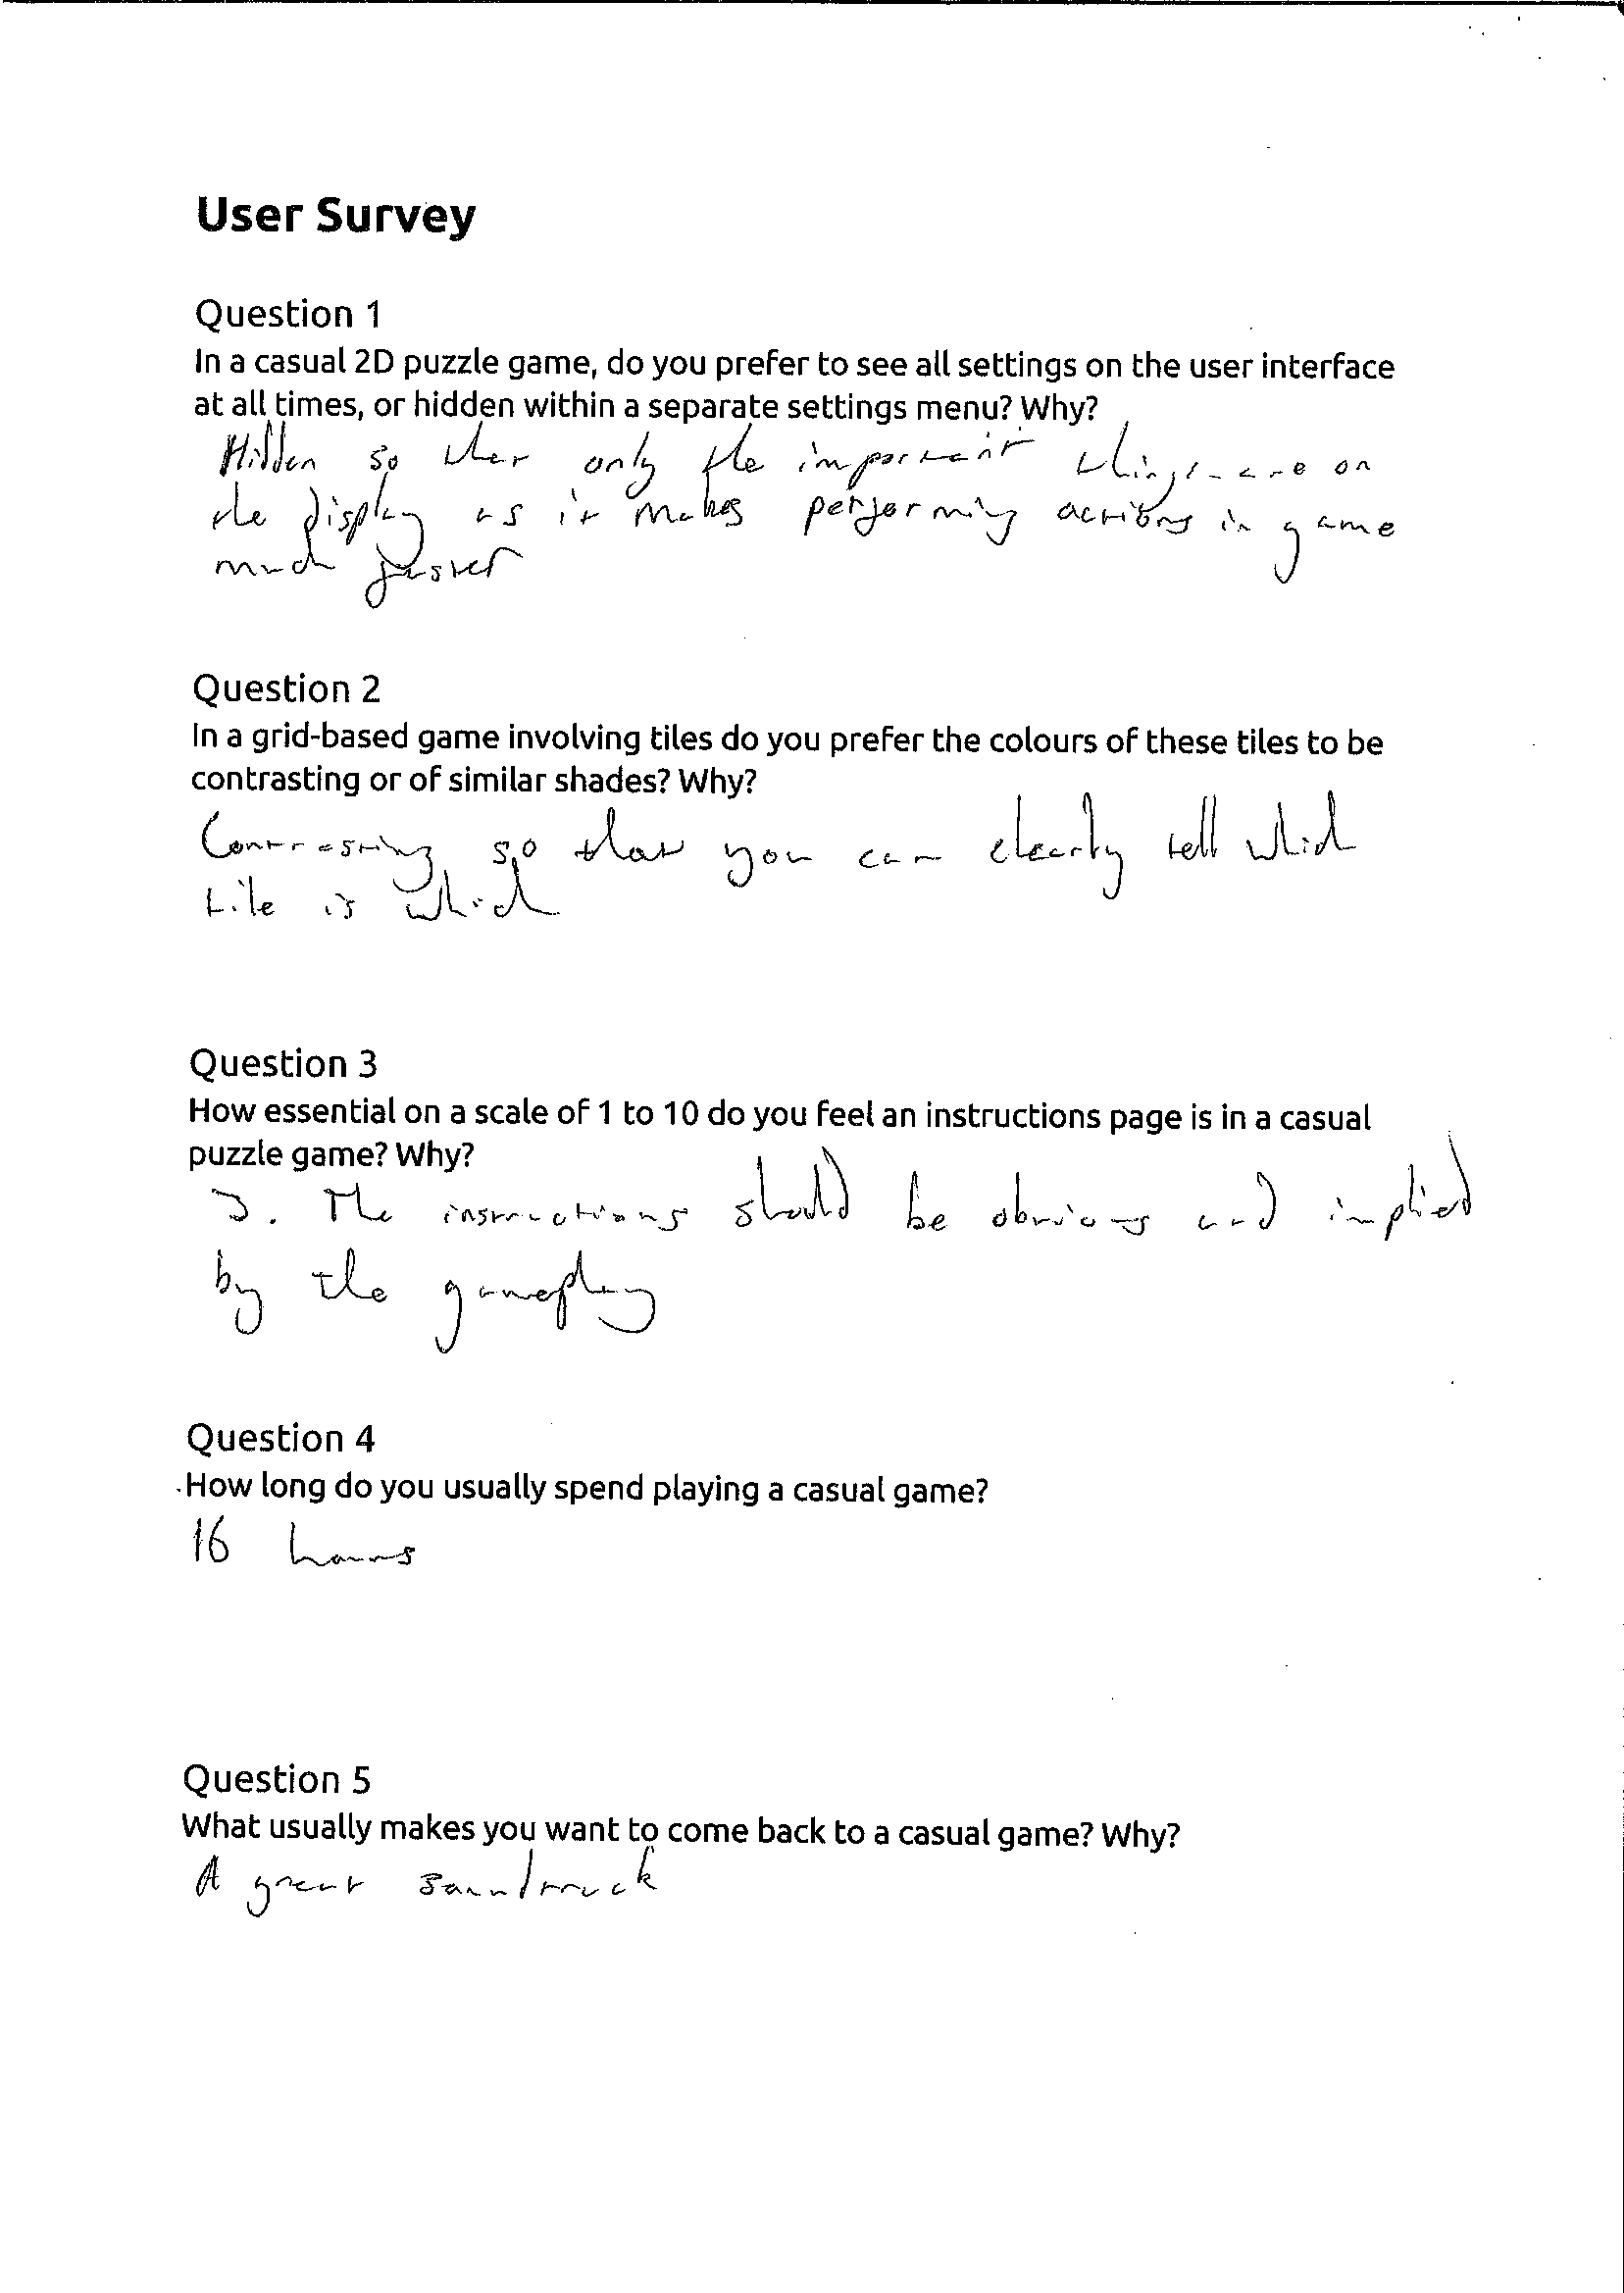

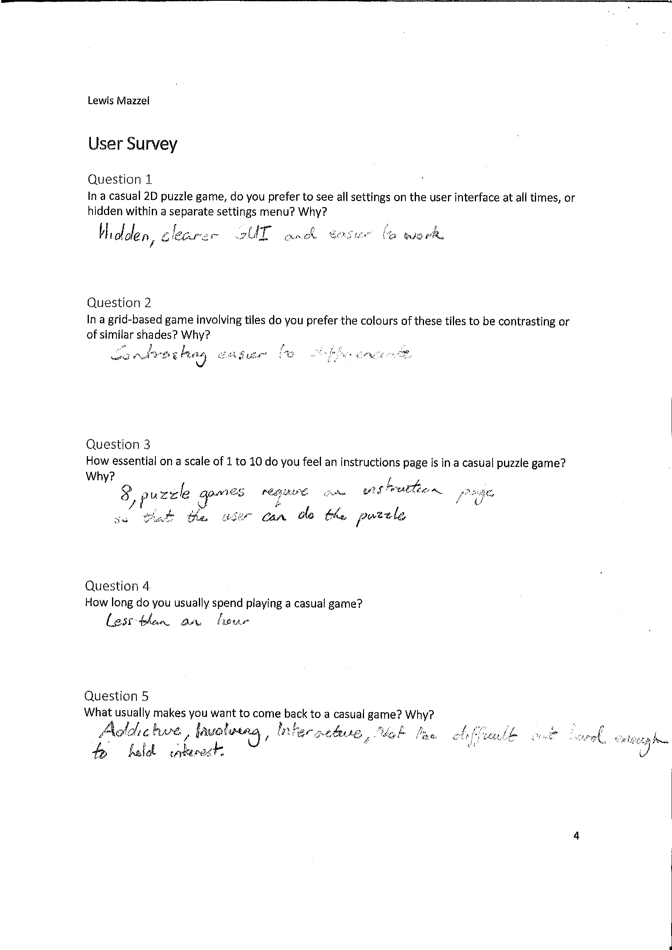

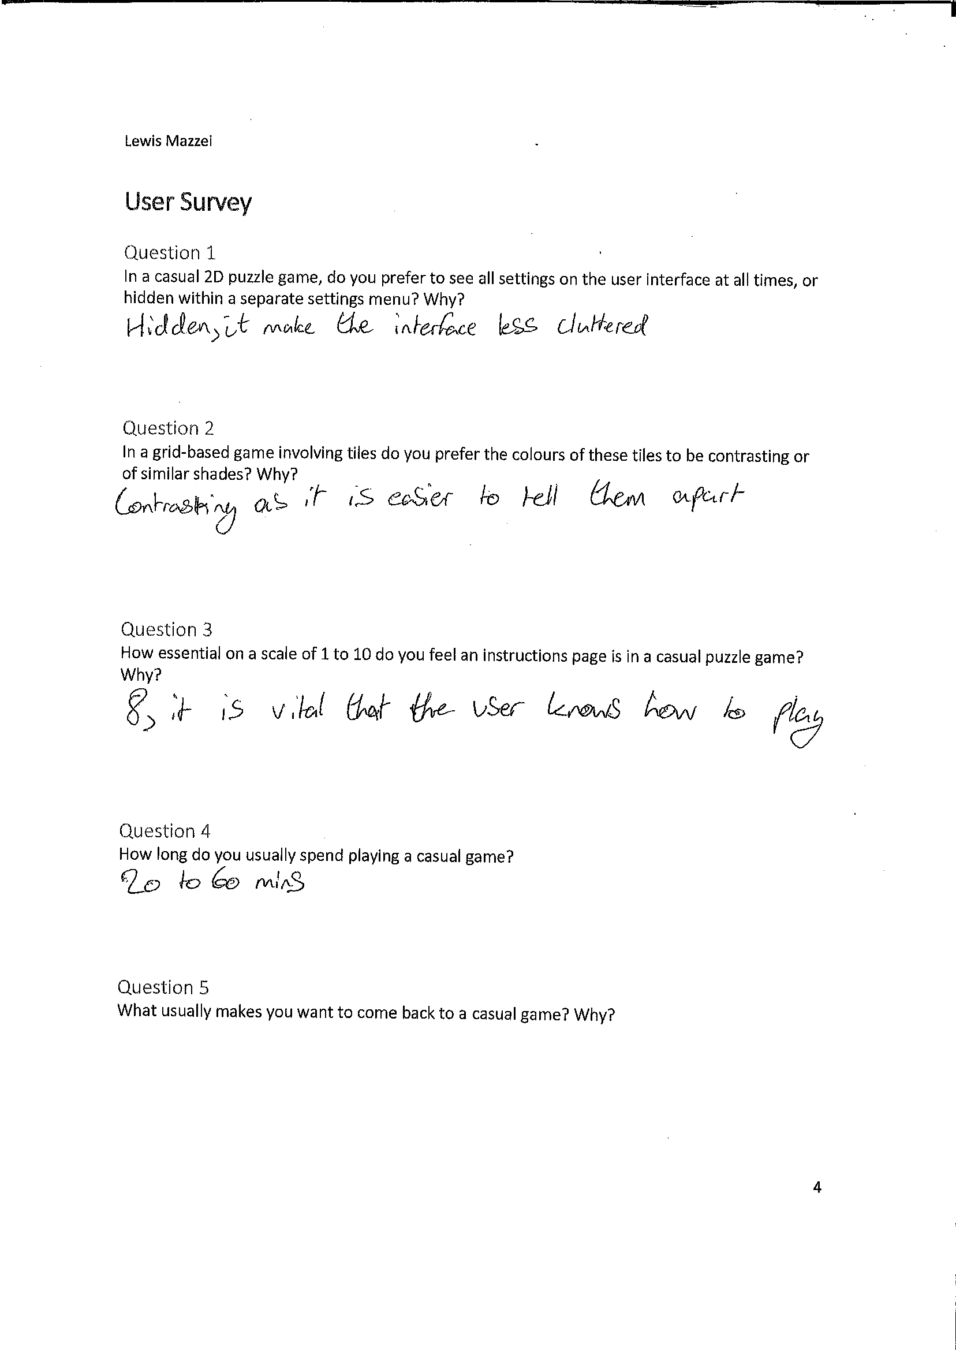

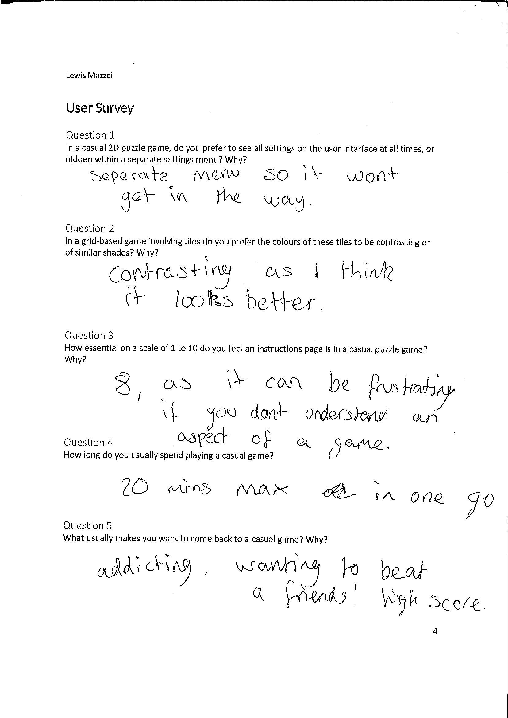





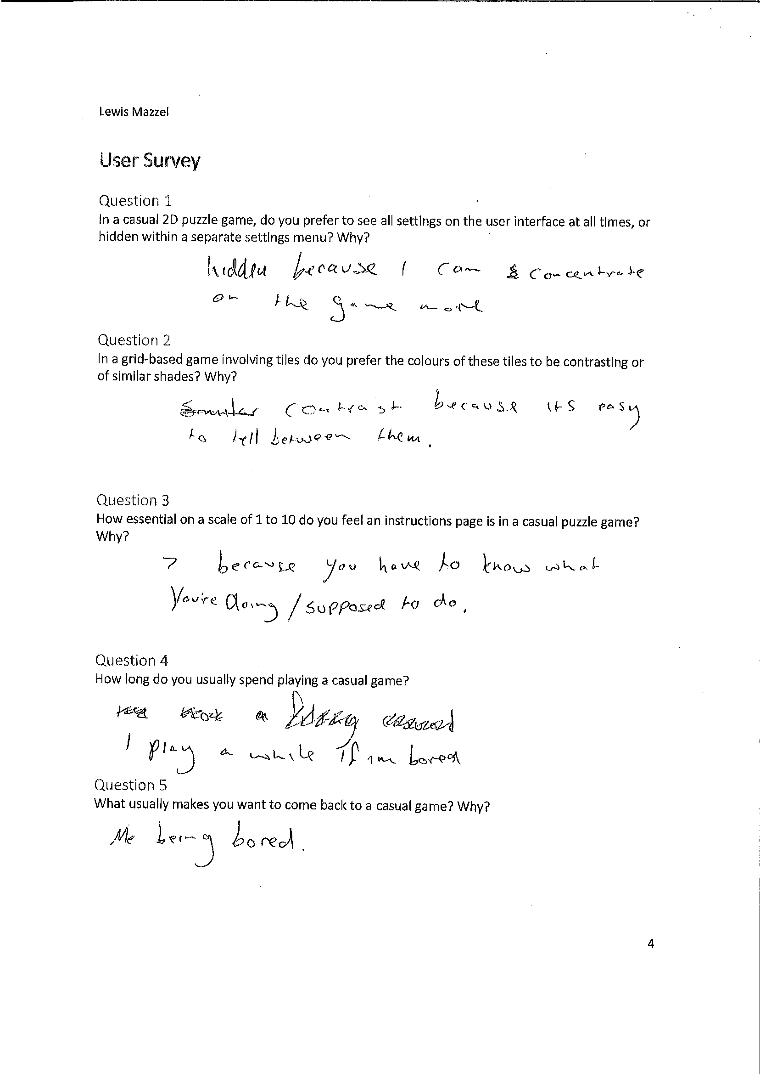



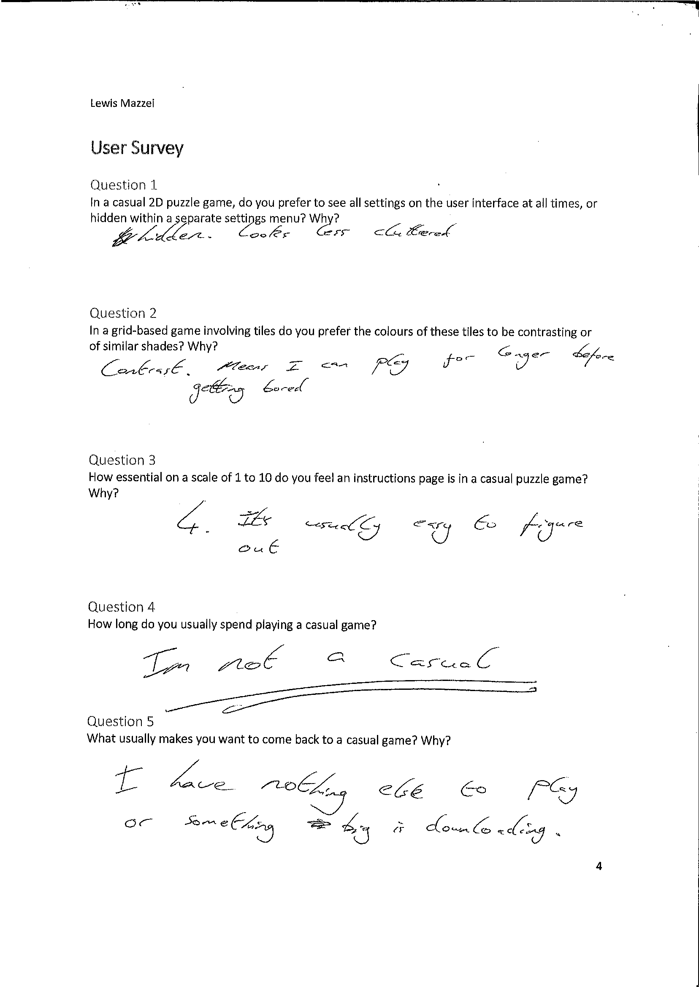

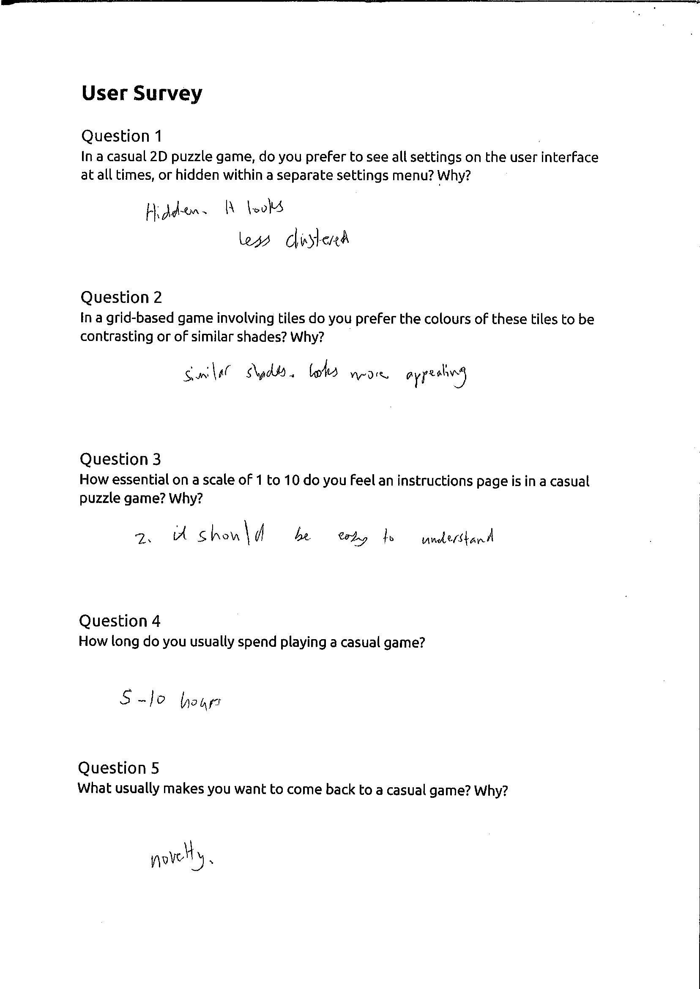



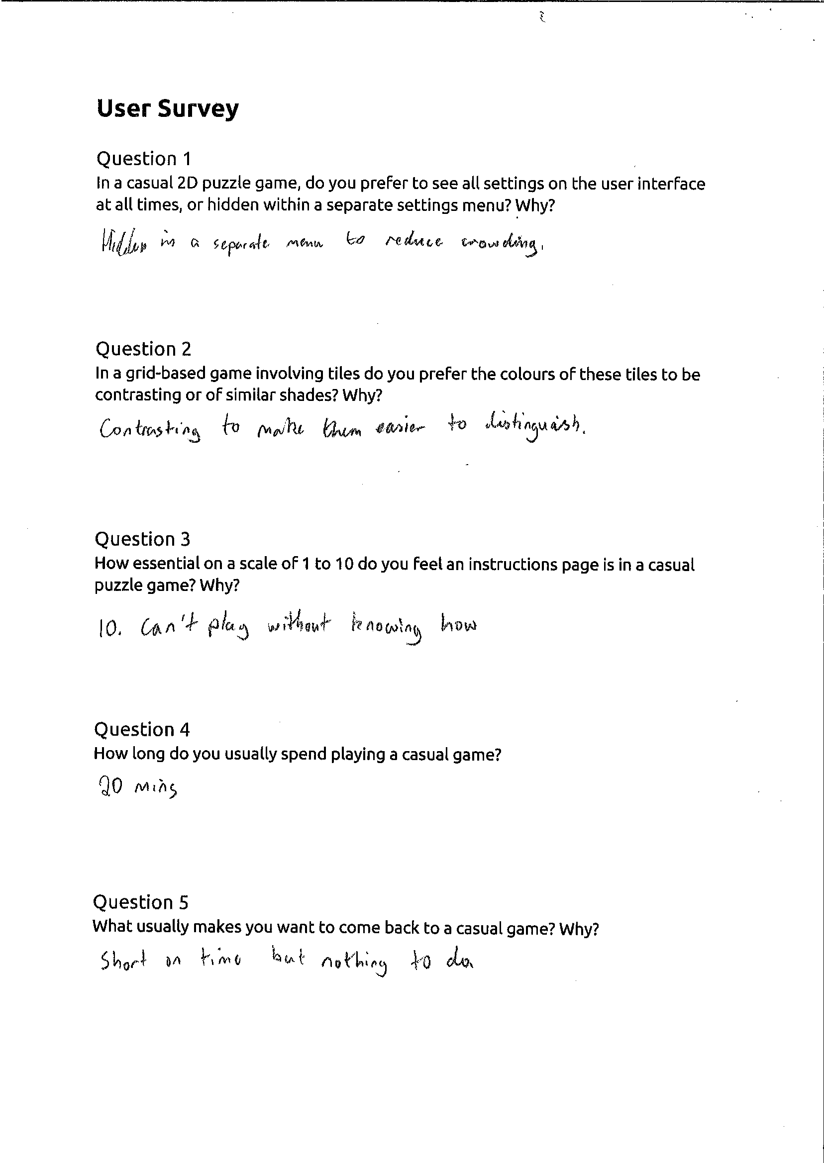

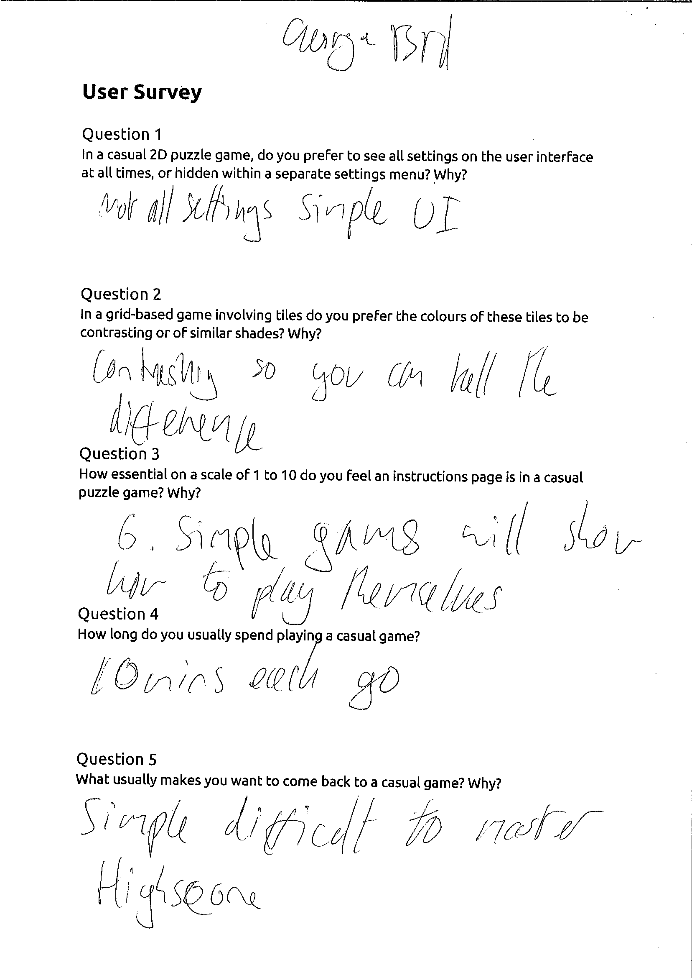











**User Questionnaires**

User Questionnaire

Age: 17

Gender: Male

Prior gaming experience: Advanced

Question 1

Did you find the user interface easy to understand and use? If not, how do you think this aspect of the game could be improved?

**Easy to understand however a consistent design could be implemented**

Question 2

Did you find the colours of the tiles appealing? If not, why do you think this was?

**Yes**

Question 3

How challenging did you find the game? If it was either too easy or too hard why was this?  
**Easy to start, but got more difficult as the game progressed.**

Question 4

Were the instructions easy to understand? If not, how do you think they could have been improved?

**Text could be bigger/ sharper.**

Question 5

Have you played the game ‘2048’ before? If so do you think it helped your understanding of how to play the game?

**Yes but the instructions also helped.**

Question 6

How long do you think you would play this game for at a time? What do you think would make you want to play it for longer?

**10 minutes. I feel that i would get frustrated with the lack of animations after a while.**

Question 7

On a scale of 1 to 10 what would you rate this game overall? Would you play it again?

**7. Yes.**

User Questionnaire

Age: 17

Gender: Male

Prior gaming experience: Expert

Question 1

Did you find the user interface easy to understand and use? If not, how do you think this aspect of the game could be improved?

**Yes it was fine.**

Question 2

Did you find the colours of the tiles appealing? If not, why do you think this was?

**Yes I thought they were appealing.**

Question 3

How challenging did you find the game? If it was either too easy or too hard why was this?

**Easy to learn, hard to master. Well balanced learning curve.**

Question 4

Were the instructions easy to understand? If not, how do you think they could have been improved?  
**I found the instructions hard to read, they need to be sharper and larger.**

Question 5

Have you played the game ‘2048’ before? If so do you think it helped your understanding of how to play the game?

**Yes. The comparison between this game and 2048 is pretty accurate, it definitely helped my understanding of how to play this game.**

Question 6

How long do you think you would play this game for at a time? What do you think would make you want to play it for longer?

**10 minutes. Animations**

Question 7

On a scale of 1 to 10 what would you rate this game overall? Would you play it again?

**6/10. Yes I would.**

User Questionnaire

Age: 17

Gender: Female

Prior gaming experience: Intermediate

Question 1

Did you find the user interface easy to understand and use? If not, how do you think this aspect of the game could be improved?

**It was a nice design however i would prefer it to fill the whole screen.**

Question 2

Did you find the colours of the tiles appealing? If not, why do you think this was?

**I thought the colours were too dull, i prefer bright colours as they are more appealing to ones eye.**

Question 3

How challenging did you find the game? If it was either too easy or too hard why was this?  
**I think the concept is easy however the fact that there are other levels amazes me because no one has ever reached them yet, a bigger grid could help.**

Question 4

Were the instructions easy to understand? If not, how do you think they could have been improved?  
**Yes, however not for a blind person, would help if the text was bigger and it was split onto two pages.**

Question 5

Have you played the game ‘2048’ before? If so do you think it helped your understanding of how to play the game?

**Yes and yes.**

Question 6

How long do you think you would play this game for at a time? What do you think would make you want to play it for longer?

**Until i got bored because i couldn’t beat my highscore. If it was easier to reach the next levels I might play for longer, as it would be more exciting.**

Question 7

On a scale of 1 to 10 what would you rate this game overall? Would you play it again?

**7/10, yes i would!!!**

User Questionnaire

Age: 18

Gender: Male

Prior gaming experience: Expert

Question 1

Did you find the user interface easy to understand and use? If not, how do you think this aspect of the game could be improved?

**Instructions were blurry and hard to read. Tiles moved instantly so were sometimes hard to keep track of.**

Question 2

Did you find the colours of the tiles appealing? If not, why do you think this was?

**Colours looked bland.**

Question 3

How challenging did you find the game? If it was either too easy or too hard why was this?

**The game felt fine in terms of difficulty.**  
  
Question 4

Were the instructions easy to understand? If not, how do you think they could have been improved?

**The instructions were blurry and hard to read.**

Question 5

Have you played the game ‘2048’ before? If so do you think it helped your understanding of how to play the game?

**Yes and yes.**

Question 6

How long do you think you would play this game for at a time? What do you think would make you want to play it for longer?

**Not very long since I’ve played 2048 before, but it could become addictive if it was nicer to look at.**

Question 7

On a scale of 1 to 10 what would you rate this game overall? Would you play it again?

**7. No, see above.**

User Questionnaire

Age: 17

Gender: Male

Prior gaming experience: Expert

Question 1

Did you find the user interface easy to understand and use? If not, how do you think this aspect of the game could be improved?

**It is clear and concise which I really like. The game is laid out nicely. I think it could be improved by not having to click on the input box in order to input your name before you play the game.**

Question 2

Did you find the colours of the tiles appealing? If not, why do you think this was?

**The vast majority of colours were nice on the eye. However, some of the colours were rather dark and depressing. I think you would have been better using a flat UI colour scheme.**

Question 3

How challenging did you find the game? If it was either too easy or too hard why was this?

**I think it was at an appropriate level for my level of previous experience. Perhaps, it might be too difficult for a novice user.**  
Question 4

Were the instructions easy to understand? If not, how do you think they could have been improved?

**I didn’t read them because I have prior experience playing the 2048 game.**  
Question 5

Have you played the game ‘2048’ before? If so do you think it helped your understanding of how to play the game?

**Yes I have and yes this aided me a lot because it meant that I know how the game functions.**

Question 6

How long do you think you would play this game for at a time? What do you think would make you want to play it for longer?

**I would probably play this game for a few minutes at a time. It it sort of the pick up and play type of game. It is a good game to pass the time when you are bored. Maybe different versions of the game, for instance, some sort of challenge within the game would make me play the game for a longer period of time.**

Question 7

On a scale of 1 to 10 what would you rate this game overall? Would you play it again?

**8/10, there are still a few aspects that need to be fixed but other than that I enjoyed it a lot.**

User Questionnaire

Age: 14

Gender: Male

Prior gaming experience: Minimal

Question 1

Did you find the user interface easy to understand and use? If not, how do you think this aspect of the game could be improved?

**The colours are too dull. I struggle to comprehend everything.**

Question 2

Did you find the colours of the tiles appealing? If not, why do you think this was?

**From a side on view i can’t make out any of the colours. I also think you should of used a brighter palette.**

Question 3

How challenging did you find the game? If it was either too easy or too hard why was this?  
**There was no challenge really. Very easy to burn out completely.**  
  
Question 4

Were the instructions easy to understand? If not, how do you think they could have been improved?

**No, I can’t understand any of it. The text is way too small. Using an image has made the text incredibly low res.**

Question 5

Have you played the game ‘2048’ before? If so do you think it helped your understanding of how to play the game?

**Yes because they are the exact same game.**

Question 6

How long do you think you would play this game for at a time? What do you think would make you want to play it for longer?

**Its a casual game so i am happy playing it for less than 5 minutes**

Question 7

On a scale of 1 to 10 what would you rate this game overall? Would you play it again?

**6. No**

User Questionnaire

Age: 17

Gender: Male

Prior gaming experience: Casual Gamer

Question 1

Did you find the user interface easy to understand and use? If not, how do you think this aspect of the game could be improved?

**The user interface made sense however the instructions were awfully small.**

Question 2

Did you find the colours of the tiles appealing? If not, why do you think this was?

**Yes.**

Question 3

How challenging did you find the game? If it was either too easy or too hard why was this?  
**I found it hard to keep track of the tiles moving because of the lack of animation.**  
  
Question 4

Were the instructions easy to understand? If not, how do you think they could have been improved?

**No, they need to be much bigger.**

Question 5

Have you played the game ‘2048’ before? If so do you think it helped your understanding of how to play the game?

**Yes. Yes.**

Question 6

How long do you think you would play this game for at a time? What do you think would make you want to play it for longer?

**I would play it in small doses maybe 10 or 15 minutes at a time. I would play it longer if it was more interesting.**

Question 7

On a scale of 1 to 10 what would you rate this game overall? Would you play it again?

**6. Yes.**

User Questionnaire

Age: 17

Gender: Male

Prior gaming experience: Pro gamer

Question 1

Did you find the user interface easy to understand and use? If not, how do you think this aspect of the game could be improved?

**Yes was easy to understand.**

Question 2

Did you find the colours of the tiles appealing? If not, why do you think this was?

**The colours were OK, nice pastels and stuff.**

Question 3

How challenging did you find the game? If it was either too easy or too hard why was this?  
**The same as regular 2048. Good difficulty.**  
  
Question 4

Were the instructions easy to understand? If not, how do you think they could have been improved?  
**Didn’t bother reading them as i didn’t see them on the main menu. Text was too small and not bold enough when i did though.**

Question 5

Have you played the game ‘2048’ before? If so do you think it helped your understanding of how to play the game?

**Yes I’ve played it before. Helped me understand.**

Question 6

How long do you think you would play this game for at a time? What do you think would make you want to play it for longer?

**Dunno. Wouldn’t go out of my way but it’s pretty good so maybe couple runs at a time.**

Question 7

On a scale of 1 to 10 what would you rate this game overall? Would you play it again?

**Solid 6.5. Yes.**

User Questionnaire

Age: 17

Gender: Male

Prior gaming experience: Advanced

Question 1

Did you find the user interface easy to understand and use? If not, how do you think this aspect of the game could be improved?

**Easy to understand however a consistent design could be implemented**

Question 2

Did you find the colours of the tiles appealing? If not, why do you think this was?

**Yes**

Question 3

How challenging did you find the game? If it was either too easy or too hard why was this?  
**Easy to start, but got more difficult as the game progressed**

Question 4

Were the instructions easy to understand? If not, how do you think they could have been improved?

**Text could be bigger/ sharper**

Question 5

Have you played the game ‘2048’ before? If so do you think it helped your understanding of how to play the game?

**Yes but the instructions also helped**

Question 6

How long do you think you would play this game for at a time? What do you think would make you want to play it for longer?

**10 minutes. I feel that i would get frustrated with the lack of animations after a while**

Question 7

On a scale of 1 to 10 what would you rate this game overall? Would you play it again?

**7. Yes**

**Rough Workings**

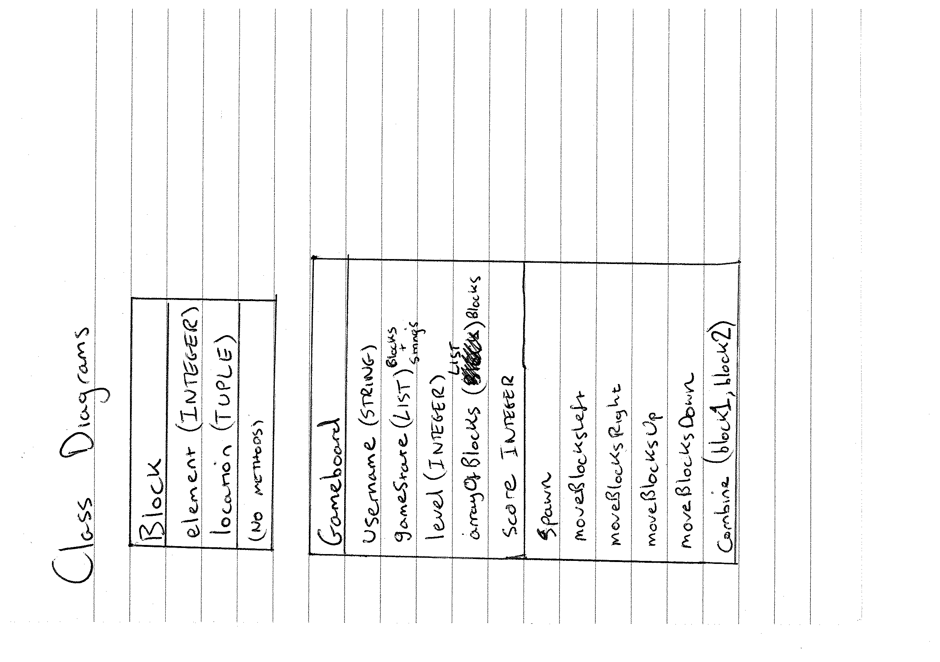

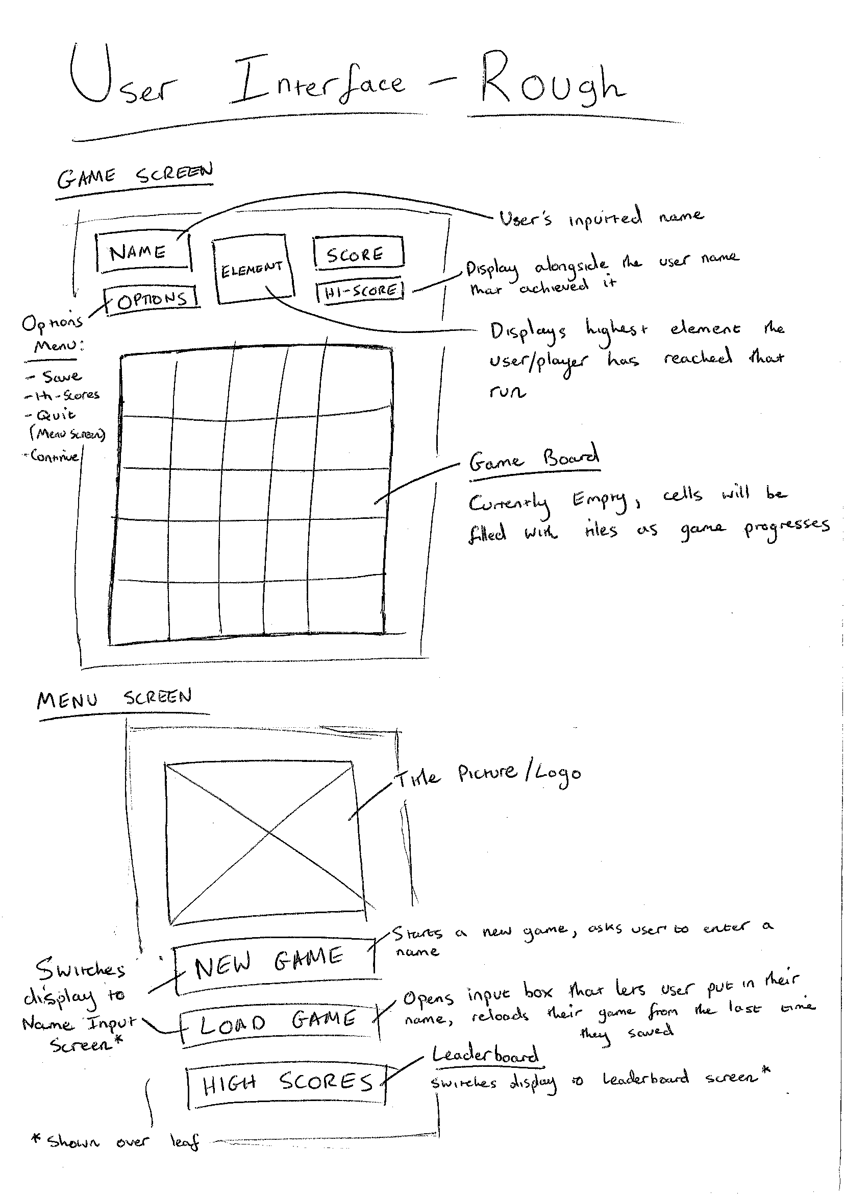

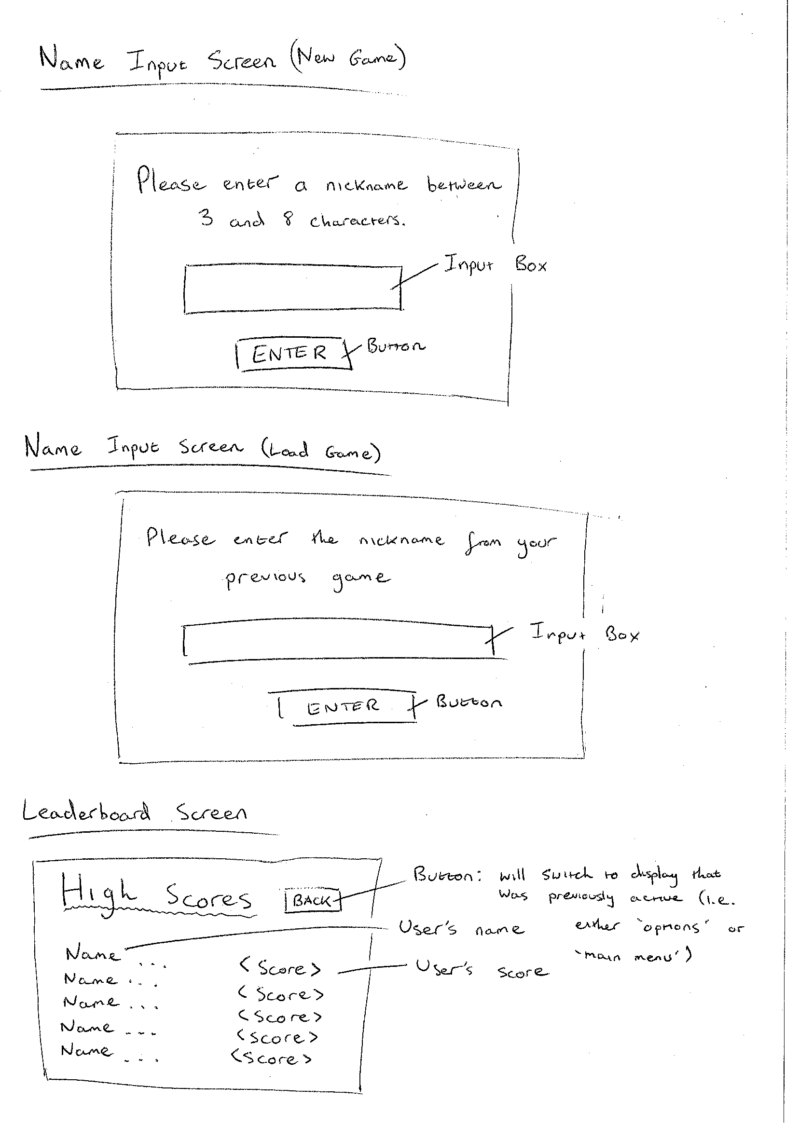

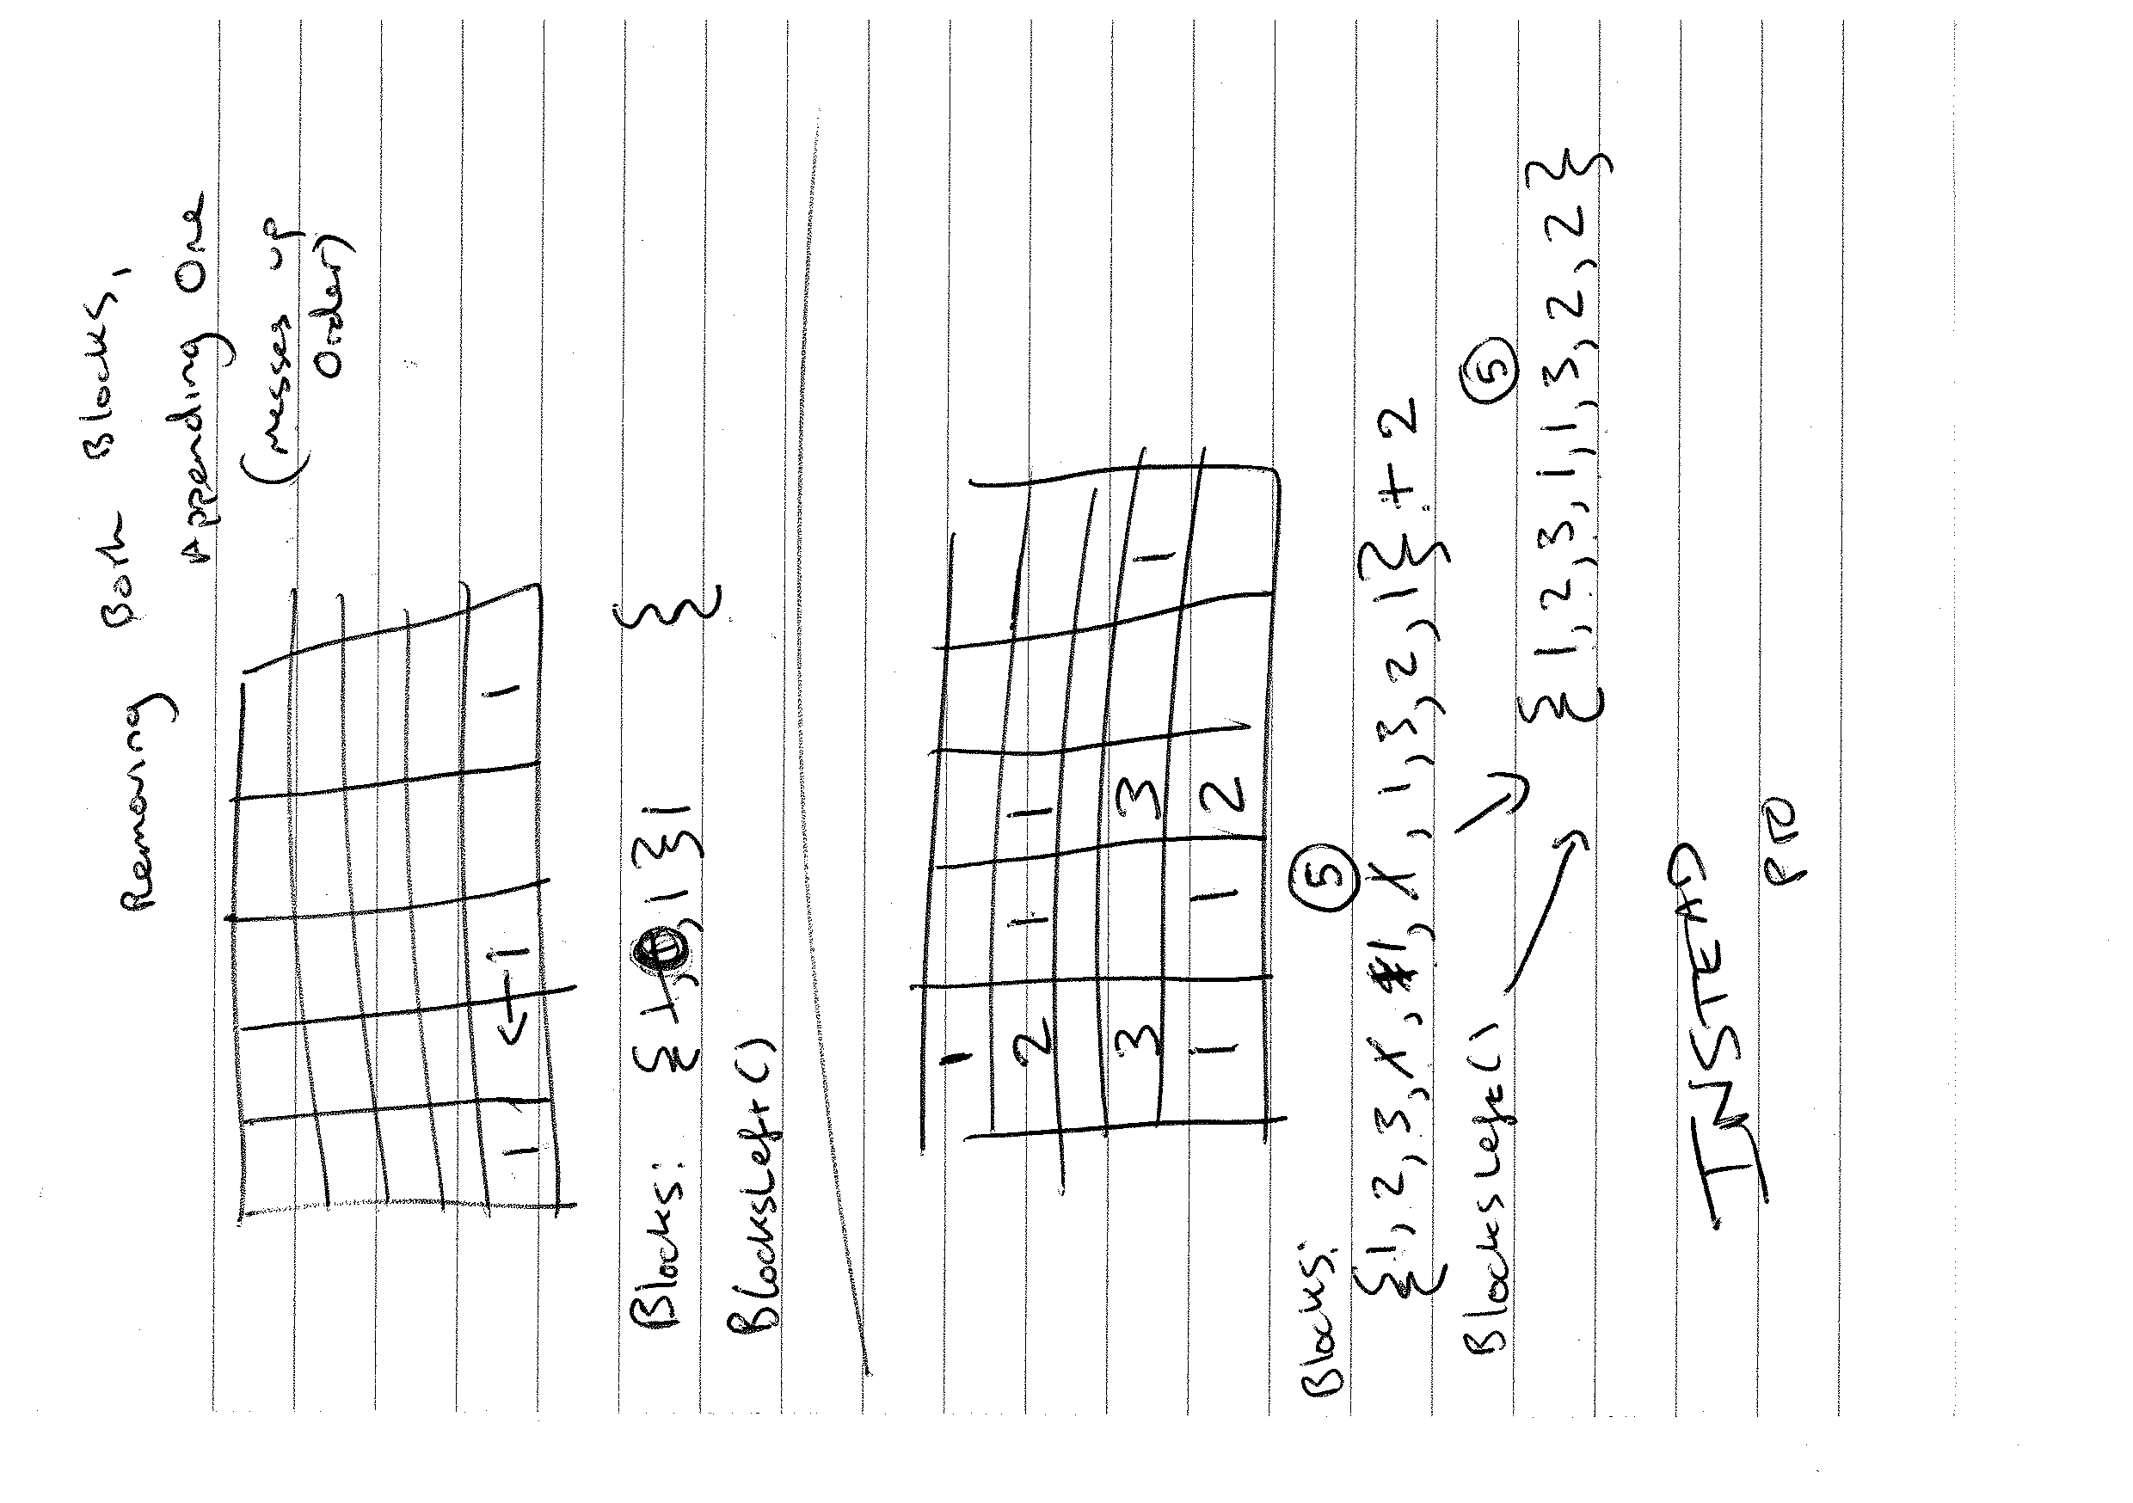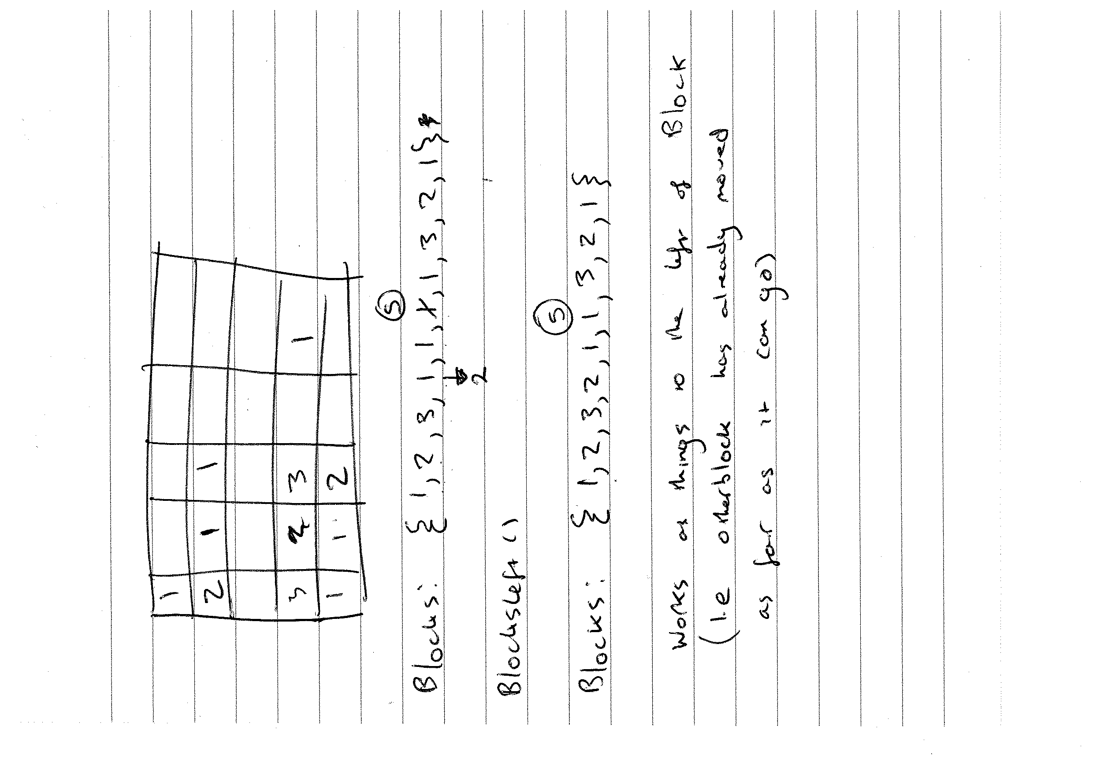

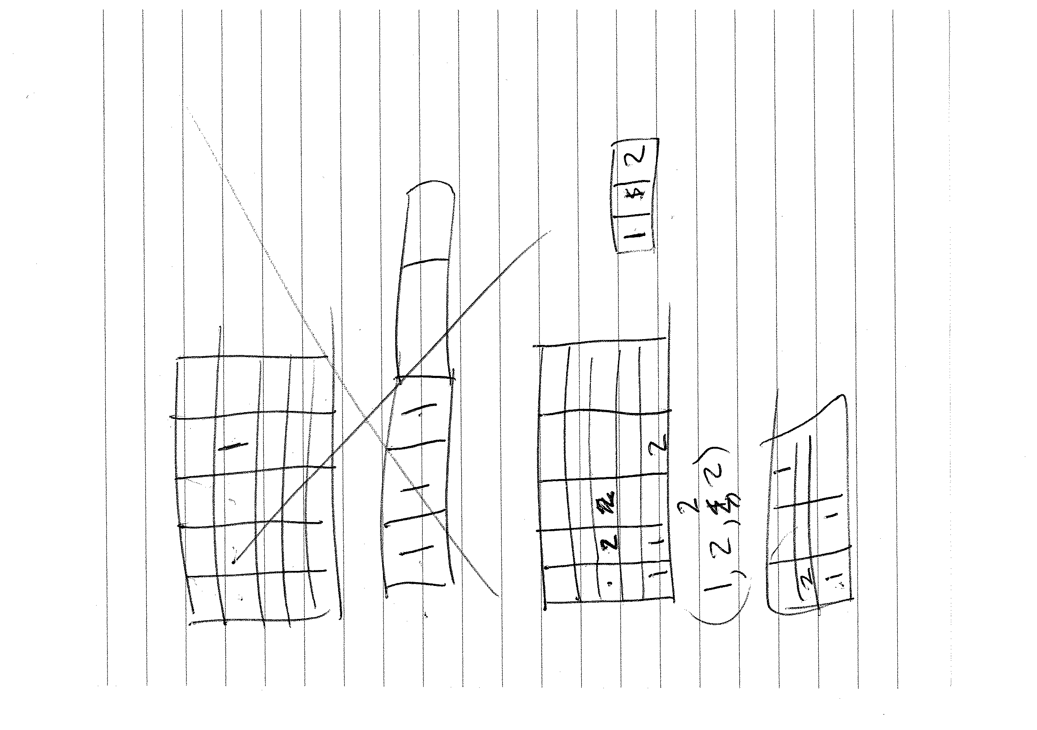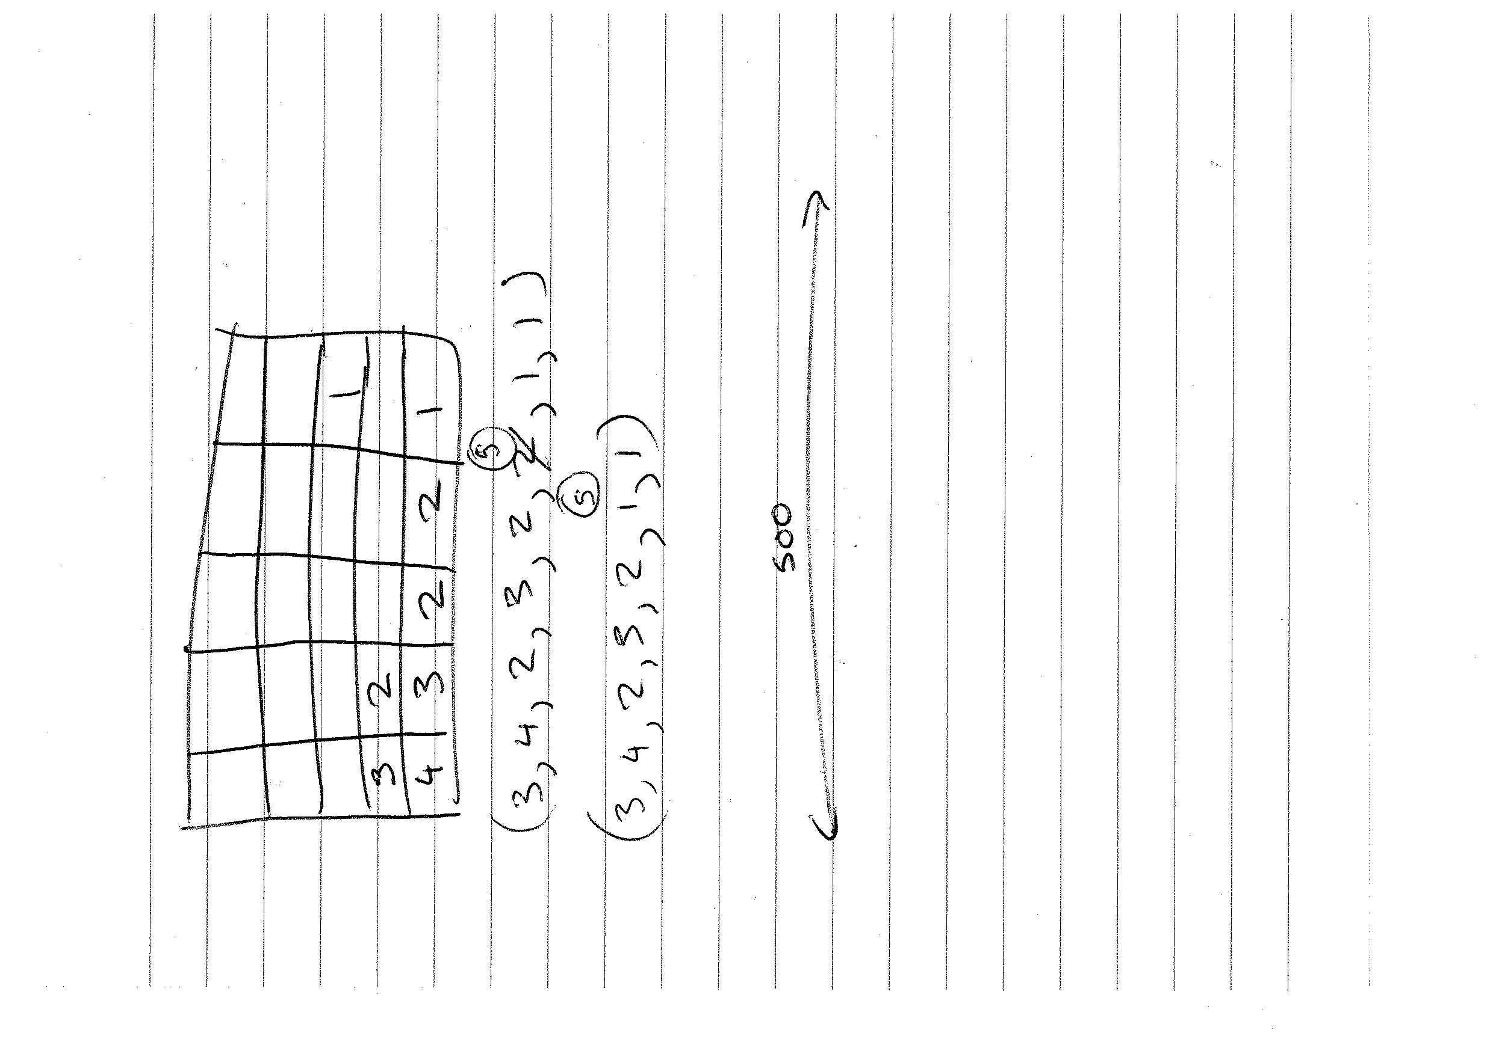

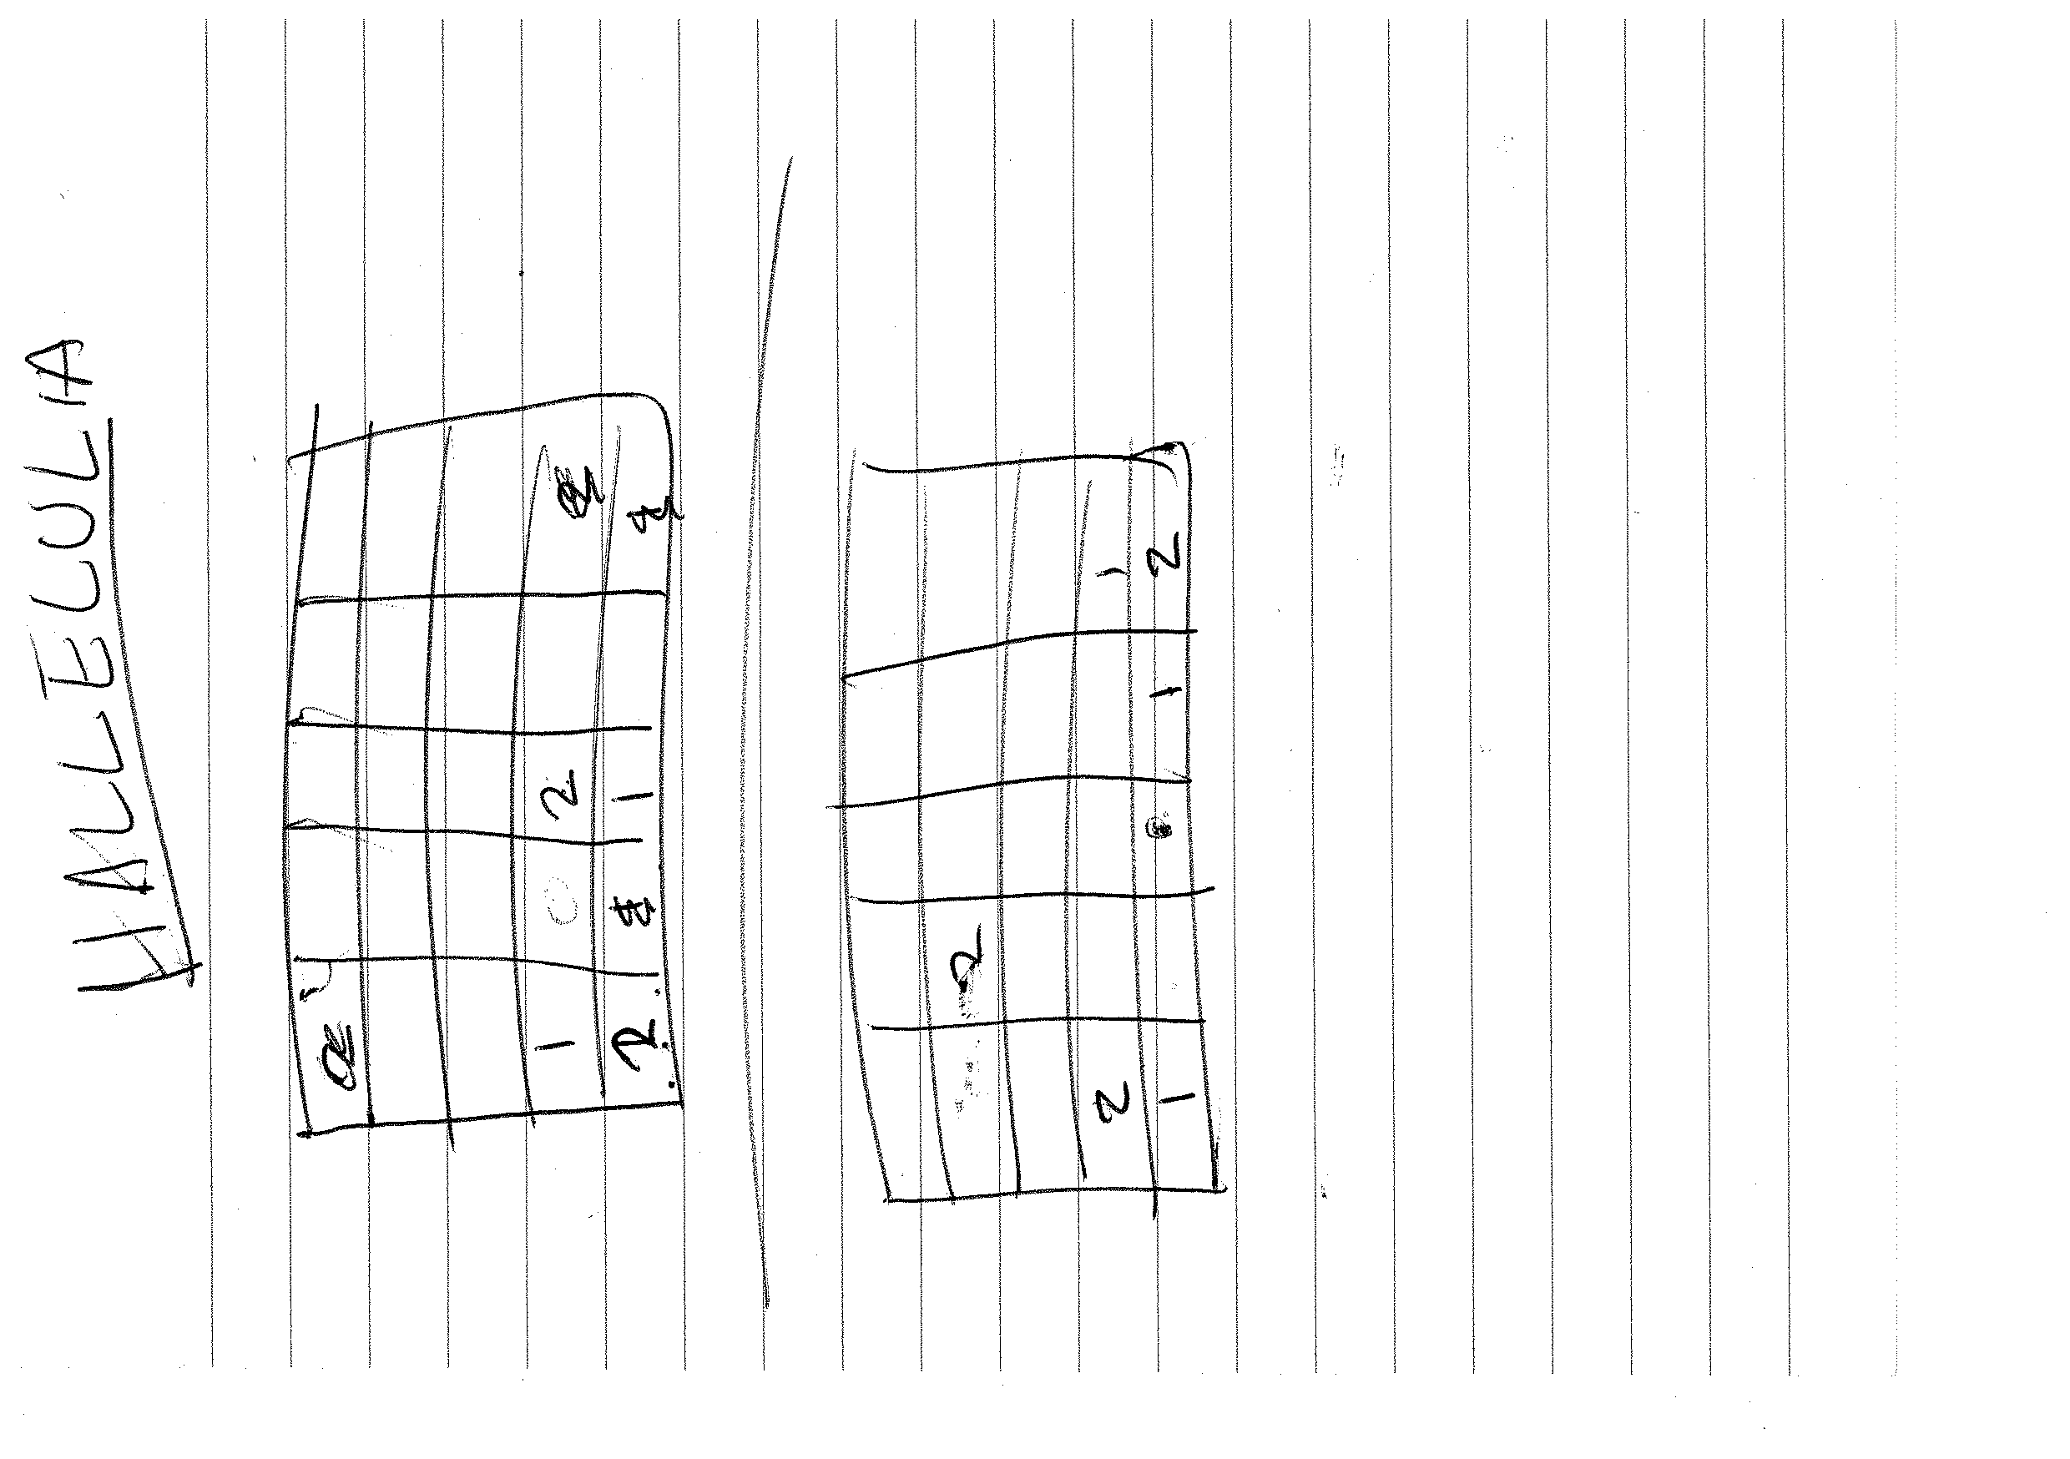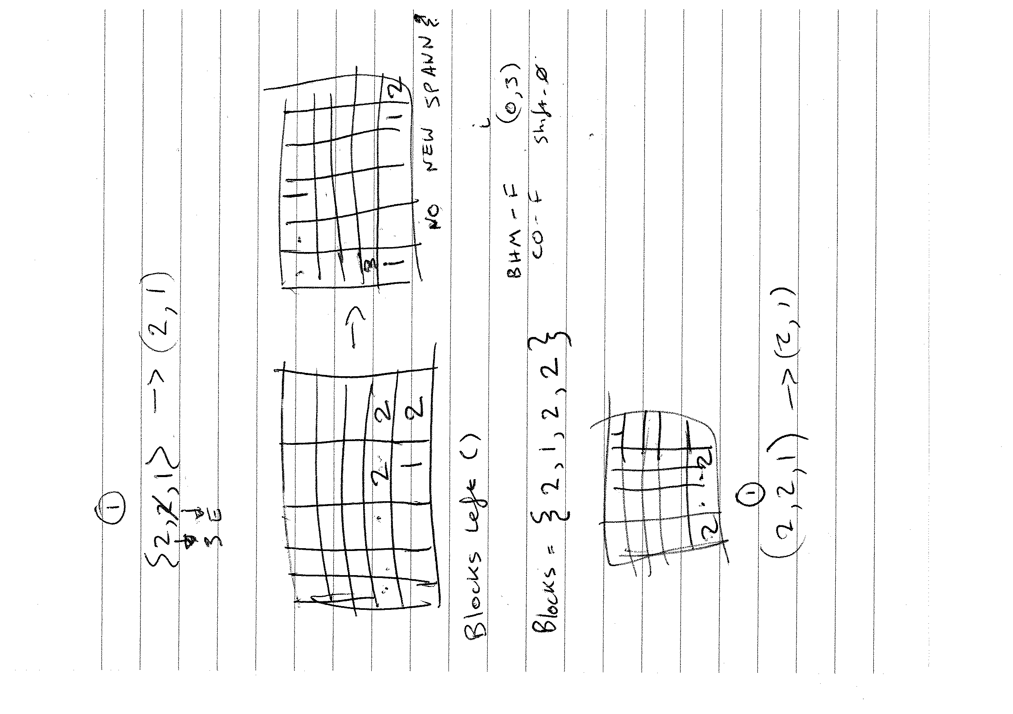

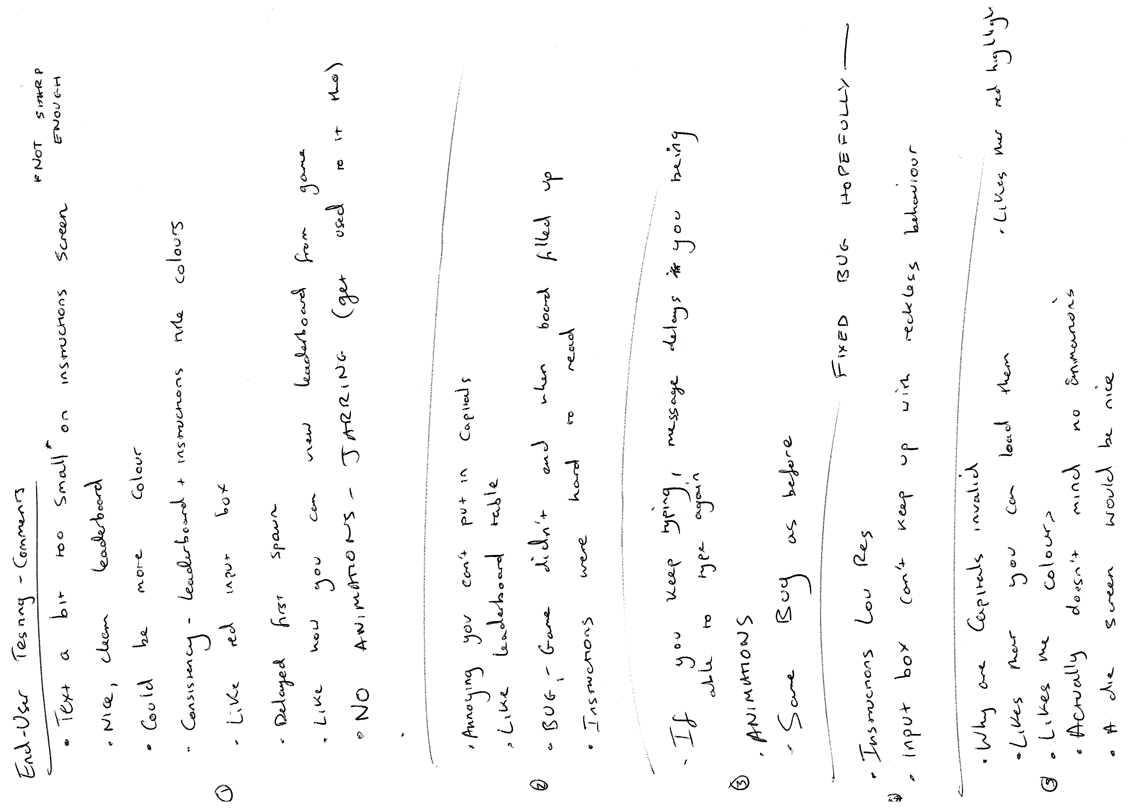

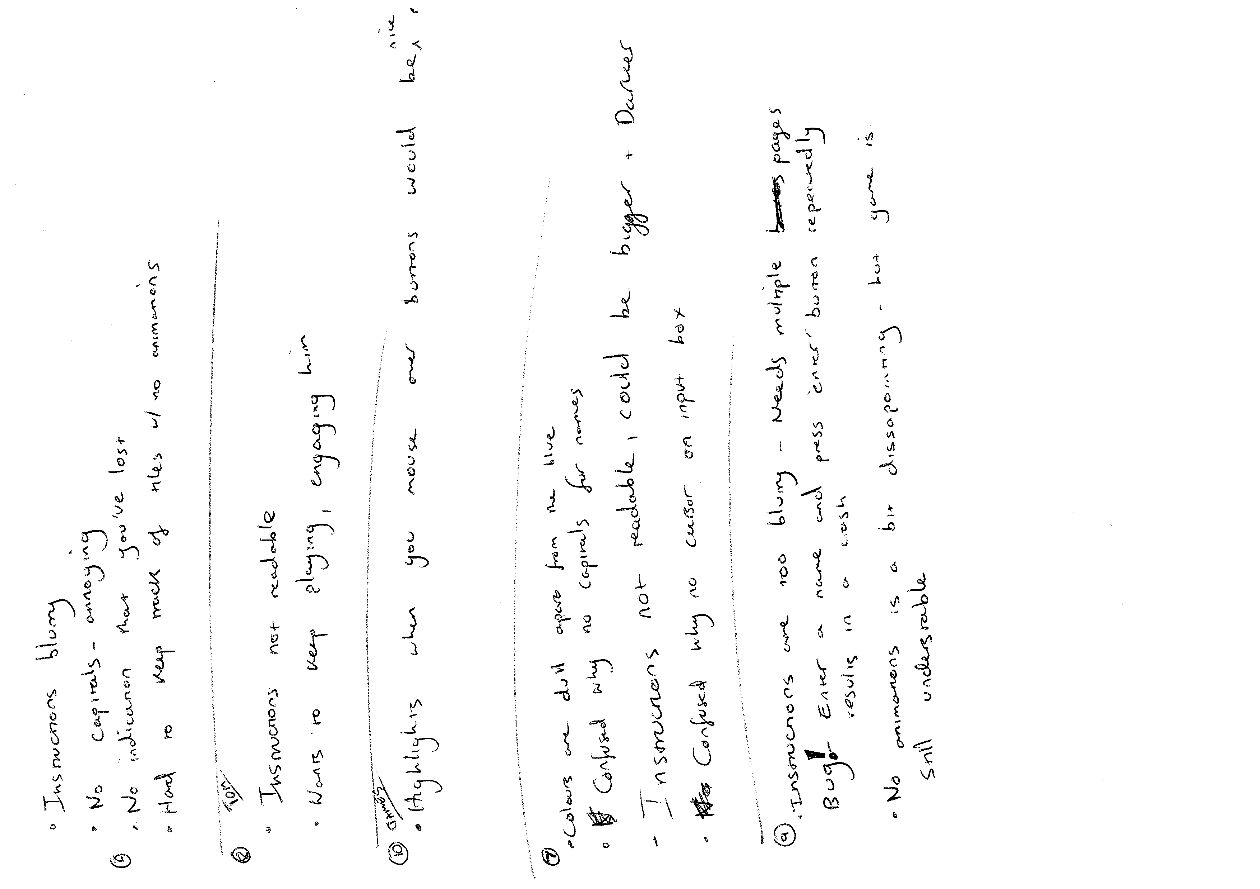

**Old Versions**

**Project Proposal** (Version 1.0)

**Concept**

Fusion is a simple puzzle game inspired by the popular app ‘2048’ in which the player slides tiles around a 5x5 game board and combines identical tiles. These tiles represent elements in the periodic table and are displayed on the game board with their chemical formula and respective atomic number.

**Mechanics**

A tile occupies a 1x1 cell on the board. When the player initiates a game either of the lowest two elements will spawn in a random cell on the board. Player input will be accepted in the form of arrow key presses. A key press will cause all tiles shift in the direction of the arrow key, provided the tile has an unoccupied cell to move into. tiles will continue to shift until they are either at the edge of the game board or are blocked by an occupied cell.

Every time the player makes a move another tile (either of the two smallest elements: i.e. Hydrogen as it has the atomic number 1 or Helium as it has atomic number 2) will spawn in a random cell on the board. If a tile collides with another tile identical to it (i.e. the same element) it will merge into a new tile (occupying a 1x1 cell) representing the next higher element on the periodic table.

To allow players to progress through all elements in the periodic table the game will be divided into stages. Once the 11th element has been created (i.e. 2 Neon tiles are combined to create a Sodium tile) a ‘Stage complete’ screen will be shown and the player will be prompted to proceed to the next stage. In doing so the game board will be cleared (i.e. every cell will be made empty) and as before, either of the lowest two elements will spawn into a random cell on the board. The difference is however that now the two lowest elements will be that of Magnesium and Aluminium (as they have atomic numbers 12 and 13 respectively).

This system will repeat every time the 11th element is created with the final stage being that of stage 11 with the final obtainable element therefore being unbiunium with an atomic number of 121. Reaching this element will be how the game is effectively ‘won’. A score will be kept throughout the game and will be incremented every time two tiles are combined with the atomic number of the two tiles combined being what the score is incremented by. For example, if two Boron tiles (with the atomic number 5) are combined to create a single Carbon (with the atomic number 6) then a total of 10 will be added to the player’s score. When the player starts a game they will be prompted to submit a username between 1 and 3 characters long allowing their score to then be saved in a leaderboard when the game is over. If the user wishes to pause the game before it is over and close the application they will have the option to save and restart it from the game state that they left it in by entering the name they chose at the start of their game.

This game is targeted at novice users of both genders over the age of 8. It will be specifically targeted at kids interested in science however it is a casual game that can be enjoyed by anyone, even if they have no scientific background. This is true as players can simply use the numbers on the tiles to play even if they do not understand what the element abbreviations actually represent.

I am going to be developing the game using the Python language and the PyGame class library.

It will fulfill the following requirements:

* Include an appropriate interface that validates all inputs
* The interface of the menu and game itself will be very basic and cater to my selected target audience
* The username will be validated to check it is no shorter than 1 character and no longer than 3 characters before it is submitted
* Include an interface with stored data
* My leaderboard will be stored on an external file and will be written and read to by the program to both retrieve and add scores to it
* Include a 2D array
* The game board itself will consist of a 2D array, with the tiles being objects that are placed inside it
* Include a sort algorithm
* I will sort the scores shown on the leaderboard using the bubble sort algorithm

**Feasibility Study** (Version 1.0)

Technical

As I will be using my laptop to run and test my program the minimum technical specifications will be that of my laptop's:

* RAM – 3820MB
* Processor - Intel® Core™ i3-2310M CPU @ 2.10GHz × 4
* Graphics Card - Intel® Sandybridge Mobile
* Operating System – Ubuntu 15.10 64-bit
* Hard Disk – 488.1GB

The only software required to run the program will be a Python compiler.

Legal

**Data Protection Act**

My program will not store sensitive data about the user as their abbreviated name does not reveal their identity. This means that I do not need to worry about the implications of the Data Protection Act.

**Copyright, Designs and Patents Act**

All images used in my program will either be non-copyright or will be created by me therefore I will not need to worry about the implications of the Copyright, Designs and Patents Act.

Economic

All hardware and software (laptop, scanner, text editor, word processing software etc.) I will use to create my program I own or will be free to use therefore I will not need to budget for any resources. Educational resources I will use to help me build my solution will all come from free sources as well. I am not selling my software on therefore I do not need to concern myself with marketing costs.

Schedule

I have 6 months and 3 days until the final submission deadline. I have already created an outline plan and will create a detailed plan of my schedule to help me plan when I need to achieve certain aspects of the project by.

|  |  |  |
| --- | --- | --- |
| **Task** | **Time** | **Target Date** |
| *Project Start* |  | 08/09/16 |
| Project Plan | 3 weeks | 29/09/16 |
| Requirements Spec | 1 week | 07/10/16 |
| Test Plan | 2 weeks | 22/10/16 |
| Interface Design | 1 week | 30/10/16 |
| Program Design | 2 weeks | 14/11/16 |
| Implementation | 3 months | 07/02/17 |
| *‘Working’ Alpha* |  | 13/12/16 |
| Testing | 2 weeks | 22/02/17 |
| Evaluation | 2 weeks | 09/03/17 |
| *Final Submission* |  | 24/03/17 |

**Outline Plan** (Version 1.0)

**Detailed Plan** (Version 1.0)

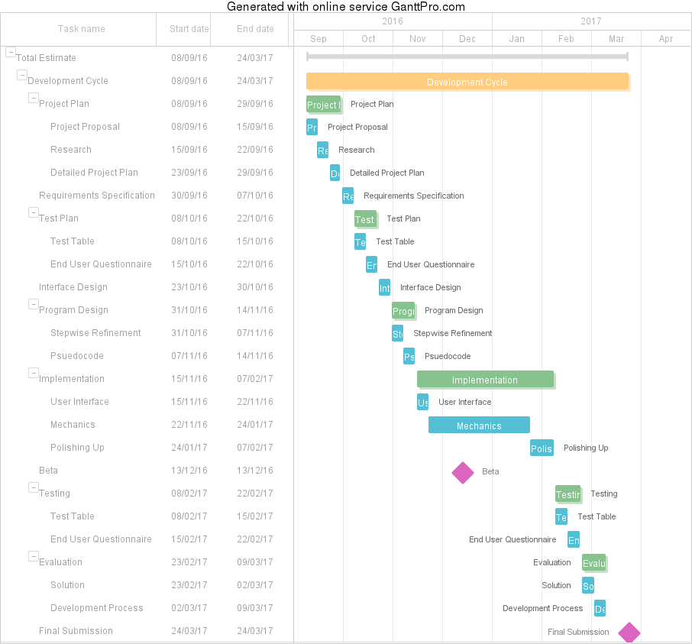

**Resources** (Version 1.0)

* Word Processor
* Printer
* Surveyees
* Gantt Chart Software
* Pen
* Paper
* Text Editor
* Wireframe Tool

**Resources** (Version 1.1)

Tools

* Laptop
* Word Processor - WPS Writer
* Printer
* Surveyees
* Gantt Chart Software - GanttPro.com
* Pen
* Paper
* Ruler
* Text Editor - Sublime Text
* Wireframe Tool - Moqups.com
* Python Translator - REPL
* Printer
* Ring Binder
* Dividers

Educational Resources

* Youtube.com
* StackOverflow.com

**Comprehensive Test Plan** (Version 1.0)

Functional Requirements

|  |  |
| --- | --- |
| **Requirement** | **Date Achieved** |
| Tracks mouse location and listen for clicks |  |
| Takes in input from both the mouse and keyboard |  |
| Reads data (scores and save data) from a text file |  |
| Writes data (scores and save data) to a text file |  |
| Sorts a list of scores (in descending order) |  |
| Validates input from the keyboard (length of name) |  |
| Stores the positions of multiple blocks of different values within a 5x5 2D grid |  |
| Displays images |  |
| Displays Text |  |
| Draws Shapes |  |

Non-Functional Requirements

|  |  |  |
| --- | --- | --- |
| **Requirement** | **Date Achieved** | **Comment** |
| Doesn’t crash unexpectedly |  |  |
| Has a fast response time after input from the user (almost instant) |  |  |
| Reads from the text file instantly |  |  |
| Writes to the text file instantly |  |  |
| Reliably stores save data without it being corrupted or deleted |  |  |

Input Validation

|  |  |  |
| --- | --- | --- |
| **Action** | **Expected Result** | **Actual Result** |
| Name input: Normal Data |  |  |
| Name input: Extreme Data |  |  |
| Name input: Exceptional Data |  |  |

**Comprehensive Test Plan** (Version 1.1)

Functional Requirements

|  |  |
| --- | --- |
| **Requirement** | **Date Achieved** |
| **Main Menu Screen** | |
| Left clicking the ‘New Game’ button switches display to the ‘Game’ screen |  |
| Left clicking the ‘Load Game’ button switches display to the ‘Name Input (Load Game)’ screen |  |
| Left clicking the ‘Leaderboard’ button switches display to the ‘Leaderboard’ screen |  |
| ‘New Game’ button loads and displays in the correct position and is the correct size |  |
| ‘Load Game’ button loads and displays in the correct position and is the correct size |  |
| ‘Leaderboard’ button loads and displays in the correct position and is the correct size |  |
| Title Picture loads and displays in the correct position and is the correct size |  |
| **Game Screen** | |
| Block(s) slide to the left when the left arrow key is pressed |  |
| Block(s) slide to the right when the right arrow key is pressed |  |
| Block(s) slide upwards when the up arrow key is pressed |  |
| Block(s) slide downwards when the down arrow key is pressed |  |
| ‘User’s Name’ text loads and displays in the correct position and is the correct size |  |
| ‘User’s Score’ text loads and displays in the correct position and is the correct size |  |
| ‘Highscore’ text loads and displays in the correct position and is the correct size |  |
| Left clicking the ‘Options’ button switches display to the ‘Options’ Screen |  |
| 5x5 grid loads and displays in the correct position and is the correct size |  |
| **Options Screen** | |
| ‘Options’ text loads and displays in the correct position and is the correct size |  |
| ‘Save’ button loads and displays in the correct position and is the correct size |  |
| ‘Leaderboard’ text loads and displays in the correct position and is the correct size |  |
| ‘Main Menu’ text loads and displays in the correct position and is the correct size |  |
| ‘Continue’ text loads and displays in the correct position and is the correct size |  |
| Left clicking the ‘Save’ button writes the current game state to an external text file and is linked with the ‘User’s Name’ |  |
| Left clicking the ‘Leaderboard’ button switches display to the ‘Leaderboard’ screen |  |
| Left clicking the ‘Main Menu’ button switches display to the ‘Main Menu’ screen |  |
| Left clicking the ‘Continue’ button switches display to the ‘Game’ screen |  |
| **Name Input Screen (Load Game)** | |
| ‘Prompt’ text loads and displays in the correct position and is the correct size |  |
| ‘Input Box’ loads and displays in the correct position and is the correct size |  |
| ‘Input Box’ allows text to be written inside it |  |
| Left clicking the ‘Enter’ button switches display to the ‘Game screen’ |  |
| Left clicking the ‘Enter’ button writes the ‘User’s Name’ to an external file |  |

Non-Functional Requirements

|  |  |  |
| --- | --- | --- |
| **Requirement** | **Date Achieved** | **Comment** |
| Doesn’t crash unexpectedly |  |  |
| Has a fast response time after input from the user (almost instant) |  |  |
| Reads from the text file instantly |  |  |
| Writes to the text file instantly |  |  |
| Reliably stores save data without it being corrupted or deleted |  |  |

Input Validation

|  |  |  |
| --- | --- | --- |
| **Action** | **Expected Result** | **Actual Result** |
| Name input: Normal Data |  |  |
| Name input: Extreme Data |  |  |
| Name input: Exceptional Data |  |  |

**Comprehensive Test Plan** (Version 1.2)

Functional Requirements

|  |  |  |  |
| --- | --- | --- | --- |
| **Action** | **Expected Result** | **Actual Result** | **Comments** |
| **Main Menu Screen** | | | |
| Left clicking the ‘New Game’ button | Switches display to the ‘game’ screen |  |  |
| Left clicking the ‘Load Game’ button | Switches display to the ‘Name Input (Load Game) Screen’ |  |  |
| Left clicking the ‘Leaderboard’ button | switches display to the ‘Leaderboard’ screen |  |  |
| Display switches to ‘Main Menu Screen’ | ‘New Game’ button loads and displays in the correct position and is the correct size |  |  |
| Display switches to ‘Main Menu Screen’ | ‘Load Game’ button loads and displays in the correct position and is the correct size |  |  |
| Display switches to ‘Main Menu Screen’ | ‘Leaderboard’ button loads and displays in the correct position and is the correct size |  |  |
| Display switches to ‘Main Menu Screen’ | ‘Title Picture’ loads and displays in the correct position and is the correct size |  |  |
| **Game Screen** | | | |
| Clicking the left arrow key | Tile(s) move to the left (tiles with empty cell(s) to the left) |  |  |
| Clicking the right arrow key | Tile(s) move to the right (tiles with empty cell(s) to the right) |  |  |
| Clicking the up arrow key | Tile(s) move upwards (tiles with empty cell(s) upwards) |  |  |
| Clicking the down arrow key | Tile(s) move downwards (tiles with empty cell(s) downwards) |  |  |
| Two tiles of the same element collide | They combine into a single 1x1 tile of the next higher element |  |  |
| Two tiles of the same element collide | Score is incremented and displays in the ‘User’s Score’ text as such (score += element atomic number * 2) |  |  |
| Display switches to ‘Game Screen’ | ‘User’s Name’ text loads and displays in the correct position and is the correct size |  |  |
| Display switches to ‘Game Screen’ | ‘User’s Score’ text loads and displays in the correct position and is the correct size |  |  |
| Display switches to ‘Game Screen’ | ‘Highscore’ text loads and displays in the correct position and is the correct size |  |  |
| Left clicking the ‘Options’ button | Switches display to the ‘Options’ Screen |  |  |
| Display switches to ‘Game Screen’ | 5x5 grid loads and displays in the correct position and is the correct size |  |  |
| Player’s saved game is loaded | The correct game state displays and is fully playable from that point |  |  |
| 11th highest element of current stage is created | Display switches to ‘Stage Complete’ screen |  |  |
| 11th highest element of current stage is created | ‘Game board’ is reset and either of the two lowest (previously two highest) elements spawns in a random cell |  |  |
| **Options Screen** | | | |
| Display switches to ‘Options Screen’ | ‘Options’ text loads and displays in the correct position and is the correct size |  |  |
| Display switches to ‘Options Screen’ | ‘Save’ button loads and displays in the correct position and is the correct size |  |  |
| Display switches to ‘Options Screen’ | ‘Leaderboard’ text loads and displays in the correct position and is the correct size |  |  |
| Display switches to ‘Options Screen’ | ‘Main Menu’ text loads and displays in the correct position and is the correct size |  |  |
| Display switches to ‘Options Screen’ | ‘Continue’ text loads and displays in the correct position and is the correct size |  |  |
| Left clicking the ‘Save’ button | Writes the current game state to an external text file and is linked with the ‘User’s Name’ |  |  |
| Left clicking the ‘Leaderboard’ button | Switches display to the ‘Leaderboard’ screen |  |  |
| Left clicking the ‘Main Menu’ button | Switches display to the ‘Main Menu’ screen |  |  |
| Left clicking the ‘Continue’ button | Switches display to the ‘Game’ screen and displays the same game state that the player left the game in when they clicked the ‘Options’ button on the ‘Game’ screen |  |  |
| **Name Input (New Game) Screen** | | | |
| Display switches to ‘Name Input (New Game) Screen ’ | Correct ‘Prompt’ text loads and displays in the correct position and is the correct size |  |  |
| Display switches to ‘Name Input (New Game) Screen’ | ‘Input Box’ loads and displays in the correct position and is the correct size |  |  |
| Left clicking inside the input box and typing | Displays typed characters inside input box |  |  |
| Left clicking the ‘Enter’ button | Switches display to the ‘Game screen’ |  |  |
| Left clicking the ‘Enter’ button | Writes the ‘User’s Name’ to an |  |  |
| **Name Input (Load Game) Screen** | | | |
| Display switches to ‘Name Input (Load Game) Screen’ | Correct ‘Prompt’ text loads and displays in the correct position and is the correct size |  |  |
| Display switches to ‘Name Input (New Game) Screen’ | ‘Input Box’ loads and displays in the correct position and is the correct size |  |  |
| Left clicking inside the input box and typing | Displays typed characters inside input box |  |  |
| Left clicking the ‘Enter’ button | Switches display to the ‘Game screen’ |  |  |
| Left clicking the ‘Enter’ button | Reads the ‘User’s name’, then successfully searches for them and their corresponding score in an external file |  |  |
| **Leaderboard Screen** | | | |
| Display switches to ‘Leaderboard Screen’ | ‘Leaderboard’ text loads and displays in the correct position and is the correct size |  |  |
| Display switches to ‘Leaderboard Screen’ | ‘Back’ button loads and displays in the correct position and is the correct size |  |  |
| Left clicking the ‘Back’ button | Switches display to the ‘Main Menu Screen’ |  |  |
| Display switches to ‘Leaderboard Screen’ | ‘Leaderboard’ table and headers load and display in the correct position and are the correct size |  |  |
| Display switches to ‘Leaderboard Screen’ | All names and scores display in the correct columns. |  |  |
| Display switches to ‘Leaderboard Screen’ | All scores display in descending order from the top to the bottom |  |  |
| Display switches to ‘Leaderboard Screen’ | All names match up with their correct corresponding scores |  |  |
| Instructions Screen | | | |
| Display switches to ‘Instructions Screen’ | ‘Instructions’ title text displays in the correct position and is the correct size |  |  |
| Display switches to ‘Instructions Screen’ | ‘Instructions’ body text displays in the correct position and is the correct size |  |  |
| Display switches to ‘Instructions Screen’ | ‘Back’ button displays in the correct position and is the correct size |  |  |
| Left clicking the back button | Switches display to the ‘Main Menu Screen’ |  |  |

Non-Functional Requirements

|  |  |  |  |  |  |
| --- | --- | --- | --- | --- | --- |
| **Action** | **Expected Result** | **Actual Result** | | **Comments** | |
| **Name Input (New Game) Screen** | | | | | |
| Application has a fast response time after input is received from the user | < 25ms from key press to all updates displaying on the screen (text appearing on the screen) | |  | |  |
| Writes to the ‘Save Data’ text file quickly | < 10ms from key press to the file being written | |  | |  |
| Save from ‘Save Data’ text file | Reliably stores saved game state data in the correct format without it being corrupted or deleted | |  | |  |
| **Name Input (Load Game) Screen** | | | | | |
| Application has a fast response time after input is received from the user | < 25ms from key press to all updates displaying on the screen (text appearing on the screen) | |  | |  |
| Application reads from the ‘Save Data’ text file quickly | < 10ms from key press to the file being read | |  | |  |
| Load from ‘Save Data’ text file | Reliably stores saved game state data in the correct format without it being corrupted or deleted | |  | |  |
| **Game Screen** | | | | | |
| Application has a fast response time after input is received from the user | < 25ms from key press to all updates displaying on the screen (tiles having moved to their new location on the gameboard) | |  | |  |
| **All Screens** | | | | | |
| Application is run | Runs without crashing or freezing unexpectedly | |  | |  |

Input Validation

|  |  |  |  |
| --- | --- | --- | --- |
| **Action** | **Expected Result** | **Actual Result** | **Comments** |
| **Name Input (New Game) Screen** | | | |
| Name input: Normal Data |  |  |  |
| Name input: Extreme Data |  |  |  |
| Name input: Exceptional Data |  |  |  |
| **Name Input (Load Game) Screen** | | | |
| Name input: Normal Data |  |  |  |
| Name input: Extreme Data |  |  |  |
| Name input: Exceptional Data |  |  |  |

Options Screen (Version 1.0)

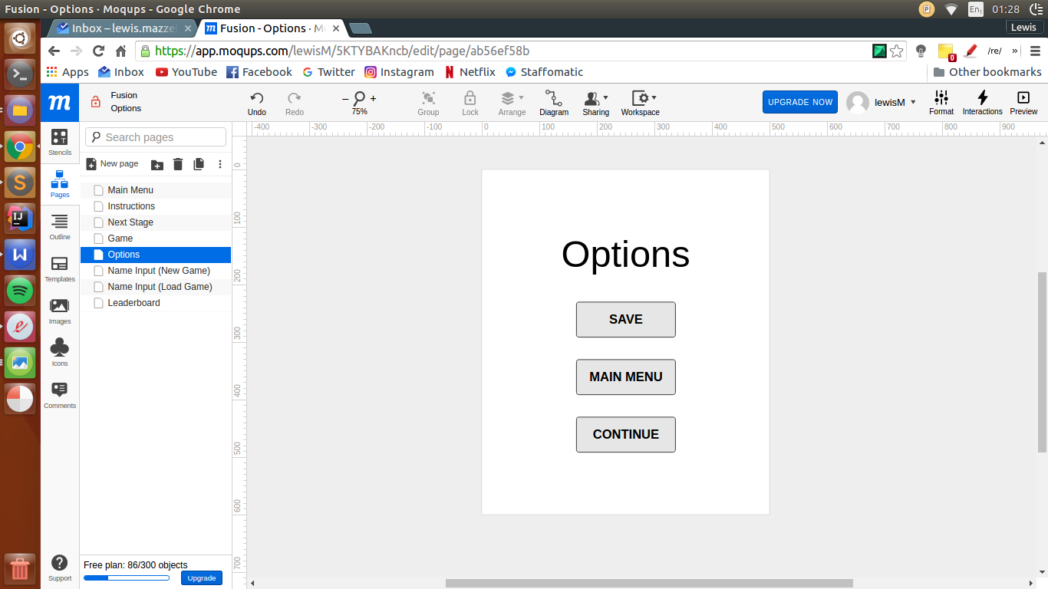

Saves the current game state

Button: Switches display to the ‘Main Menu Screen’

Button: Switches display back to the ‘Game Screen’

Leaderboard Screen (Version 1.0)

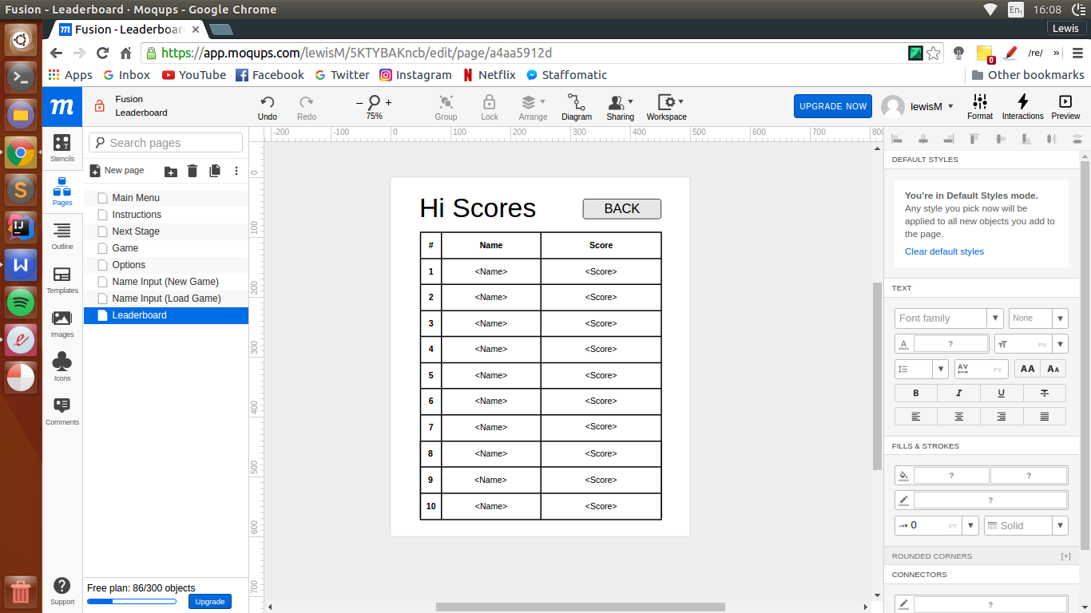

Button: Switches display to the previous screen (either the ‘Main Menu Screen’ or the ‘Options Screen’ depending on where it was accessed from

Title header

Leaderboard Grid

**Screenshots**

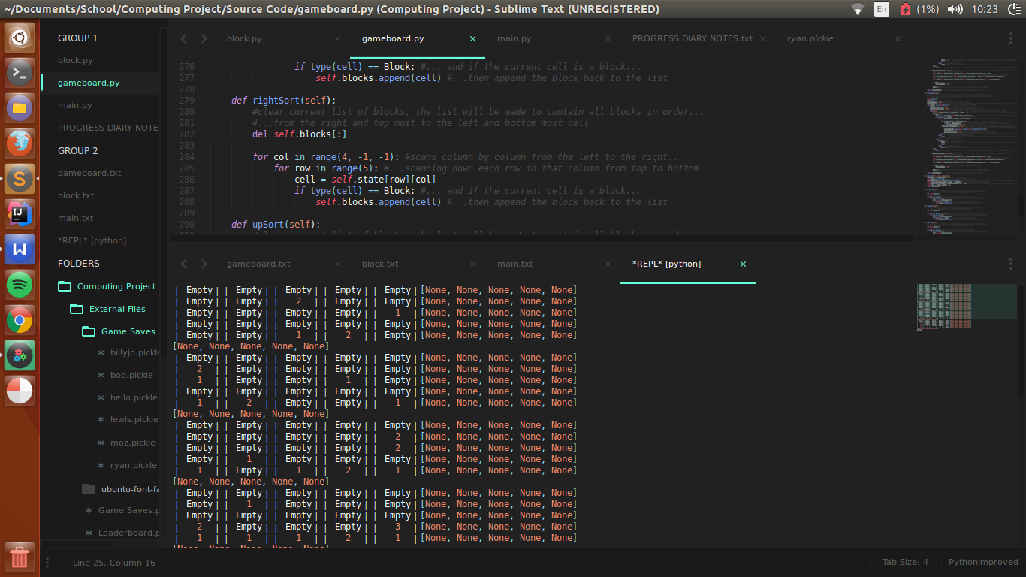**1.0**

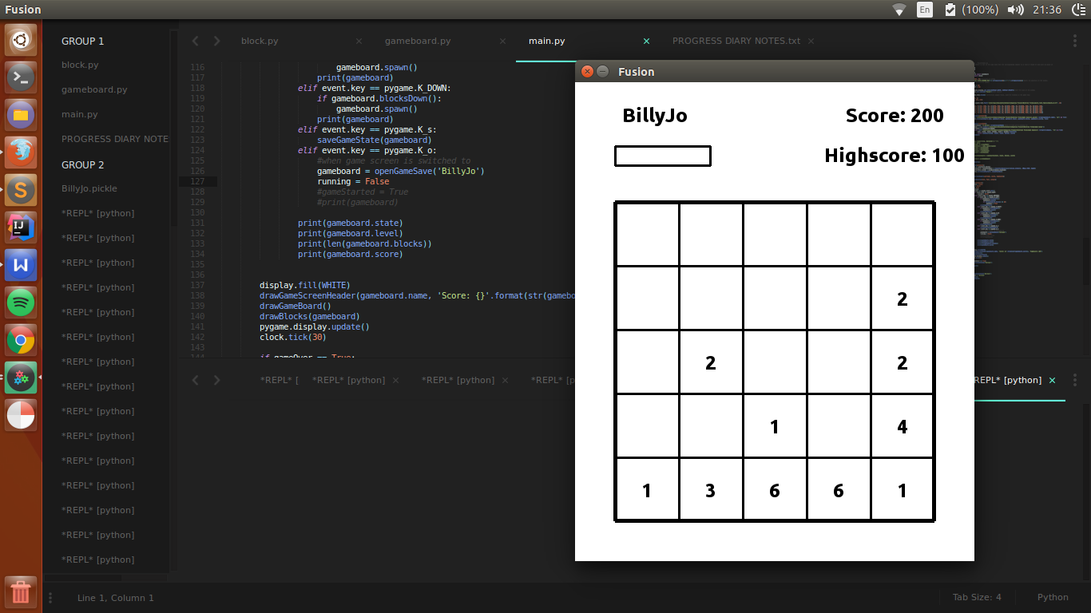**1.1**

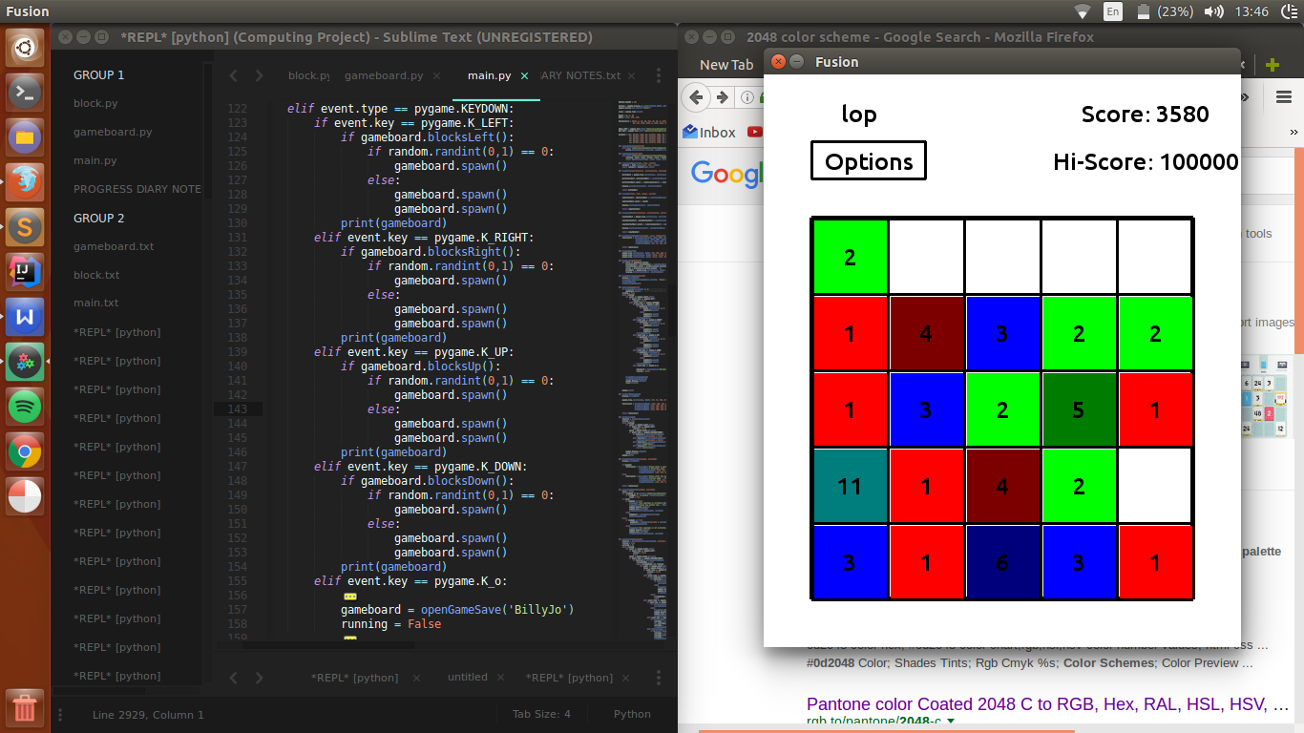**1.2**

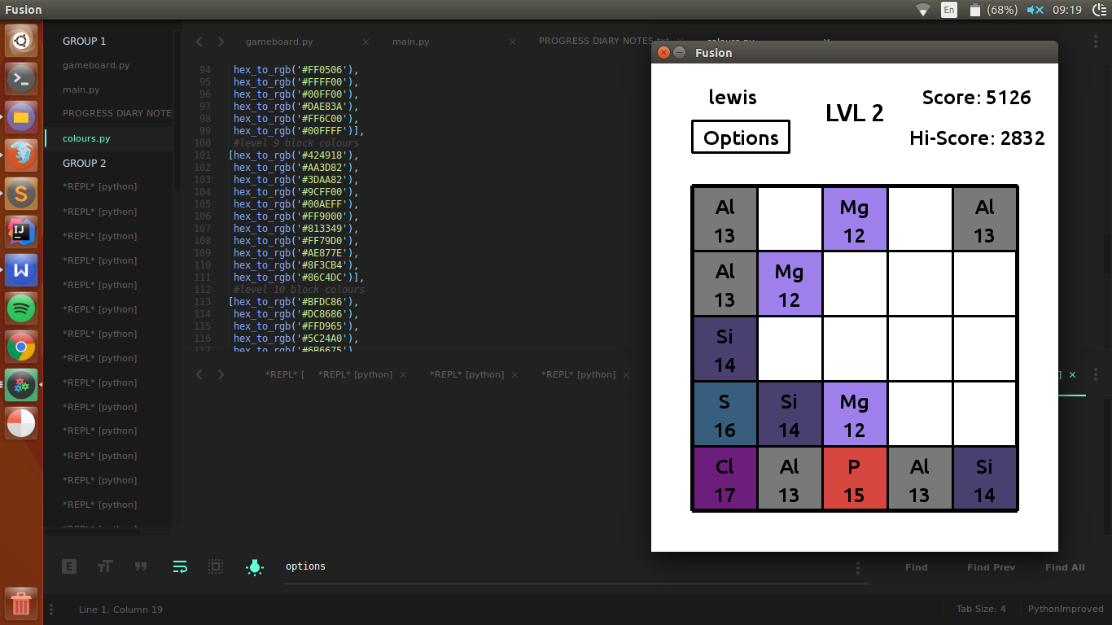**1.3**

**2.0**

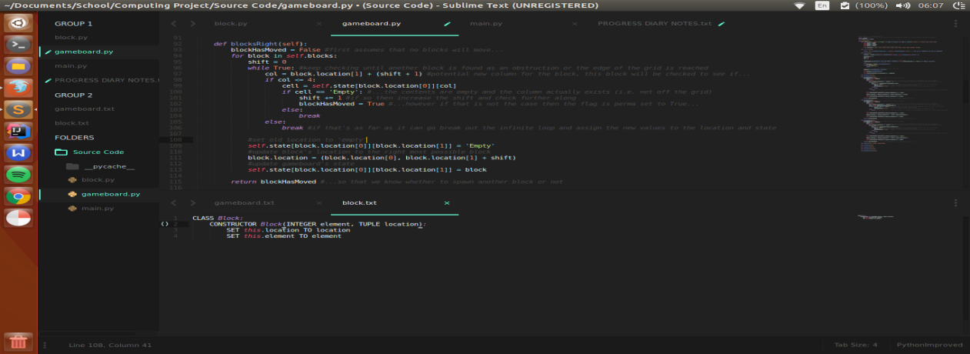

**2.1**

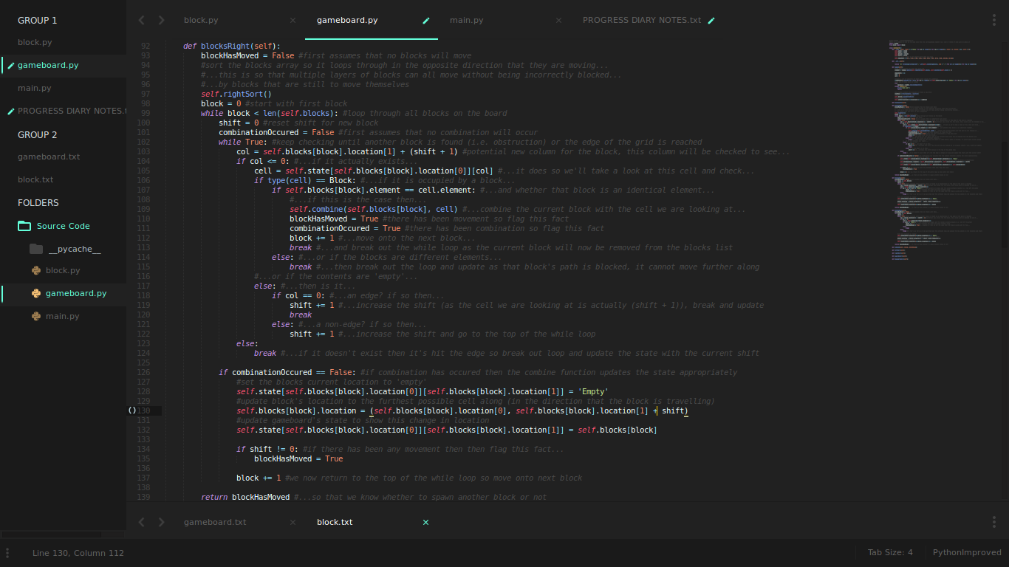

**2.2**

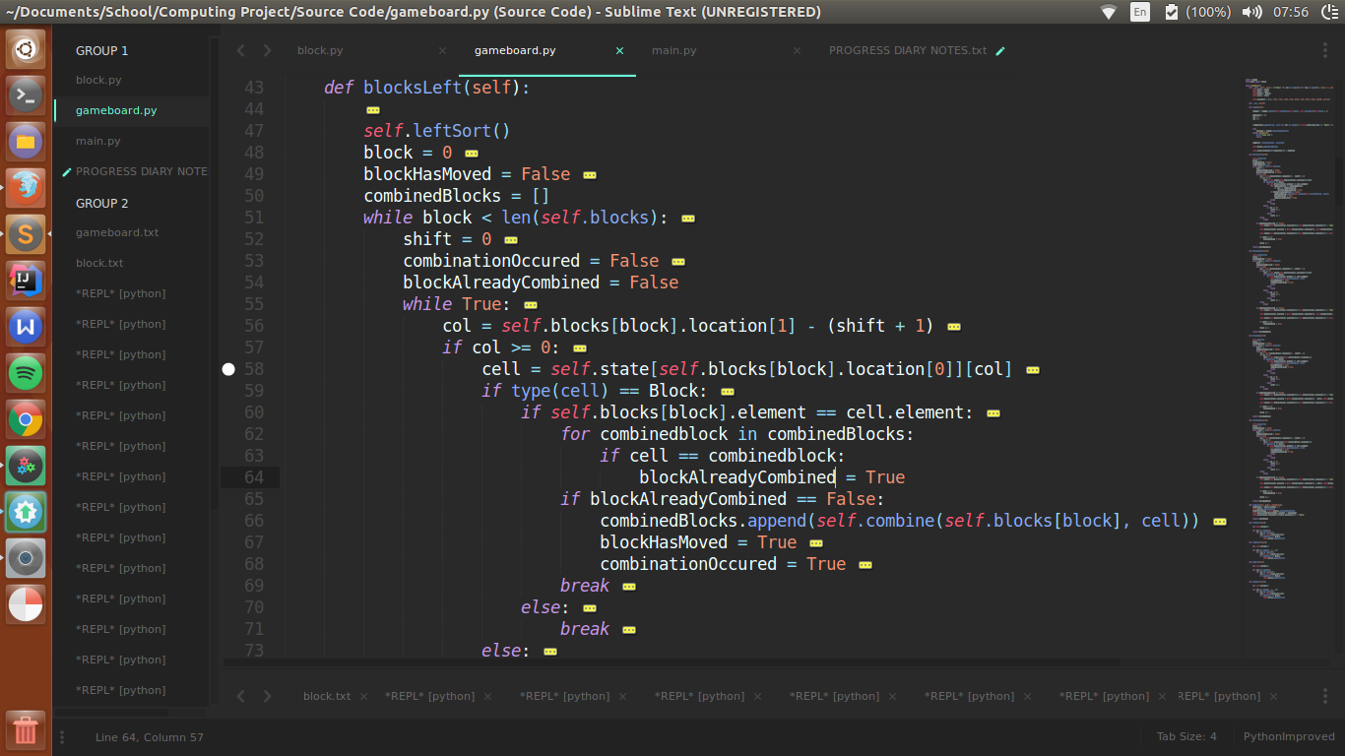

**3.0**

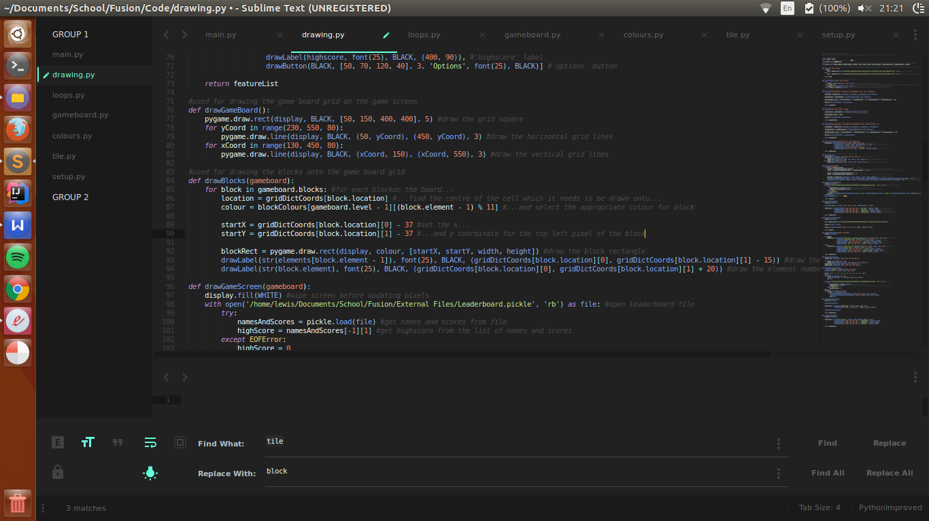

**3.1**

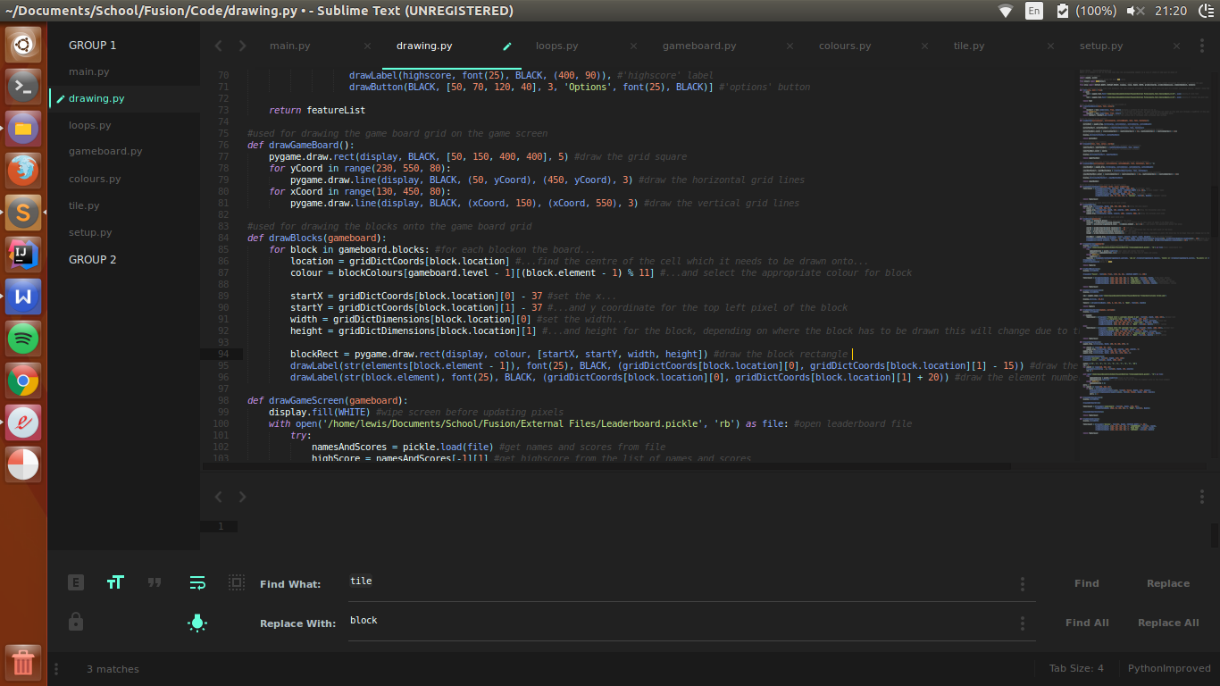

**4.0**

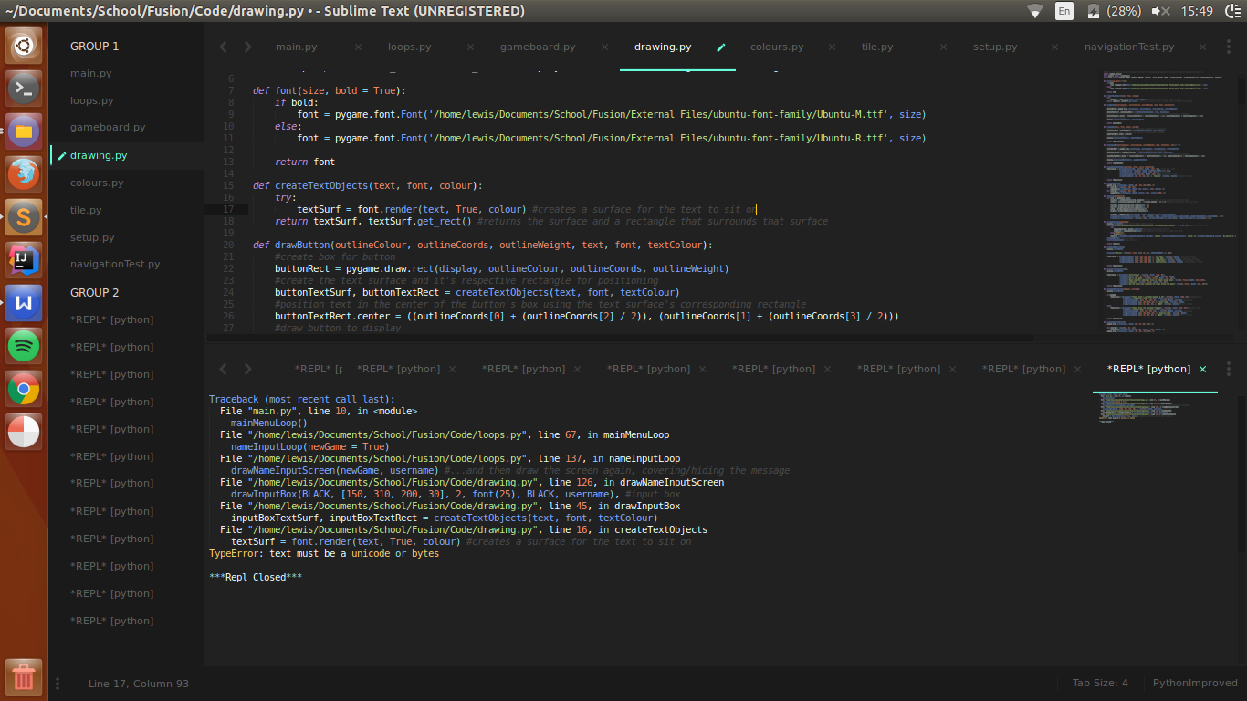

**4.1**

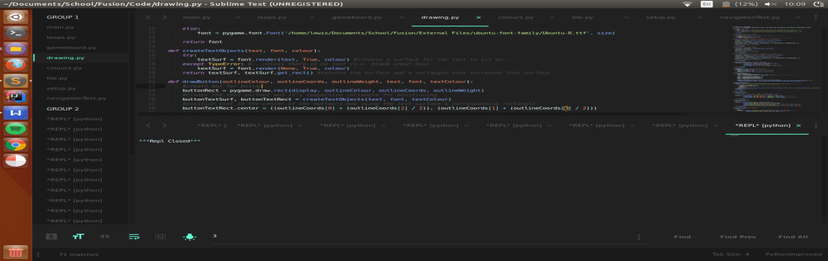

**5.0**

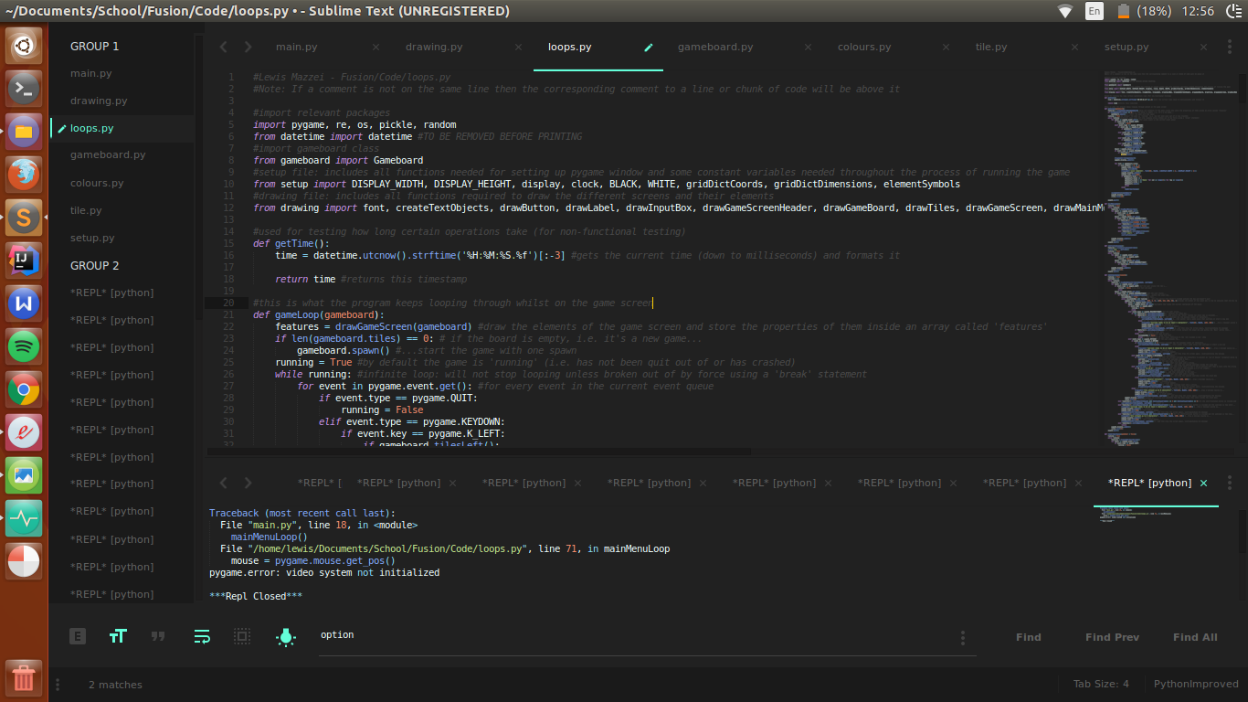

**5.1**

